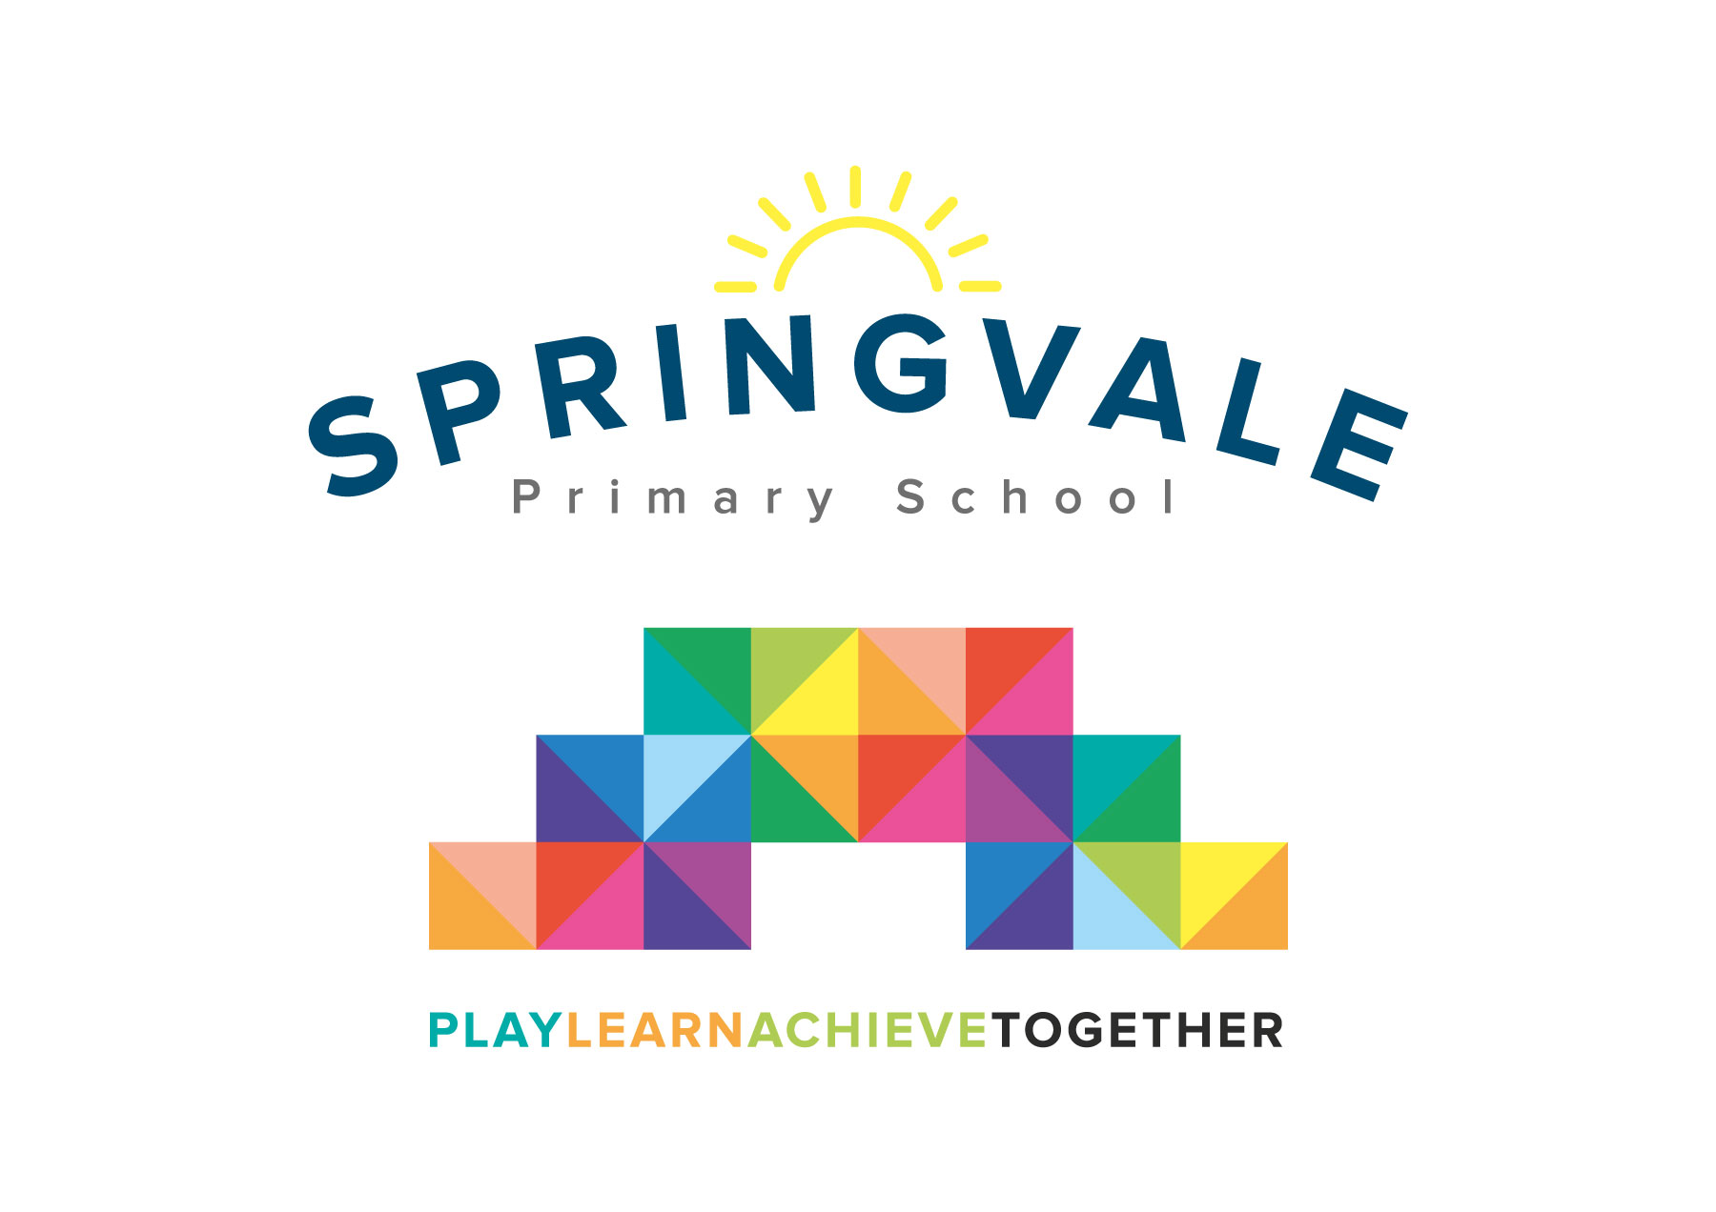
SPRINGVALE PRIMARY SCHOOL
01226 760930

Headteacher: Mr L McClure
l.mcclure@springvaleprimary.org
www.springvaleprimary.org
@SpringvalePS

Enterprise Finals Monday 3rd December 2018

Dear Y5/6 parent,

One of our passions in education is teaching enterprise skills. Enterprise is a way of teaching that develops leadership skills in our young learners and it encourages them to be creative, work in teams and devise plans to design and create new business ideas from a very early age. Enterprise is a great way for young people to use and apply their curriculum skills in a real life context but it does, unfortunately, cost money to provide such high quality opportunities to the pupils.

We have recently engaged with lots of enterprise projects and several weeks ago our Y5 and Y6 pupils took on the ‘Louder than Life’ enterprise challenge. I’m delighted to confirm that your child was part of the winning team and they have been invited to go to Tankersley Manor Hotel next Monday (10th) to compete with their enterprise team against 20 other schools! The children will travel from school to the event with Mrs Kelly at 9.15am and they will return at 2.30pm, well before the end of the school day.

Children require your permission to attend and a packed lunch on the day. We will provide the children with additional time to work together this week to prepare for the finals and children are welcome to take any props or materials that have been prepared at school or at home during the week before the finals to help them with their project and/or final pitch to real business leaders!

Kind Regards

Mr L McClure

Headteacher

My child can take part in this activity and I will provide a packed lunch on the day.

My child can travel with Mrs Kelly to and from the event ___________

Pupil Name _______________________________ Class __________

Signed by parent _____________________________________

