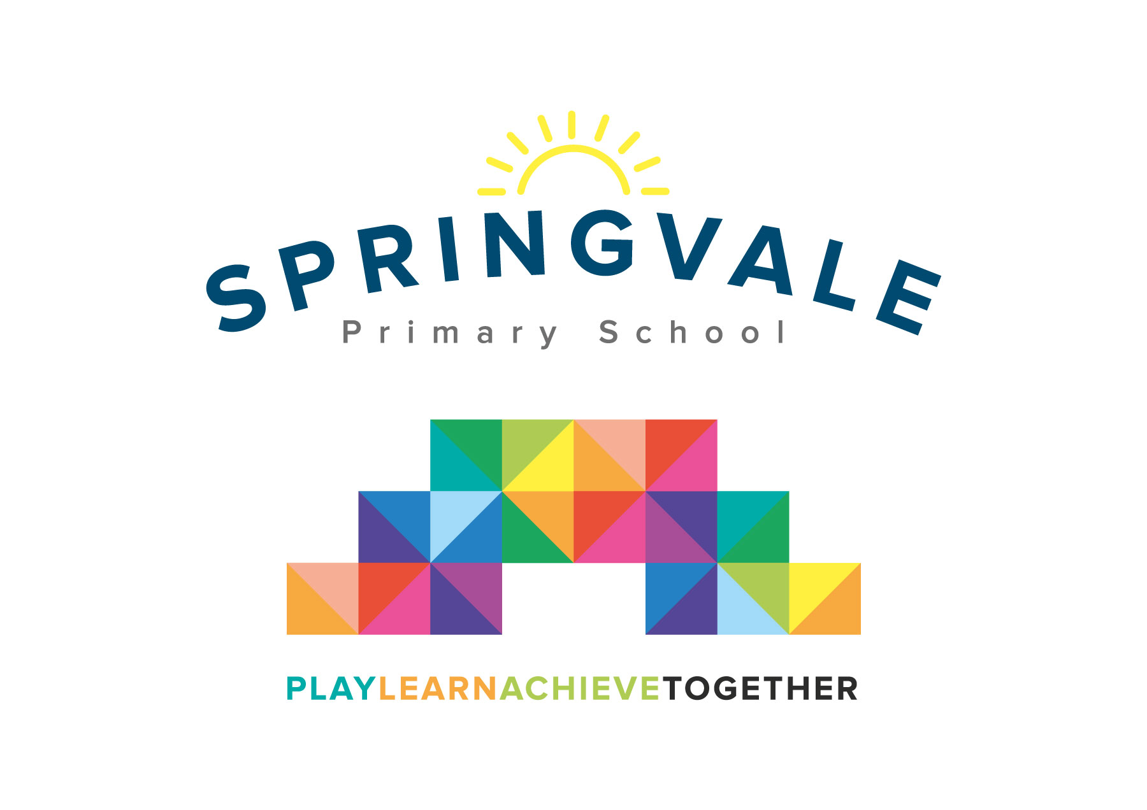
SPRINGVALE PRIMARY SCHOOL
01226 760930

Headteacher: Mr L McClure
l.mcclure@springvaleprimary.org
www.springvaleschool.org.uk
@SpringvalePS

Murton Park Visit 06/11/2018

Dear Parents/Carers
I have organised a trip for our class to visit Murton Park in York on Friday 16th November 2018. The children will be spending the whole day dressed up as Tudors, and taking part in different fun activities. This is always a fantastic and memorable trip for the children, as well as being highly educational and informative. The children need to be in school at 8.45am and we will return to school by 4.15pm. If the coach gets stuck in traffic then the school will be in contact via text message to let you know the new time of arrival. If you would like your child to go on this trip then can you please sign the consent form, and pay £20 online by Friday 16th November. This trip is subsidised by school fund, as the cost of £20 will not be enough to cover the full cost of the coach and entry. We really believe that this trip is very special, and the children who have been in previous years have thoroughly enjoyed it. On the day the children will have the chance to go the museum shop where they will be allowed to spend a maximum of £5. The children will be responsible for keeping their money safe during the day, and we suggest it is put inside a purse/wallet.

Thank You
Mrs Fearn/Mrs Henstock

Consent form: I agree for my child __________________________ from Class 5 to go to Murton Park
Signed parent/guardian ________________________
I give a voluntary contribution of £20.00 towards the coach and ticket into Murton Park

Please tick your child’s lunch option and return by Monday 12th November
Child _______________________ Class ______ Date of trip _______________
Own sandwiches _____________ Grab a bag ____________

Grab a bag filling
Ham _________ Cheese _________ Tuna/mayo _________

