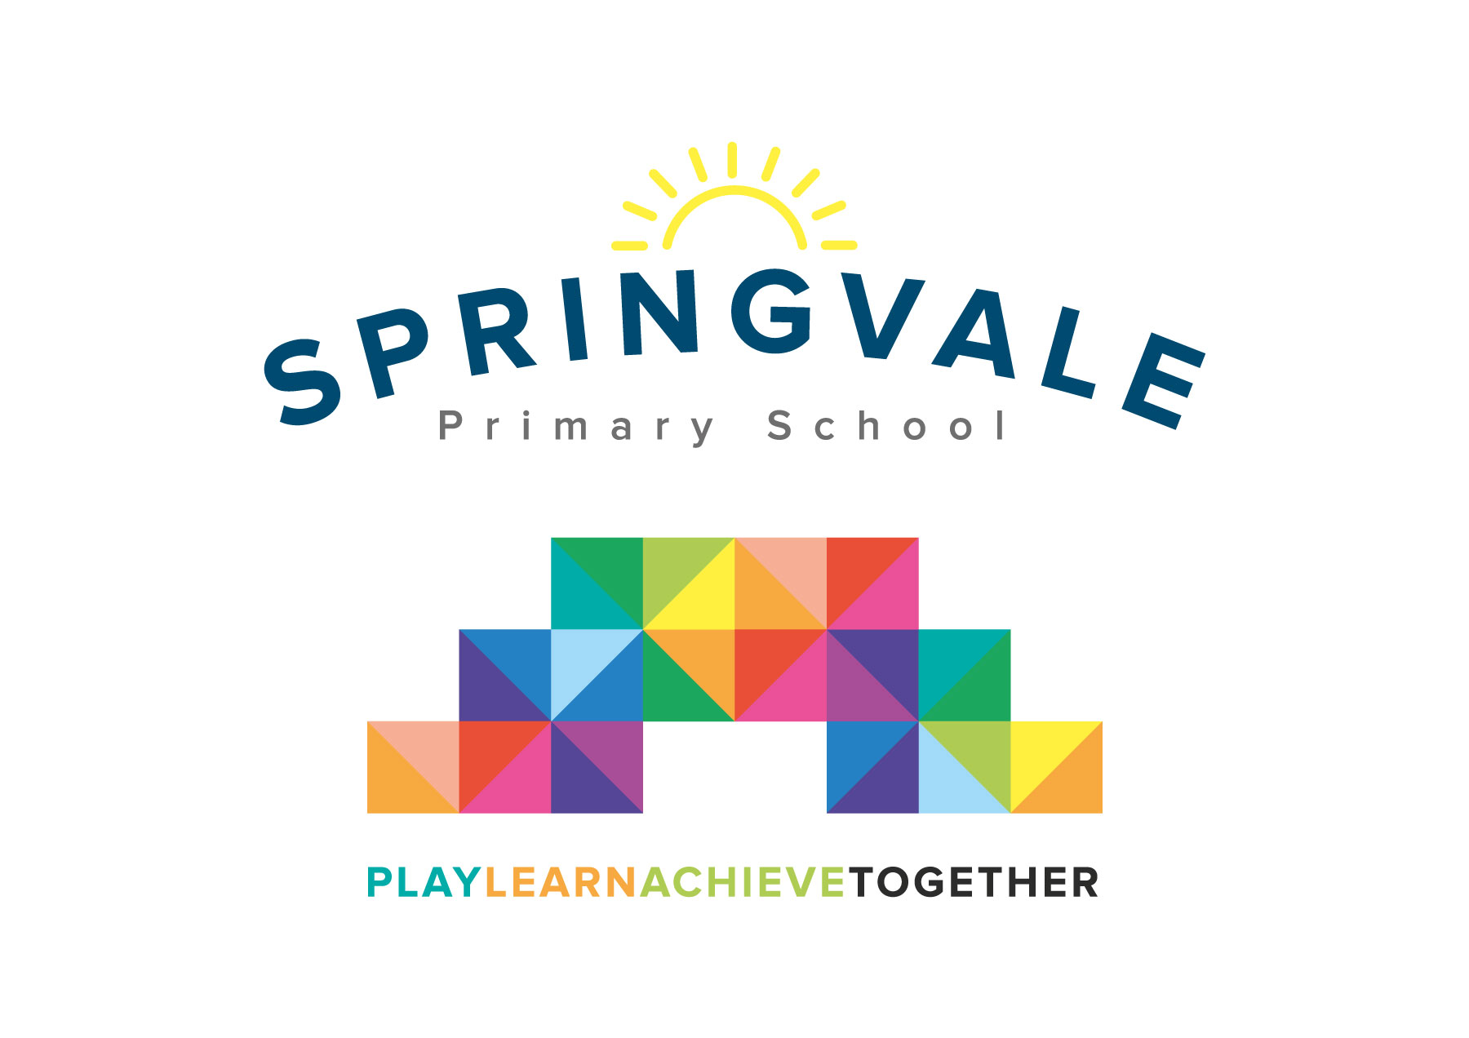
SPRINGVALE PRIMARY SCHOOL
01226 760930

Headteacher: Mr L McClure
l.mcclure@springvaleprimary.org
www.springvaleschool.org.uk
@SpringvalePS

Spelling Bee Tuesday 13th November 2018

Dear Parent/Carer

As part of our work to promote high standards of spelling throughout Key Stage 2 will shall be holding a Spelling Bee in December 2018. We feel that this will be a motivating and a fun way to help the children learn their spellings.

The spelling bee will run as follows:
Round One: Each class in Key Stage 2 (Classes 3, 4, 5 and 6) will be given 5 weeks to learn a list of thirty words taken from the National Curriculum word list. Children will have already practised some of these words in the first half of the Autumn term, and this will be a useful opportunity to ensure that they have remembered these words. Each class teacher will give their class a written test on these words during this current school week.

Semi-Final: The same words will be given to the children 5 weeks later during the final week of this term (w/c 17th December). The highest scorers from each year group in Key Stage 2 will be invited to take part in the Semi-Final. Spelling words will be from their own and higher year groups and will be spelt out loud. Each child will win a house point for taking part. The children who have also made the most progress in each class will also win a house point and a prize.

Final: The highest two scorers in each class will take part in the final in front of an audience of peers, spelling words aloud in the style of a traditional spelling bee. There will be one overall winner from each year group. The date of the final will be confirmed as soon as possible.

We believe that this structure gives all the children the opportunity to win house points, and take part in an event which should be great fun!
Please note: Children will still be getting their weekly spellings, the spelling bee is additional.

Yours Sincerely,
Mrs Fearn
Deputy Head and Literacy Lead

