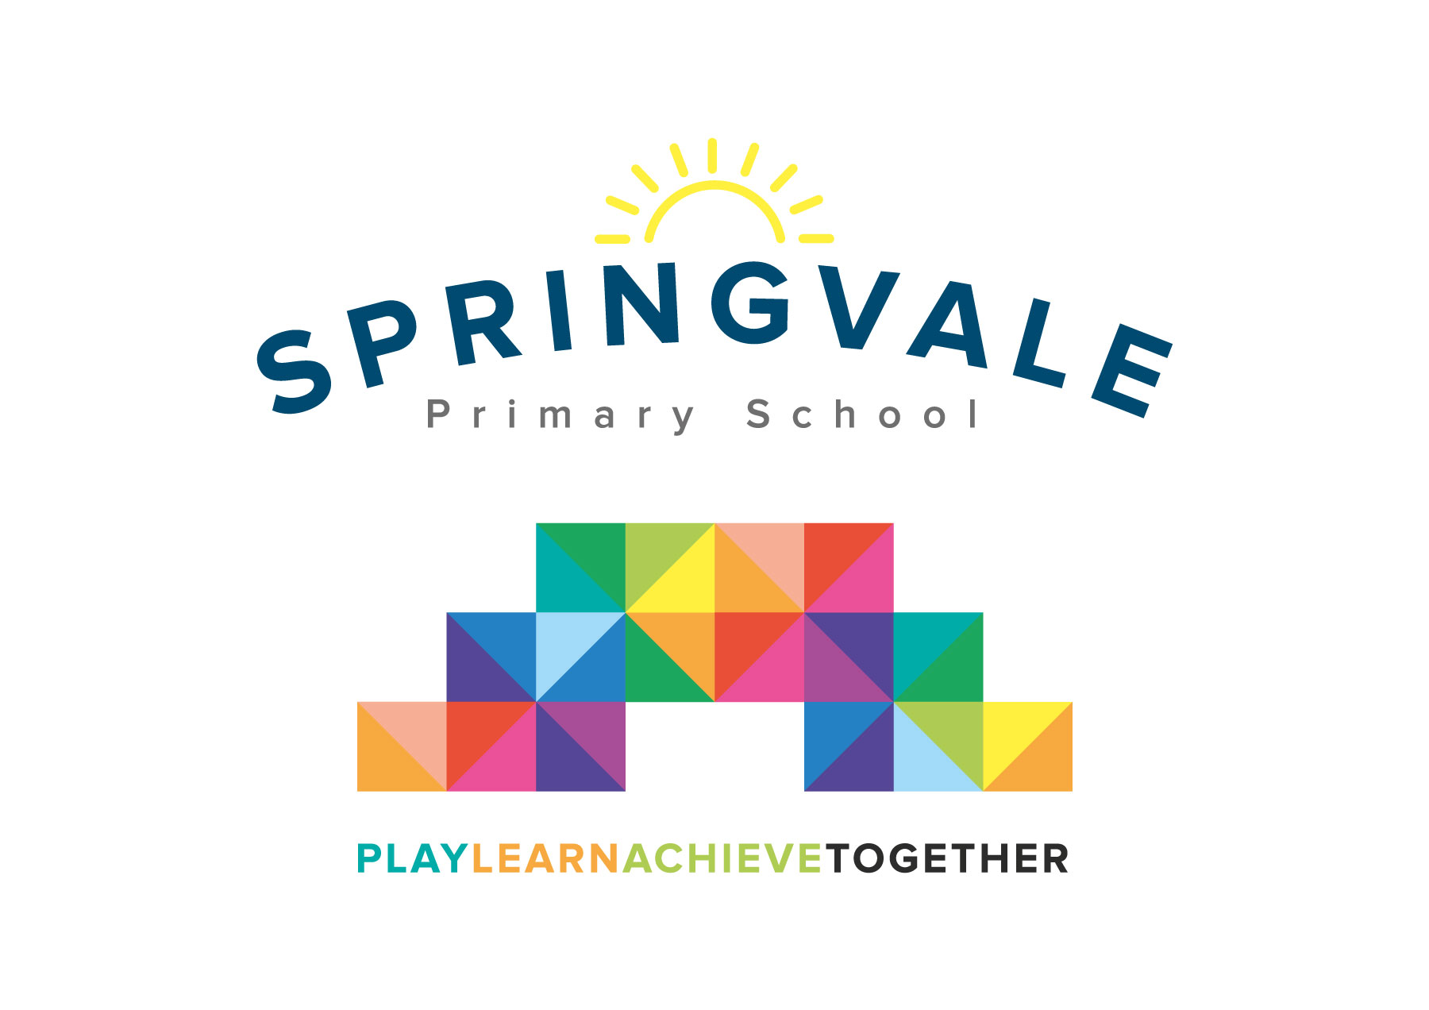
SPRINGVALE PRIMARY SCHOOL
01226 760930
Headteacher: Mr L McClure
l.mcclure@springvaleprimary.org
www.springvaleprimary.org
@SpringvalePS

Newsletter- Week 10 Monday 12th November 2018

Dear families,
Welcome to our latest newsletter! It’s a busy one so let’s get started!

Remembrance Events: We had a wonderful event last Friday when we observed a period of silence prefaced with an information, extended assembly about the World Wars and the debt that we owe to former generations of our community and beyond. The children have really extended their knowledge and understood the importance of remembering our past to help us to shape our future for the better. Special thanks to Ted’s Great Grandad for his interviews and to Y3/5 children and staff for generating the questions! Thanks also to Mr Venus for dressing as a soldier to support the assembly and Mrs Andrew for playing The Last post on flute so superbly. An enormous thank you to everyone who contributed to the Poppy Appeal this year. We will let everyone know how much we raised in due course.

Sports Update: A slightly quieter week this week but still lots of good news to share! First of all, we have seen a fantastic number of children enjoying our latest batch of clubs…this is great to see as the progress reported by coaches of all skills- patchwork, cricket, tennis, arts and crafts, etc, are fantastic and music to my ears! We also say well done to our amazing Y3/4 boys’ football team who came third after some excellent performances at the Barnsley Finals’ last Thursday! All seven of the players were superb but a special mention to Seth with three goals and Henry with his player of the tournament award! We also had lots of achievement at the cross country team event last Friday. Our team of 32 superstars made their way to Cannon Hall, flanked by their supportive families and our staff, and we were so proud of each and every one of them. Special mentions to the whole group who qualified for the South Yorkshire finals Y3/4 girls and Y5/6 girls taking the GOLD to become Barnsley champions, Y5/6 boys taking SILVER and Y3/4 boys taking 4th place and ensuring qualification for all! Wow!

Friendship/Faith Week: This week we will be focusing on friendship and respect for others. We will have special lessons, assemblies and circle time discussions as we strive to promote a community (and a wider World) based on respect, tolerance and kindness for and towards everyone.

Nursery lunch club: We have some spaces available at our Nursery lunch club which is fully staffed/supervised. The club allows children to stay for an extra hour in the day at a cost of £4. Children bring their packed lunch and eat with their friends in the nursery and then access the provision for a little longer. Please speak to Miss Chapman or Mrs Exley if this is something that interests you.

Road Safety: Our big push on safety has started well with lots of special assemblies and lessons all about staying safe around roads and railway lines/stations. F2 have had special stories about being road safe and KS1 learned how to navigate a busy road scenario with specialist road safety officers! Our Y3/4 pupils went one step further and went out onto the roads and achieved their road safety certificates! We will continue our drive to increase awareness of safety through ongoing assemblies and lessons later this month incorporating Y6 Crucial Crew feedback messages, eSafety learning, Stranger Danger and Street Feet to learn about how to cross roads safely for our older children.

Lost Property: We have had an awful lot of lost property recently…please ensure that all items (especially expensive or new items) have your child’s name and class in them (noting that this could wash off every so often). Thank you!

Pupil Premium: With our recent updates about school budgets becoming tighter and tighter we wanted to make families aware of some additional funding streams that could benefit school and families themselves. The Government launched the Pupil Premium back in 2011 which means that any child whose family need the support of free school meals (at any point in their school life) will receive additional funds into school to support them with their learning. This means that families who are temporarily/long-term unemployed, or receive additional benefits, or those who have served in the armed forces or children have been adopted are entitled to the payment. We know that many families who might be eligible for Free School Meals in lower school do not take them up as all meals are free until the end of Y2 now. We would like anyone who may be eligible to contact us as, even if it doesn’t affect school meals, we could be receiving extra funds to help your child all the way from F2 to Y6! Children who do receive the payment are highlighted in more detail to all staff to ensure that they receive additional help and intervention, thus giving them extra potential to achieve and enjoy their learning. I am currently 6 months into an 18 month plan to raise the quality of provision for pupils who receive this funding and we are already seeing an improvement in their rates of progress, attendance and achievement. If you’re not sure if you are eligible, please get in touch with us for support to find out!

Packed Lunches: Apologies about the error on last week’s newsletter. It should have read that… we are advised, as part of a healthy school ethos, to not allow sweets or chocolate bars in packed lunch. Chocolate covered biscuits ARE allowed.

Christmas Events: Much like last year we want our children to enjoy a very special festive period. Today we launched Christmas with a surprise Pantomime performance of ‘Cinderella’ for F2 to Y6 pupils. Later this month we will be taking all pupils (including Nursery) to the cinema for a Christmas celebration and an ice-cream. We also hope to have a special visitor just before Christmas with some gifts too! As ever, our Christmas programme is heavily subsidised (approx. 70%) by school funds created by fundraising. We will be emailing out our Christmas Fayre plans very soon and appreciate any help from parents is very much appreciated.

School Photographs: Remember, please return the photograph orders ASAP and before the deadline of Friday 16th November. Thank you.

Safety before/after school: We have sent out a few texts of late about use of the car park and general safety messages before and after school. Children or adults on bikes and scooters need to dismount once you enter school property as the paths are narrow and busy at key times. We have had several parents using the car park despite several texts and messages to refrain and at the Hallowee’en Disco one parent damaged the car park gates and left the area without reporting the accident, at significant expense to school. Sadly, the damage caused may cost us more than the actual disco funds raised which demonstrates our frustration! Due to this and similar incidents we have had to close our gates just before 8.45am and until after 3.30pm. Please note that the MUGA should not be used before or after school as we have had several injuries which have impacted learning time. Children need to be supervised before they are collected by teachers at the door and children who arrive without adults must uphold high standards of behaviour or we will contact parents to ask that children are supervised in the future. Thankfully the children are fantastic 99% of the time anyway. We just want EVERYONE to be safe and comfortable on school property. Thank you for your support in the vital matters mentioned above.

Parents’ Evening: Special thanks to everyone who logged on Monday evening and signed up for a Parents’ Evening appointment- over 90% were signed up that evening! Please note that, much like last year, our Parents’ Evening will be:
- Please access through reception, all meetings are held in the hall. If you would like to discuss a sensitive matter or would generally prefer a more private discussion please contact me via email to arrange this beforehand or mention it to the teacher at the start of the meeting
- Y6 leaders will greet you and sign you in
- They will then collect your child’s books if you are Y1-Y6 to have a look at (EYFS children don’t have books but their observations are online)
- Please go into the hall and wait at the central tables to be called by the teacher
- Please help us to ensure that the whole day runs smoothly and, if you have concerns that you would like more than 10 minutes to discuss, make an appointment to come back and see the teacher on a different evening. We have 30 parents to see across one afternoon and evening so please help us to keep things running efficiently.
- Please return your child’s books to the Y6 leaders afterwards
- Teachers will hand out a ‘how to help my child’ sheet of top tips based on their current curriculum expectations
- All clubs will go ahead as normal and children should be collected from the normal places
- KS1 football club will be outside for one week only so please wrap up warm and Cartoon Club will be held in the Y4 classroom, collection for both is from the main entrance area
- Children can be collected early, following your appointment by asking Mr McClure and signing them out at reception
- Please don’t worry if your appointment spans your child’s collection time, we will hang on to them for 10 minutes
- Feedback on how we organise Parents’ Evening is always welcomed via email or Twitter

If you’re in no rush or want to have an extra-long look at your child’s work, we will be selling some refreshments this year raising funds for the local Scout group!

Children in Need: This Friday is the national Children in Need Day. As this day is part of our annual fundraising programme, we will be dressing down with a simple theme or spots or stripes (can even just be stripy socks!) and a suggested donation of £1 per family to go to teachers on Friday morning at registration. I am sure you will agree this is a great cause and one that highlights so many of the values of our school and the families that we serve…sharing, charity, supporting others, etc!

Have a great week everyone!
Kind Regards, Mr L McClure, Headteacher
Week 9 Information | Average 2018/19 Stats | Week 10 Diary Dates
Attendance: 97%  Late marks: 2  GREEN LIGHTS: 99.6% | Attendance: 97.4%  Late marks: 0  GREEN LIGHTS: 99.1% | Monday 12th: Shoebox Appeal assembly- Friendship/Faith Week all week  Tuesday 13th: Blue Cross Talks (Y1-Y6), extra Nursery parents’ evening (2-5pm)  Tuesday 13th: Football v Thurgoland (Home) Y5/6 3-4.15pm  Wednesday 14th: Parents’ Evening (Hall 1.30-7.30pm)  Friday 16th: Children in Need dress down day  Friday 16th: Y5 visit to Murton Park (back at 4.15pm approx.)  Friday 16th: School photograph return deadline  Friday 16th: PM- KS2 individual Cross Country Finals- Cannon Hall- see letters  Friday 16th: EYFS/KS1 Captain’s Table and Star of the Week for F2-Y6
Class of the Week: Y3 Wild Flowers with 99.3%

