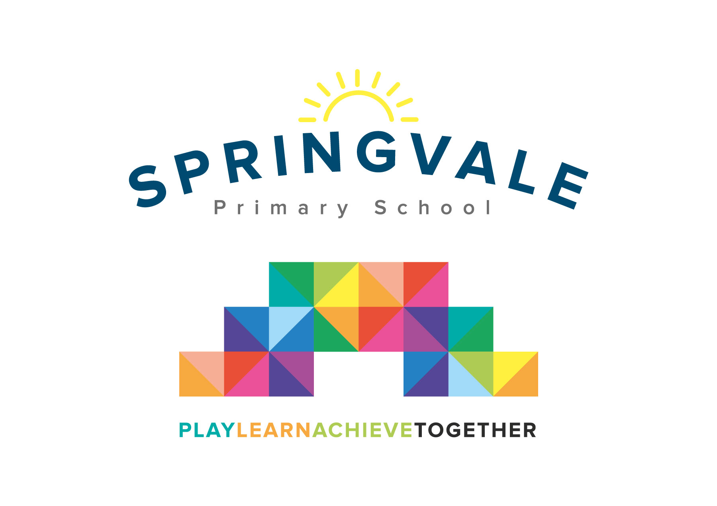
SPRINGVALE PRIMARY SCHOOL
01226 760930
Headteacher: Mr L McClure
l.mcclure@springvaleprimary.org
www.springvaleprimary.org
@SpringvalePS

Newsletter- Week 11 Monday 19th November 2018

Dear families,
Welcome to our latest weekly newsletter. This is your weekly digest of all that is going on at our busy and thriving school!

CCTV Cameras: We have recently updated and improved our CCTV facilities in school in terms of camera angles, quality and recording facilities. The main purpose of the cameras is to protect the school building and the safety of our pupils, parents and staff. The cameras mostly cover playgrounds, walk-ways, the car park and key corridors in school to protect the building and the people in it. The cameras may also be used to review any incidents in and around school. We will be sending out a policy about safe use of CCTV in due course but we wanted to make parents aware that we will never ask children to change for PE in any area covered by CCTV and that we would contact parents if a child was involved in a serious incident- behavioural or otherwise- that was captured on the cameras.

Out of School Achievements: Our School Council have decided to introduce a special display in school and special assemblies to celebrate the very many achievements of our amazing pupils that occur out of school. Please email any pictures with a brief explanation of the achievement to l.mcclure@springvaleprimary.org and they will be shared ASAP.

Governor School Meal Scrutiny: Last Thursday (15th) we had 7 of our 12 Governors in school to enjoy a school meal and to speak to pupils and key staff about their views on school meals. This was organised in response to feedback from the Parent Council and through recent questionnaires. The visit demonstrated lots of positives about lunchtimes at Springvale but also some areas to develop, mainly the portion sizes for older pupils. We will be taking steps to address these issues and seeking further feedback along the way. We do have a fantastic new menu to choose from so if your child is on packed lunches and they would like to try school meals again, please let Mrs Ridgwick know! As the Penistone winter draws in there is more need for a hot meal at lunchtime so feel free to give them a try for a few weeks! Some immediate changes include a fully replenished salad bar for KS2 and that any leftovers of any kind are offered to the oldest children. We will be making more substantial changes in due course.

Christmas Plans: Next week’s newsletter will be really important. It will give all of our Christmas plans- show tickets, Christmas meal information, cinema visit details, party plans, etc. We fund our Christmas events through fundraising activities but please be aware that we always require a contribution) to ensure that we have enough funds for the Pantomime, cinema and a little Christmas gift.

School Uniform: Just a reminder that we have got the new logo (the simpler version shown on PE shirts) going on to all branded school uniform from the end of this academic year (July 2019). I want to keep reminding everyone so that parents can get good value for money out of any uniform bought recently or between now and then. All forms of the logo will be allowed in school but we would love for the new logo to be phased in sooner rather than later so thought it would be good to keep parents abreast of the situation throughout the year. Uniform standards remain high but we do have some pupils each week with ear-rings, nail polish or trainers on who have to be reminded of the current policy. Lots of children tell us they have lost items of clothing. Please ensure that names, and ideally classes, are in each item so that we can return them immediately. Any unnamed items are placed in the basket in the foyer (main entrance) for half a term and then displayed on the playground.

Road Safety/Dark Nights: Please note that we are continuing to teach the children about being safe throughout the rest of the month and this week we are focussing on Road and Cycle Safety. This Friday we have a dress down for ‘Be Bright and Be Seen’ and there is no donation required. As an additional safeguarding measure, from the start of next week, (Monday 26th November) we will ask that all pupils- even those in Y5 or Y6 with permission to walk home alone are collected from clubs or events that finish after 4pm due to the dark nights. We will keep this system in place until February half-term and then relax it again to the current arrangement.

Parents’ Evening: A big thank you to everyone who came along to Parents’ Evening appointments last week to celebrate their child’s progress so far in their new classes. The evenings are now really well organised and I have to thank the Y6 leaders who were superb hosts! Staff were delighted with the progress that children are making and the way that they continue to enjoy school and all that we offer. Thank you for continuing to support all that we do and for supporting our ethos of Play Together, Learn Together and Achieve Together through our ongoing effective partnership between home and school.

Children in Need: A big thank you to everyone who supported the Children in Need Day appeal. Children enjoyed their dress down day and the messages in school last week about friendship, respect and empathy for others all across the world, especially those who are less fortunate than ourselves. We raised £190 and the appeal nationally broke records once again with the total currently standing at over £50million! Wow!

Sports Update: Another eventful and exciting week of sport to report on! On Monday a group of Y3/4 pupils went to PGS to tackle the districts finest in a Sportshall Athletics event. We competed in 10 different disciplines and came 3rd out of the 8 teams present! On Tuesday we had 2 excellent football fixtures against Thurgoland Primary. Our competitive team drew 2-2 in a pulsating fixture with some very close goal-line technology decisions! Well done to everyone involved! The development team lost 3-1 in an equally fabulous game. The spirit and sporting attitudes on show were fabulous and made us all very proud of the children. Special mention to Players of the Match Graihagh, Alex C, Noah and Charlie R. Lastly, on Friday we had our competitive cross-country runners racing for individual awards after their amazing team outcomes last week. We were so proud to take such a large group to the event- 15 in total! Well done to everyone involved and special mentions for Anya and Leah with 1st places in Y3 and Y6 respectively. A huge well done also with so many top 10/20 places and improving personal best scores! You were all incredible, again!

School Photographs: The deadline has now passed for photograph orders. Thank you for the orders received so far. The photos will arrive in a few weeks and we will give them out as soon as they arrive. The pictures will be with us before Christmas.

Reminder: Please note that the MUGA should not be used before or after school as we have had several injuries which have impacted learning time. Thank you for your support on this matter.

Reminder: Tickets are now on sale for the special Christmas Celebration to raise funds for Heads Together on Wednesday 19th December. They are available from the office and Audrey Parsons at Pop Shop.

Have a great week everyone!
Kind Regards, Mr L McClure, Headteacher
Week 10 Information | Average 2018/19 Stats | Week 11 Diary Dates
Attendance: 97.7%  Late marks: 0  GREEN LIGHTS: 99.7% | Attendance: 97.5%  Late marks: 0  GREEN LIGHTS: 99.2% | Monday 19th: Y4 at Eden Camp and Y1/2 Sportshall Athletics at PGS (4-5.30pm)  Tuesday 20th: Modeshift Awards Event in York  Friday 23rd: Be Bright, Be Seen dress down day (no donation)  Friday 23rd: Football Y3-6 Away to Churchfield (see letters)  Friday 23rd: KS2 Captain’s Table and Star of the Week for F2-Y6
Class of the Week: Y4 Venus’ Flytraps with 100%

