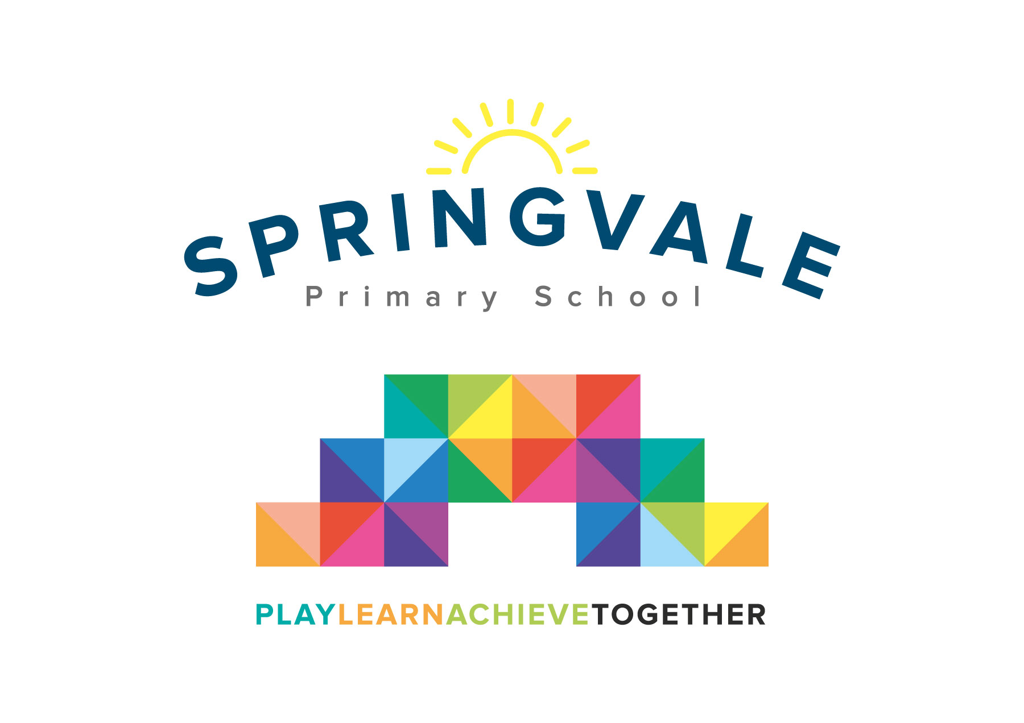
SPRINGVALE PRIMARY SCHOOL
01226 760930
Headteacher: Mr L McClure
l.mcclure@springvaleprimary.org
www.springvaleprimary.org
@SpringvalePS

Newsletter- Week 13 Monday 3rd December 2018

Dear families,

Welcome to our latest newsletter. Thank you for your fantastic, ongoing support with all our Christmas events and fundraising. We all look forward to seeing you over the festive period!

Christmas Arts Week: This week our children will be decorating the school, learning their Christmas lines and songs and completing lots of art and craft activities during the week. On Thursday we will hold a special Christmas Art Gallery in the hall from 2.30pm to 3.30pm. Work from every child will be displayed including all age groups (Nursery to Y6). The work will also feature on Twitter. In Y1-Y6, two children will be selected to explain their art work. We hope you can come along and join us! On Friday, we end the week with our Christmas Fayre. We can all wear Christmas Jumpers (and general non-uniform trousers, etc) and have a fun afternoon with raffles, stalls, games, refreshments and a special Grotto! The event will run from 2pm to 4.30pm so that children can be signed out early to enjoy the Fayre or enjoy it in a less chaotic environment after school once collected as normal- the choice is yours! If you wish to collect early please come along to the Main Reception by 3pm. After 3pm we will close the collection desk and children should be collected as normal. We have an amazing raffle this year (thanks, as ever, to our amazing and supportive parents/community) so please get involved and support our school funds by getting a ticket or two when you can!

Leadership/Staffing Update: We are excited to share the news that Mrs Wildsmith and her partner are expecting their first child in April 2019…congratulations to them both and their whole family. Mrs Wildsmith is likely to take a full year off for maternity, starting around Easter 2019, which will affect her current class and a class the following academic year. After Christmas we will be advertising a maternity cover role in school to recruit a qualified teacher on a one year contract. We will keep you updated every step of the way and we are confident of recruiting a quality teacher to cover the maternity; our excellent reputation can only help us to attract a suitable candidate! We have already started to plan the recruitment/transition to ensure that the positive progression in Y3 seen this year isn’t lost and that things like Parents’ Evenings and Annual Reports are well managed.

In other news, I has been asked to support other schools in Barnsley and the South Yorkshire area. Some schools are identified as a cause for concern by their respective Local Authority or Academy chain. This arrangement would not affect my role at Springvale but it would ensure that I continue to develop as a school/system leader and that our school continues to develop through partnership work with other schools. It would also bring significant extra funds into school at a time when they will help us to maintain our own standards. We have an excellent wider Senior Leadership Team now who are developing well too, they will take on the day-to-day running of school in my temporary absence. To clarify as an illustration, my first deployment is to work for 10 days- 1 day every fortnight until April- to support a school to prepare for their next Ofsted inspection and, for this commitment Springvale benefits financially. I wanted to be transparent about this role and ensure parents that it will not have a detrimental effect on Springvale Primary or our pupils.

Carols Around the Tree: Grandparents and the elderly are invited to join us on Wednesday 19th December between 9.30 and 10.30am for a Christmas Musical extravaganza. Some invites have been posted out but we also have a guest list in main reception for any grandparents who wish to attend for pupils in Y1-Y6 who are involved. We will tweet pictures and clips of the singing/instrumental performances as always.

Budget Update: I recently communicated the concerning budget positions of many schools in the area, and indeed regionally and nationally. We continue to manage our budget as effectively as possible and we have recently held talks with the Local Authority that demonstrated very clearly just how effectively our funds are managed. The LA were very impressed by our plans for the future and our passion to ensure that the rising costs of running a school, often not matched by Governmental funding, will not lead to a fall in standards or opportunities for our pupils. We will continue to keep you updated…remember, if you think you might be eligible for Pupil Premium please speak to our office as this will raise substantial extra funds for school to utilise.

DT Days: Our (very lucky) younger learners F2-Y2 will all be accessing specialist Design Technology projects this week as our teachers work alongside a specialist DT teacher! These days will enhance the creative and engaging Christmas Arts Week and the children will all make a project to bring home as a Christmas Gift (if you’ve been good this year…) after they have been displayed at the Art Gallery! Our KS2 pupils will be taking on a special Summer DT challenge in July instead of taking part in this Christmas event.

Sports Update: Well done to our fabulous KS1 pupils who were superb despite the horrendous weather last Wednesday! The red team won 2-1 but it was more important to see the children all getting involved and playing with a huge smile on their face! The goals were scored by Mitch, Charlie S and Maxi and the Star Player Awards went to Elliot and Oliver. A huge well done to our Y5/6 league team who played their first competitive game of the new league season but sadly lost 5-1 to an excellent Silkstone Primary team on Friday! A goal from Noah and a Star Player Award for Alex! Well done guys!

Parent Council: We recently had our Autumn Term Parent Council meeting where we celebrated the positive changes brought about through effective parent voice last year. We have started to discuss potential changes for the year ahead to make school run even more efficiently. The minutes for the meeting are now online under the Parent Council heading. One thing that we wanted to share straight away is that parents can log in to their School Money account and view what their child has ordered for lunch each morning. Parents need to log in as normal and then select ‘history’ from the left sidebar, then ‘meal selections’ from the top right of the header menu. You might then need to click a little ‘x’ to expand the details. This may help you to plan your family meals in the future! If you require assistance on how to do this please contact our office staff.

General Reminders:
- Please return any unwanted show tickets so that we can share them with other families
- All after/before school clubs finish this week and we take a 2 week break before the Christmas Holidays
- Please do not ride bikes or scooters on school property as many areas are busy and we may have accidents. Children, particular our EYFS/KS1 aged pupils, need to be supervised before they enter the classrooms to ensure that they are safe around the school site
- The MUGA is out of use for children before and after school with the exception of storing bikes and scooters
- We have an INSET Day on the first day back in January, pupils return on Tuesday 8th January

Have a great week everyone!
Kind Regards, Mr L McClure, Headteacher

Week 12 Information | Average 2018/19 Stats | Week 13 Diary Dates
Attendance: 97%  Late marks: 0  GREEN LIGHTS: 100% | Attendance: 97.2%  Late marks: 0  GREEN LIGHTS: 99.3% | Monday 3rd: Christmas Arts Week Begins/DT Day Y1/F2  Monday 3rd: 4-5.30pm Y5/6 at PGS for Sportshall Athletics  Tuesday 4th: Pop Shop Show from 4pm  Wednesday 5th : DT Day Y2/F2 and Y6 Cheerleading Finals  Thursday 6th: 2.30-3.30pm Art Gallery (School Hall)  Friday 7th: KS2 Captain’s Table and Star of the Week for F2-Y6  Friday 7th: Christmas Fayre from 2pm to 4.30pm  Sunday 9^{th:} Springvale Singers at Christingle Service
Class of the Week: Y2 Sunflowers with 99.2%

