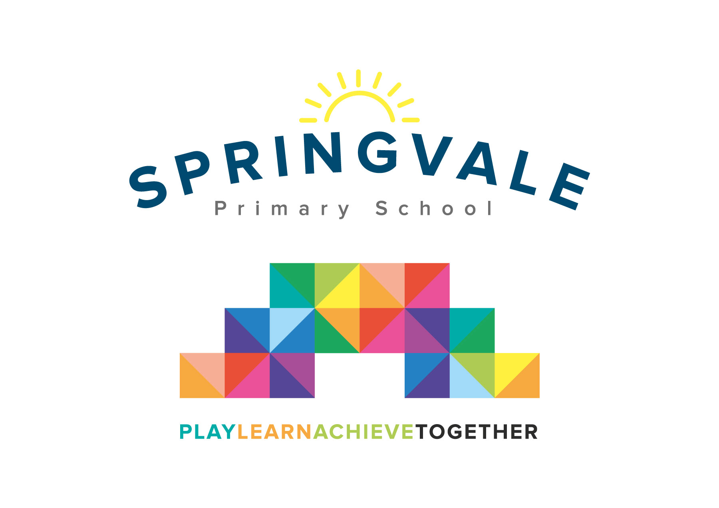
SPRINGVALE PRIMARY SCHOOL
01226 760930
Headteacher: Mr L McClure
l.mcclure@springvaleprimary.org
www.springvaleprimary.org
@SpringvalePS

Newsletter- Week 14 Monday 10th December 2018

Dear families,

Welcome to our latest newsletter. Not long now until we all find out if we’ve been naughty or nice! Thank you all for your generosity and support these last few weeks. Our Christmas Fayre was a roaring success and we made a staggering £1000 on the day which does not include current raffle takings! The raffle tickets are still on sale during Christmas Performance week. We will draw the raffle straight after Christmas Lunch- we will show videos of the draw for the main prizes just like last year and then send out an email/tweet with the full results so that prizes can be collected on the final day. Any uncollected on the final morning will be sent home with children unless they are heavy, valuable or alcoholic!

Christmas Arts Week: The staff and children had a fantastic week creating art work and special projects linked to Christmas. The EYFS and KS1 DT projects are amazing, thank you so much to Andy Heppenstall for his expertise and enthusiasm, the children had a great time and developed some vital practical technology skills. The art gallery event was well attended and it was great to see the class speakers explaining all of their hard work to the parents. Thank you for coming along!

Staffing Update: Mrs Wood has been supporting many of our pupils for many years here at Springvale and she has decided that the time is right to retire from classroom teaching. Mrs Wood has touched the lives of so many of our children and families and she will be greatly missed. Her teaching is always fun and engaging and she adds so much to our curriculum. We will be covering Y3 PPA internally with Mrs Kelly to ensure that the children have consistent and familiar staffing.

Carols Around the Tree: Grandparents and the elderly are invited to join us on Wednesday 19th December at 10.30am for a Christmas Musical extravaganza. The guest list still has spaces so please get in touch to reserve your place ASAP to avoid disappointment.

Christmas Shows: Tickets for the KS1 and KS2 shows have now been sent out, please let us know if you didn’t receive any ASAP. Please return any spare tickets ASAP so that we can reassign them where required. Please note the follow for our show week:
- Please don’t arrive more than 15 minutes before the show as staff may not be available
- During KS2 evening shows, parents with a child in each show can bring both children and stay in the hall during the interval, we will supervise the children
- Parents with little babies who may become distressed may want to come to a Dress Rehearsal to avoid the stress of a large crowd, please ask us for details if required

Sports Update: Well done to our Y5/6 Sportshall Athletics team who represented school at PGS last Monday night! They came 4th out of all of the schools present which is a great result. Special mention to all of the team members, especially those that filled in at short notice to help us get a team at this hectic time of year! Special mention also to 9 amazing Y6 girls who competed at a very high-quality cheerleading contest with so much confidence and gusto last week! We have our final sports event of the year today as Y5/6 footballers take on Dodworth St John’s at 2.30 and 3.15pm respectively! Our club list is almost ready for the new term…we will email it out on the first day back and then open bookings in week 2 for the clubs to begin soon after.
Have a great week everyone!
Kind Regards, Mr L McClure, Headteacher

Week 13 Information | Average 2018/19 Stats | Week 14 Diary Dates
Attendance: 97.6%  Late marks: 1  GREEN LIGHTS: 99.3% | Attendance: 97.3%  Late marks: 3 all year  GREEN LIGHTS: 99.3% | Monday 10th: Enterprise Finals’ Day (selected Y5/6 pupils)  Monday 10th: Football v Dodworth (Girls at 2.30pm and Boys at 3.15pm)  Wednesday 12th : 9.30am and 6pm Y3/4 Show/10.30am and 7pm Y5/6 Show  Thursday 13th: KS1 Show 9.30 and 6pm, KS2 Cinema Visit (AM)  Thursday 13th: Springvale Singers at 11.30am market at 12noon Tesco  Friday 14th: EYFS Shows at 10.30am and 2pm
Class of the Week: Y6 Yorkshire Roses with 100%

