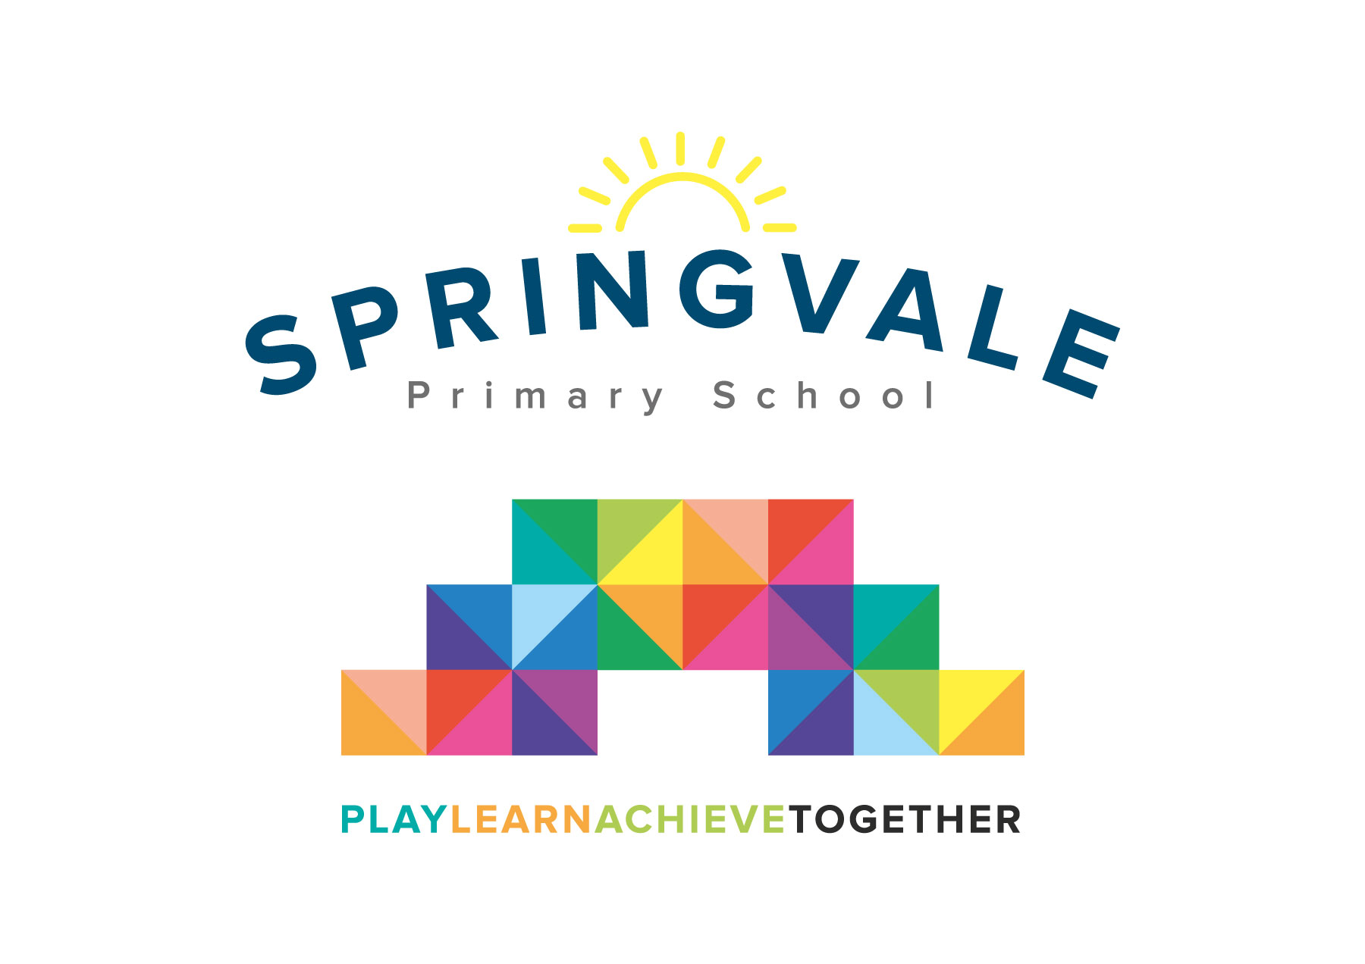
SPRINGVALE PRIMARY SCHOOL
01226 760930
Headteacher: Mr L McClure
l.mcclure@springvaleprimary.org
www.springvaleprimary.org
@SpringvalePS

Newsletter- Week 15 Monday 17th December 2018

Dear families,

Welcome to our final newsletter of a wonderful year for the school. Thank you for your incredible support and generosity in recent weeks (over the busy Christmas period) but, more importantly, throughout the whole of 2018!

Improvement Update: We will bring you a much more detailed update in the New Year but we wanted to say how impressed we are by the personal and academic progress of our pupils. They seem to be growing and developing before our very eyes in so many curriculum areas! Our pleas for support with reading at home, phonics support in lower school and a real push on multiplication skills in upper school have clearly been heard and supported well…it really has been a fabulous term. We are all excited about the coming term and the things we can and will achieve in 2019! Let’s make it the school’s best ever year!

Christmas Parties: We will offer a normal school meal on party days so staff just ask that children wear their party clothes on their party day (no make-up or jewellery though please) and school will provide some basic party food for the children- including alternatives for dietary needs or allergies. The party dates (and days when children can dress up/down) are:
Monday 17th December- KS1 Party- PM
Tuesday 18th December- F2 Party- AM and Y3/4 Party- PM
Wednesday 19th December- Y5/6 Party- PM
Friday 21st December- All Nursery Pupils- AM

Christmas Shows: I just wanted to say how proud I was of the incredible shows last week! The hall looked fantastic thanks to beautiful trees that were kindly donated by Mr and Mrs Cliffe (staff and Governor, respectively) and Mrs Akrill and her partner. The shows were all very well attended with superb audiences and the staff worked hard to put on a great show. The children were well prepared, looked the part and shone under the spotlights! We hope you all enjoyed the shows!

Sports Update: Well done to our Y5/6 footballers for a superb performance across two breathless matches on Monday against a Dodworth St John team organised by Bruce Dyer. The girls won 6-3 and the boys lost 8-4. Over 25 children took part in the games and some outstanding football was played. Star Player awards went to Noah, Graihagh, Emma and Charlie B. We take a little break from sports now until the New Year. A big thank you to the many parents who attend and support our sporting events and to Mr Crossfield for an excellent first term as our new Sports Coach. We have seen some fabulous progress and we have already started to achieve well against other schools locally and across the region!

Early Dates 2019:
School Closed until Tuesday 8th January (INSET on Monday 7th January)
Friday 11th January- launch clubs for Spring Term 1
Wednesday 16th January- 3.15-4.45pm Book Drop In (Y1-Y6) for parents
Monday 21st January- 6pm Y6 parent meeting- SATS, Robinwood, Steps to Secondary

We would finally like to wish all of our families a very Merry Christmas and all the best for the start of 2019!
Kind Regards, Mr L McClure, Headteacher
Week 14 Information | Average 2018/19 Stats | Week 15 Diary Dates
Attendance: 99.3%  Late marks: 2  GREEN LIGHTS: 99.3% | Attendance: 97.4%  Late marks: 5 all year  GREEN LIGHTS: 99.3% | Monday 17th: KS1 Party PM (KS1 dress down in party clothes)  Tuesday 18th: Led Walk to school 8.30-8.45am from TPT via Green Road  Tuesday 18th: F2 Party AM and Y3/4 Party PM (dress down in party clothes)  Wednesday 19th: 10.30am Carols Around the Tree (Y1-6 grandparents and elderly)  Wednesday 19th: Y5/6 Party PM (Y5/6 dress down in party clothes)  Thursday 20th: Christmas Lunch Day (Christmas Jumpers)  Friday 21st: F1 Party (9-11am) (Party clothes!)
Classes of the Week: F2 Amazing Acorns, Y1 Water Lilies and Y4 Venus’ Fly Traps with 100%

