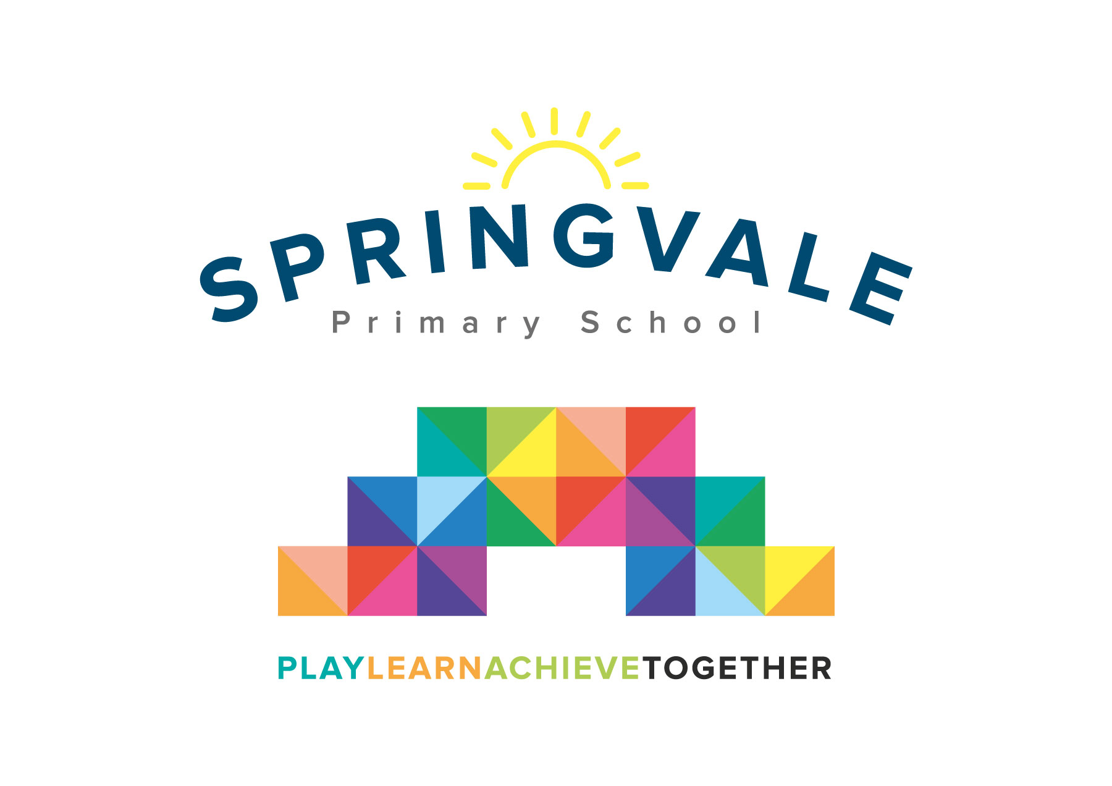
SPRINGVALE PRIMARY SCHOOL
01226 760930
Headteacher: Mr L McClure
l.mcclure@springvaleprimary.org
www.springvaleprimary.org
@SpringvalePS

Newsletter- Week 16 Monday 7th January 2019

Dear families,

A warm welcome back and Happy New Year! We hope that 2019 will be an excellent year for you all and everyone associated with Springvale Primary! We hope that you all had an excellent Christmas break.

Christmas Appreciation: A huge thank you from all of the staff for kind words, cards and gifts that were exchanged at the end of last term. They are never expected but always appreciated, especially considering the outpouring of Christmas generosity that we experienced across our fundraising drive. Your support means the World to us all. Thank you.

Developing Independence: Parents of Y6 pupils last year and this will know that we have a clear focus on pupil independence at the top end of school. This is to support children for their future education, most likely at PGS in the near future. With this in mind we would ask that parents aim to support this push for independence and ask that children, with each passing year, have greater responsibility for their items of clothing and personal belongings and that children are encouraged to be organised for the day ahead as they leave school. We receive an awful lot of interruptions to learning time (calls and visits) from parents when children have forgotten items for a sports or musical event. As the pressure is on school to ensure that all pupils make rapid progress across the curriculum every second counts and we would really appreciate your support in our drive for greater independence.

Improvement Update: Our first term of the academic year saw us further drive standards in areas from teaching and learning, subject leadership and attendance, welfare and behaviour. Attendance was a record high 97.4% for the Autumn Term and we reduced lateness to a record low with just four late marks across the whole term! We want to keep improving those stats on our drive to be the best that we can possibly be! In September we wrote to all families to say that multiplication tables and phonics/early reading were our key improvement drives this year…and possibly for the next few years as they are such vital cogs in the learning process.

Our TT Rockstars stats show incredible engagement and progress with many children moving through the achievement stages faster than any school in the region! Our ‘Reading Army’ is now embedding nicely and thanks to their hard work and our skilled staff/leaders, more children than ever are reading to trained adults in school time. Reading record entries are also on the up this year and the proof is in the pudding in our most recent assessments that ‘little and often’ reading and maths quizzes are the best way to develop confident and secure skills! We are delighted with the progress so far and excited about what we will achieve in the near future…keep it up everyone!

Early Dates 2019: Next week we will give you all a full list of Spring Term dates but here are some early ones whilst we get a comprehensive list together!
Thursday 10th: Y5/6 cinema visit for Star Wars project (AM) and KS1 Visit to The Deep (9-4)
Friday 11th: Clubs Launched at 2pm
Wednesday 16th: Parent drop in- Y1 to Y6 3.15-4.45pm
Monday 21st: Y6 Meeting (SATS and Robinwood) 6pm

Have a great week everyone!
Kind Regards, Mr L McClure, Headteacher

Week 15 Stats | Average 2018/19 Stats | Week 16 Diary Dates
Attendance: 98.3%  Late marks: 1  GREEN LIGHTS: 100% | Attendance: 97.4%  Late marks: 4 all year  GREEN LIGHTS: 99.4% | Monday 7th: INSET Day  Tuesday 8th: Back to school  Thursday 10th: Y5/6 Cinema Visit (9-11.30am)  Thursday 10th: KS1 Visit to The Deep (9am-4pm)  Friday 11th: Clubs launched at 2pm  Friday 11th: Captain’s Table (lower school) and Star of the Week
Class of the Week: Y4 Venus’ Flytraps with 100%

