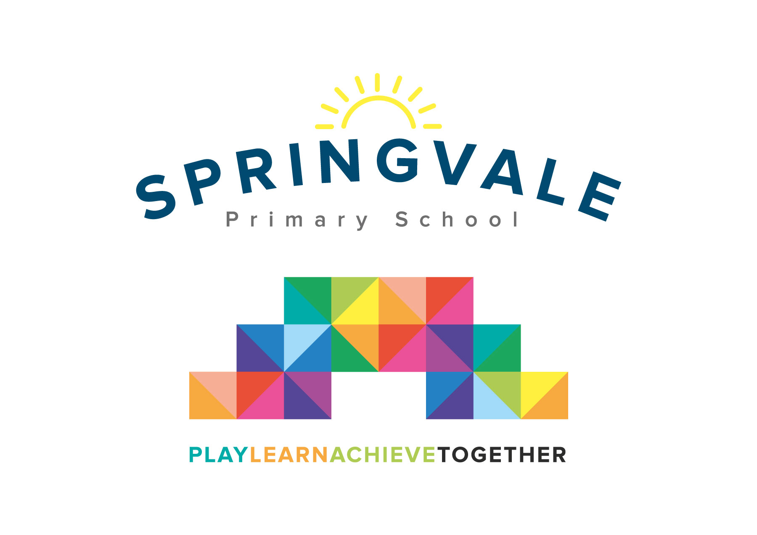
SPRINGVALE PRIMARY SCHOOL
01226 760930
Headteacher: Mr L McClure
office@springvaleprimary.org
www.springvaleprimary.org
@SpringvalePS

Dear Parent/Carer,

As part of our ‘Under the Sea’ topic we are studying how marine creatures compare to humans and their habitats. To do this, we will be visiitng The Deep in Hull on Thursday 10th January 2019. The cost of the trip, which includes a workshop at the Deep is £12.60 per child.

We will be leaving school at 9am and anticipate our return to be approximately 4pm.

You will receive an email & text notification shortly with information about how to pay for this trip on the ‘Schoolmoney’ system. Please follow the link on this message to login to your account. If you have any account login or payment queries, please do not hesitate to contact the school office. You will also be asked to give your parental consent online as well.

We are required to inform you that the trip has to be paid for by voluntary contributions, but if insufficient funds are available then the trip will not go ahead.

Please ensure your child has their school uniform on and comfortable shoes.

Please complete the slip below if your child would like a grab bag and return to school by this Friday (21st December 2018). We need to let the kitchen staff know before the holidays, so the right quantity of food is ordered.

Kind Regards,

Mrs. Evans and Mrs. Royston
_____________________________________________________________________

Please tick your child’s lunch option and return to school by Friday 21st December 2018:

Child’s Name: ________________________ Class: ______________

Date of Trip: Thursday 10th January 2019

Own Sandwiches Grab a bag

Grab a Bag Flavour

Ham Cheese Tuna Mayo

