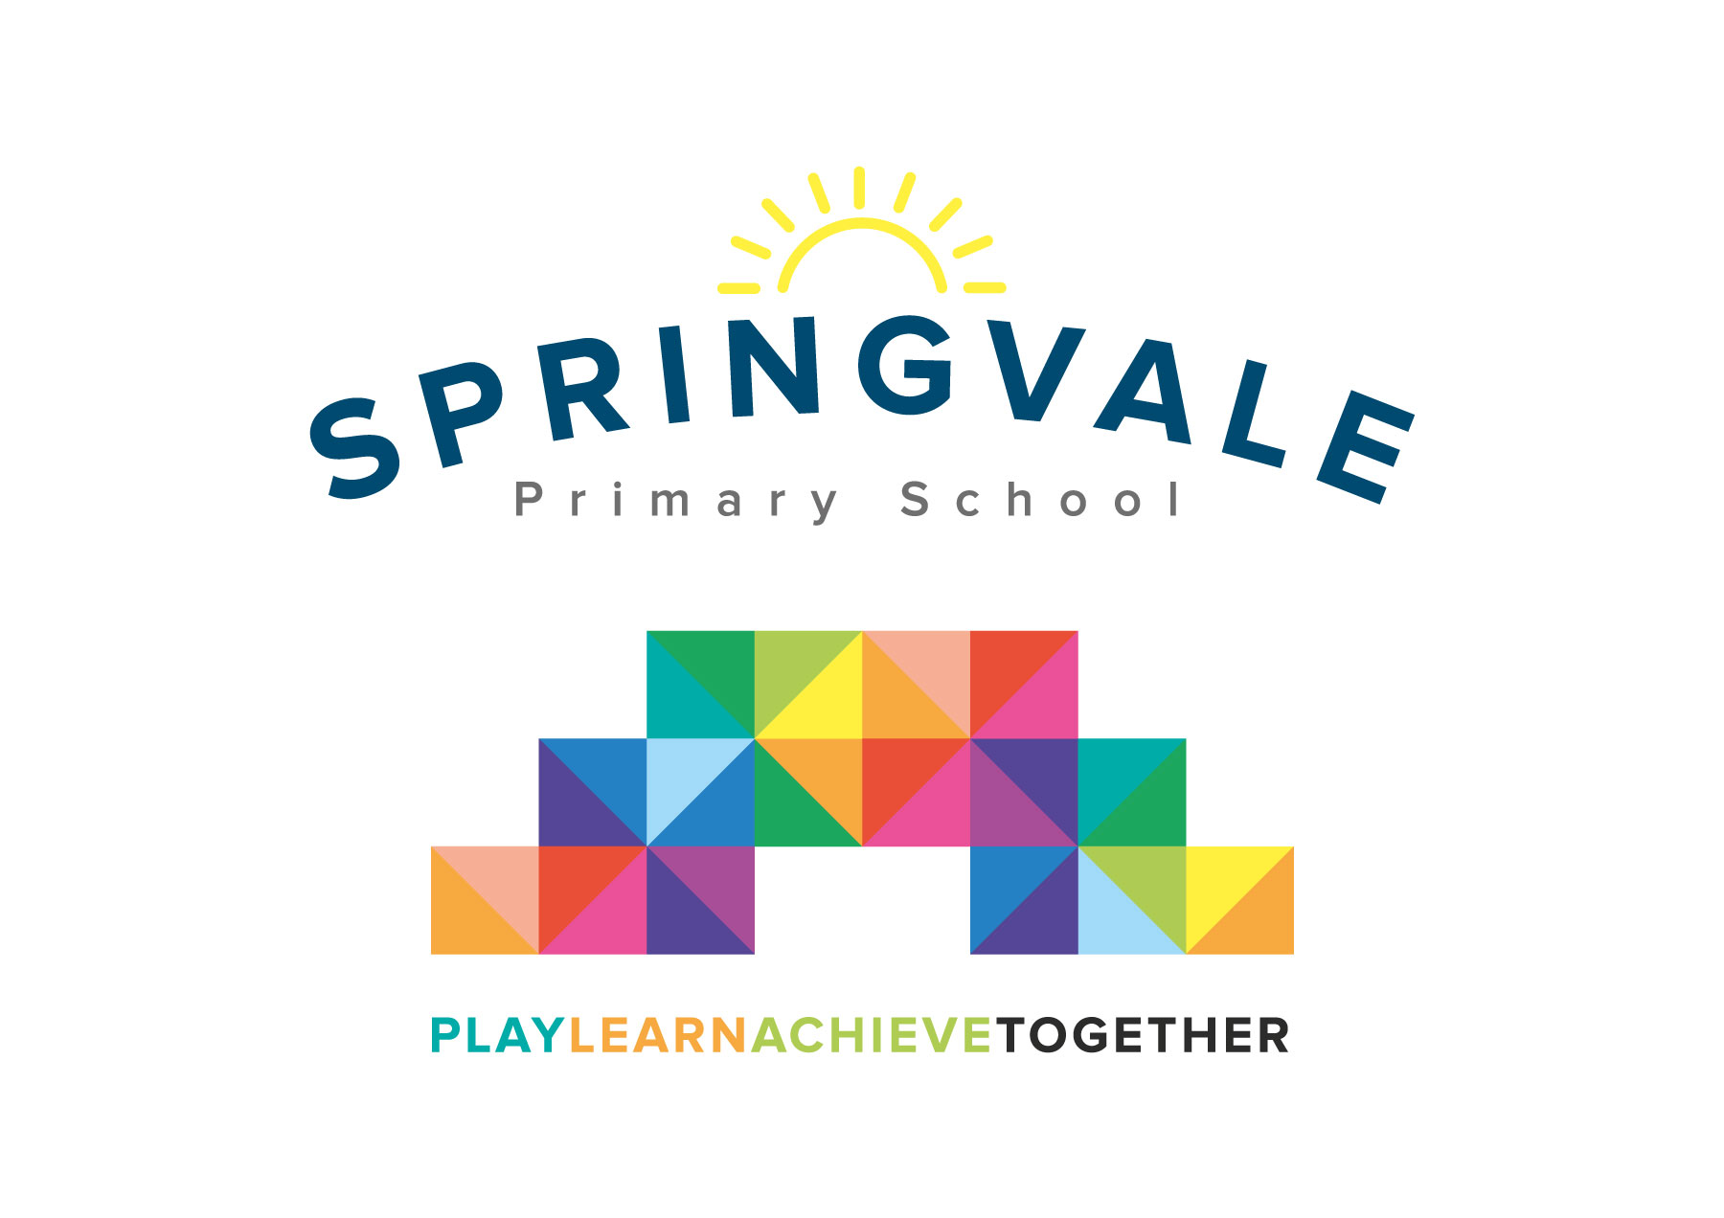
SPRINGVALE PRIMARY SCHOOL
01226 760930

Headteacher: Mr L McClure
l.mcclure@springvaleprimary.org
www.springvaleschool.org.uk
@SpringvalePS

Viking Visit 16/01/2019

Dear Parent/Guardian,

On Tuesday 12th February, we are going to be visited by a real, live Viking! The day will consist of workshops about Viking weapons and ways of life. To make the Viking feel more at home, please can all children come dressing up as a Viking (information about what Vikings looked like will be sent home with the children). This visit will bring our fantastic Viking topic to a close.

There will be a cost for the school to have this special day, so it would be greatly appreciated if you could make a voluntary contribution of £10. Please note, if we do not receive enough contributions, the visit will not be able to go ahead.

Please log into school money to pay the contribution, once you have received the link via text and email.

Kind regards,

Mr. Venus

