Springvale Primary School
Pupil Premium Funding Report 2018-19
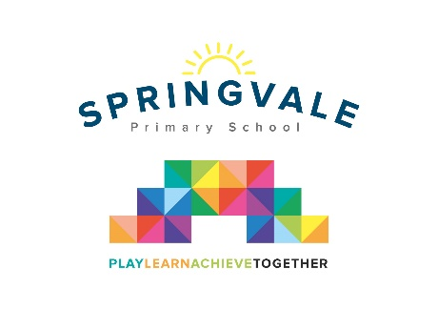

Pupil Premium funding is allocated to schools by the government to support children who fall into vulnerable groups. It is for schools to decide how the funding is spent, and careful consideration should be made, taking into account the various needs of the children eligible for this funding. We endeavor to ensure that our funding is used to support all eligible pupils in making at least good academic progress each school year.
In this financial year, 2018 -19 Springvale School received £26,600 in Pupil Premium funding.
Our objectives for this year are as follows:
- To fund TA support and intervention to our Pupil Premium in order to best promote learning
- To continue to support the development of social skills through the use of Lego Therapy and related SEMH interventions
- To use precision teaching or pre-teaching strategies with children to target specific gaps in learning
- To purchase additional Educational Psychologist Support
- To purchase additional support from Barnsley Education Specialist Support Team
- To maintain the accreditation for the Communication Friendly Schools Award
- To introduce and implement motivational spelling competitions
- To implement staff CPD which addresses the specific needs of our SEN children and those who have the potential to be more able and work at a greater depth
- To purchase specialist resources where required
- To subsidise educational visits and residential trips to enrich the curriculum and learning opportunities
- Introduce more personalised and specific approaches to support children in their needs earlier- e.g. SALT in F1-Y2 and counselling in Y2-Y6.
The new Headteacher, since February 2018, has:
- Developed and refined a policy for Pupil Premium
- Raised standards in attendance, punctuality, etc through regular communication and partnership work with all families.
- From April 2018 had a separate budget and codes for all Pupil Premium spending
- Held special ‘parental evenings’ or workshops for Pupil Premium families to discuss the school’s policy and strategy to support
- Devised and maintained individual; spending plans, akin to IEPs, for disadvantaged pupils
- Designated a key Governor to the role of Pupil Premium champion and have an annual enquiry into the provision and progress of all Pupil Premium children.
- Utilised our best support staff to deliver targeted intervention
- Ensured that PP children receive regular, high quality and subsidised experiences and opportunities to broaden their horizons
- Ensured that Pupil Premium children are targeted to achieve in-line with ARE by the end of Y6 and that some strive for greater depth outcomes
- Devised a ‘school career’ tracker to monitor every pupil, each term, of each school year across each core subject- this is shared with SLT, all staff and Gb each term
- Developed an ‘early intervention’ approach to supporting children with language needs and SEMH needs.

Last financial year (2017/18) our Pupil Premium funding was funding for £26,800
With the assistance of the Pupil Premium funding over the last year we are proud to report the following achievements:
- Increased confidence and achievement from children who take part in regular and ongoing intervention; meaning that these children are now reaching key milestones more quickly.
- Stronger relationships between parents, children and school; with greater cooperation from children who have previously struggled to cope with boundaries which were set by parents.
- Well attended parent events or workshops, with many parent suggestions now being used as new whole school initiatives (e.g. playtime systems).
- Enhanced provision to support clarity of communication for children through the Communication Friendly School accreditation.
- Improved screening of children’s communication understanding on entry to school enabling specific support for children with particular needs.
- A range of staff CPD to support enhanced provision for Pupil premium children.
- Quicker and well targeted support for individual children with individual needs.
- Closely links between SEND leadership and Pupil Premium leadership for multiple-barrier children.
- Support and advice from specialist professional services.
- Greater awareness across the school of the needs of the Pupil Premium children.
- Increased attendance for 90% of Pupil Premium learners. (Average in line with school non-PP average and above national/local averages.)
- Vastly increased punctuality for Pupil Premium learners. (Almost zero incidents)
- Increased tracking and record keeping of provision and intervention.
- Increased uptake in school clubs- before, during and after school.
- Started to develop staff awareness and training in key areas of need SALT/SEMH
- Employed specialists in SALT and SEMH to work directly with pupils and families

In 2018/19 our funding has been spent on the following:
Employment of TA to support one-one care and Pastoral Care leader | £10,200
Programme of support for learning needs of specific children, delivered by teaching assistants | £5,870
Counselling Services | £3000
Additional Ed Psych support | £1500
Additional SCI support | £900
Support from SALT - development of individual programmes of support, staff training and clinic support for pupils and families | £3600
Welcomm subscription to support the screening of communication needs in Foundation Stage | £350
Team Teach CPD for four staff | £480
Subsidy for pupil premium children to support participation in visits/residential etc | £900
Total | £26,800

Future early intervention schemes:
- Further family support work
- Family workshops to develop reading at home
- SALT workshops for F1/F2

