Springvale Primary School
Pupil Premium Projected Spending 2019-20
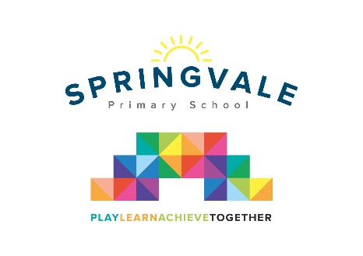
Pupil Premium funding is allocated to schools by the government to support children who fall into vulnerable groups. It is for schools to decide how the funding is spent, and careful consideration should be made, taking into account the various needs of the children eligible for this funding. We endeavor to ensure that our funding is used to support all eligible pupils in making at least good academic progress each school year.
In this financial year, 2019-20 Springvale School estimate that they will receive £24,000 in Pupil Premium funding.

In 2019/20 our funding will be spent on the following:
Employment of TA to support one-one care and Pastoral Care leader | £10,680
Programme of support for learning needs of specific children, delivered by teaching assistants | £5,870
Counselling Services | £2200
Additional Ed Psych support | £1500
Additional SCI support | £900
SALT family support workshops and TA intervention time | £1600
Welcomm subscription to support the screening of communication needs in Foundation Stage | £350
Subsidy for pupil premium children to support participation in visits/residential etc | £900
Total | £24,000

