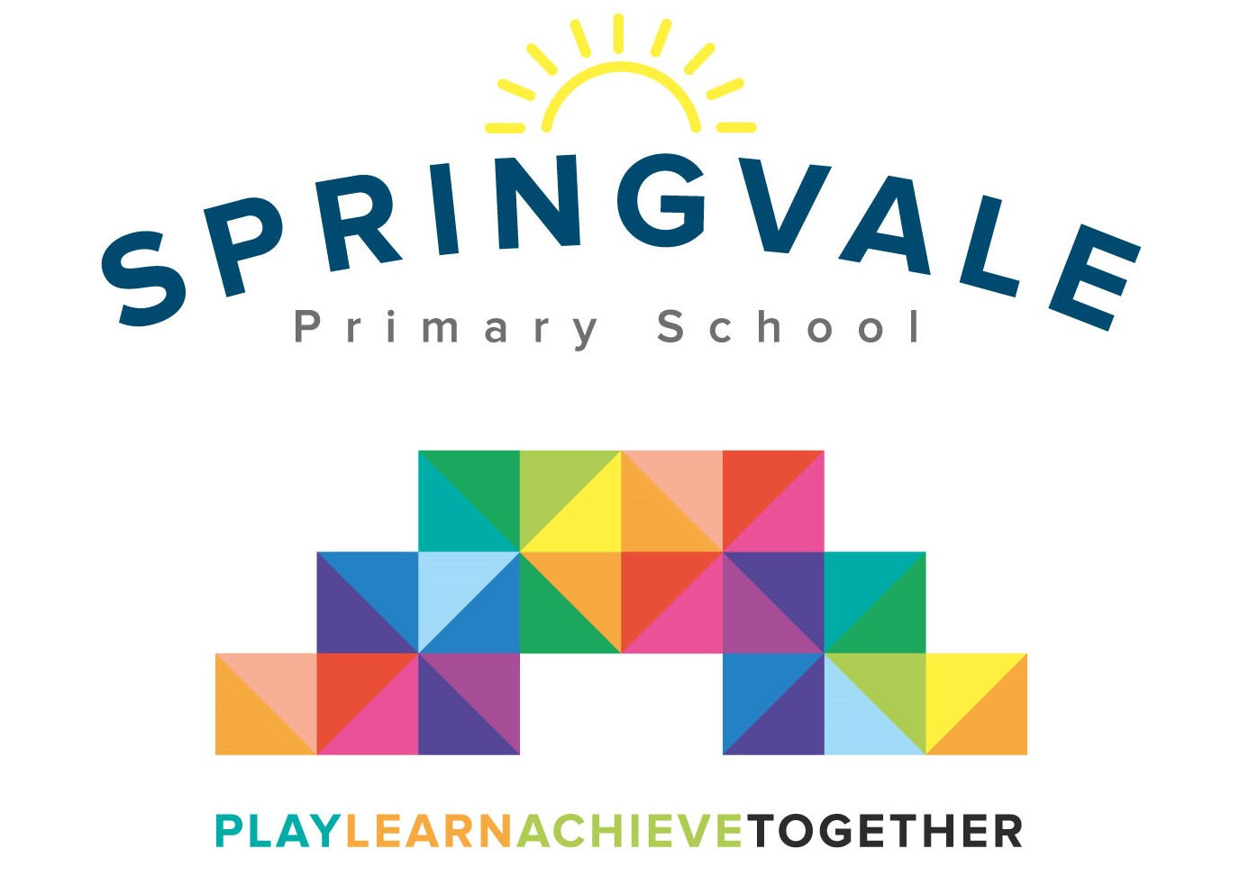
SPRINGVALE PRIMARY SCHOOL
01226 760930

Headteacher: Mr L McClure
l.mcclure@springvaleprimary.org
www.springvaleprimary.org
@SpringvalePS

Athletics Competitions Friday 17th May 2019

Dear families,

I am delighted to confirm that we have entered three athletics competitions against 7 other Barnsley schools on each occasions. The events will take place at Dorothy Hyman Sports Centre (Cudworth, Barnsley… the postcode is S72 8LH) and the details of the three events are below. The permission slip below must be completed and returned for children to take part. Children will be transported by coach at no cost to parents.

- Y5/6 event on Thursday 6th June 1pm to 3.15pm
- Y3/4 event on Monday 1st July 9.30 to 11.45am
- Y1/2 event on Tuesday 9th July 9.30 to 11.45am

Your child has been invited to the highlighted event. We are targeting Y2, Y4 and Y6 like last year but the events are optional. Any child who does not attend in Y2, Y4 or Y6 may have their place offered to an interested party in Y1, Y3 or Y5.

The reason that we are writing to you all so early about these events is that we cannot afford coach transport this year for the events. We will use staff cars and support from parents. Please let us know on the sheet below if you would like your child to take part and if you are able to help with transport. Please note the start and end times of the events above and note that travel time to and from the event is roughly 35/40 minutes.

We will communicate the situation with your child’s attendance and any travel plans a week before the event. On the day children will require an outdoor PE kit, a warm jacket and a water bottle. Parents are quite welcome to attend the event.

#PlaytogetherLearntogetherAchievetogether

Kind Regards

Mr L McClure

Headteacher

Please tick one:
My child can take part in the highlighted athletics competition above ______

My child does not wish to take part and school can offer their place to another child ______

Name _______________________________ Class _________

Signed by parent _____________________________________

I can help with transport (please tick one)

Transport to the event only ____
Transport from the event to school only _____
Transport there and back _____

