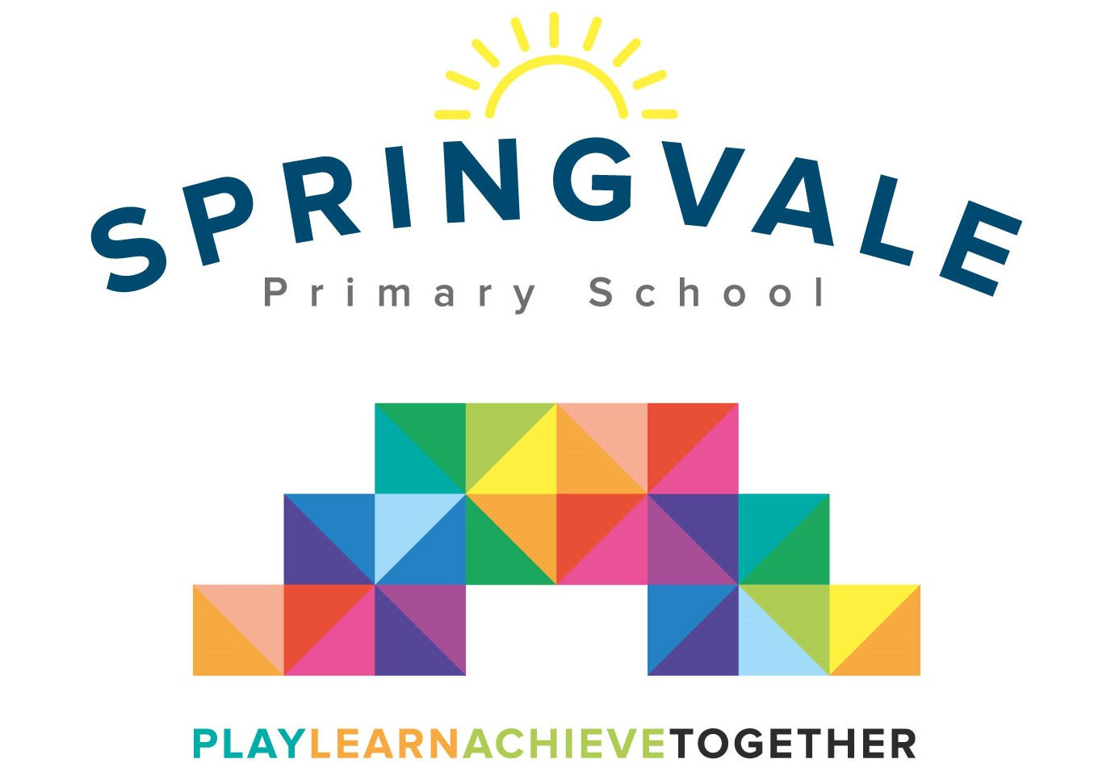
SPRINGVALE PRIMARY SCHOOL
01226 760930

Headteacher: Mr L McClure
l.mcclure@springvaleprimary.org
www.springvaleprimary.org
@SpringvalePS

Cricket Events Friday 7th June 2019

Dear parent/carer,

I am delighted to confirm that we have entered three cricket tournaments for KS2 children to enjoy this coming week!

Friday 21st June- 9.30 to 12 Y5/6 girls at Silkstone CC
Friday 21st June- 1-3.30pm Y5/6 boys at Penistone CC
Wednesday 26th June- 9.15 to 3pm Y3/4 at Shaw Lane (Barnsley CC)

The permission slip below must be completed and returned for children to take part. Children will be transported by staff cars for the events that are not within walking distance.

Children require PE kit, appropriate footwear (grass surface), a warm jacket and a water bottle. Please also send in sun cream on this day if the weather is forecast for sunshine so that children can self-apply before we travel and during the event if necessary.

Parents and spectators are very welcome to attend as spectators- if you are likely to be there throughout and can offer support with transport (to the events that require a journey) please let Mr McClure know ASAP.

We hope that the children are enjoying their cricket sessions and lessons and that they are looking forward to these events! Please note that children will only represent their school in sporting fixtures if they attending school regularly, working hard and following our ‘Steps to Success’. I am sure the children will represent their school fantastically well!

#PlaytogetherLearntogetherAchievetogether

Kind Regards

Mr L McClure

Headteacher

My child can take part in the highlighted cricket tournament.

I have noted the likely timings of the event.

Pupil Name _______________________________ Class ___________________________

Signed by parent _____________________________________

