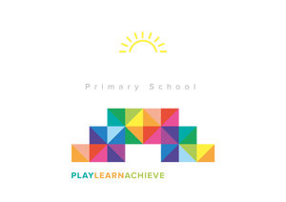

Y3 & Y4 Magna trip and workshop- Thursday 3rd October
As part of Lower Key Stage 2 Autumn term topics, we have booked a trip to Magna to learn about the four elements.
The children will take part in a hands on experiment to discover how volcanoes erupt, as well as learn about the water cycle to conclude our rivers topics. This trip also links to our summer topic on a local study ‘Steel City.’
Children will need to wear non uniform but something warm and comfortable as Magna is set in an old steel works building so can get quite cold. Please ensure children bring a packed lunch for the trip (No glass bottles or nut products please) or order a grab a bag from school.
The cost for the trip is £12.50. Please pay online through the link. Children will need to be in school for 8:45 as usual and we will return to school by 3:15
Thank you
Miss Alderson, Mr Venus and Miss McNaught.
___________________________________________________________

Please tick your child’s lunch option and return to school by Wednesday 25th September

Child’s Name: ________________________________ Class: ______________
Date of Trip: Thursday 3rd October
Own Sandwiches Grab a bag
Grab a Bag Flavour

Ham Cheese Tuna Mayo

