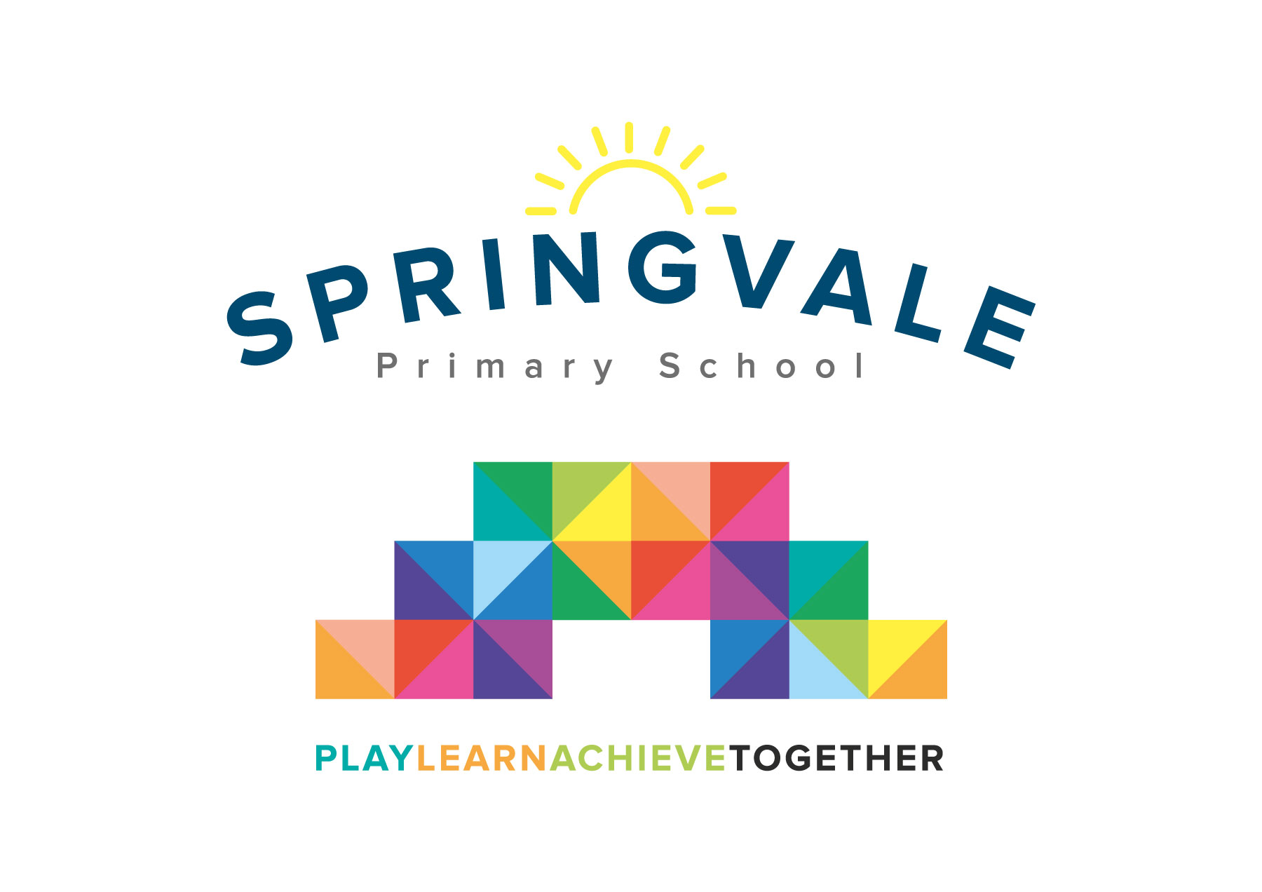
SPRINGVALE PRIMARY SCHOOL
01226 760930
Headteacher: Mr L McClure
office@springvaleprimary.org
www.springvaleprimary.org
@SpringvalePS

Dear Parent/Carer,

As part of our ‘Paws, claws and whiskers’ topic we are studying animals, their habitats and how they compare to humans. To do this, we will be visiting The Yorkshire Wildlife Park on Tuesday 24th September 2019. The cost of the trip is £13.00 per child.

We will be leaving school at 9am and anticipate our return to be approximately 3.30pm.

We are able to take a small number of volunteers on the day. If you are available and would like to help us, please let a member of staff know.

You will receive an email & text notification shortly with information about how to pay for this trip on the ‘Schoolmoney’ system. Please follow the link on this message to login to your account. If you have any account login or payment queries, please do not hesitate to contact the school office. You will also be asked to give your parental consent online as well.

We are required to inform you that the trip has to be paid for by voluntary contributions, but if insufficient funds are available then the trip will not go ahead.

Please ensure your child has their school uniform on, comfortable shoes and an appropriate coat for the weather. We will not be visiting the shop, therefore, please don’t send additional money on the day.

All children need to bring a small rucksack to carry their own lunch / drink around the park.

Please complete the slip below if your child would like a grab bag and return to school by Tuesday 17th September. We need to let the kitchen staff know, so the right quantity of food is ordered.

Kind Regards,

Mrs. Evans and Mrs. Royston
_____________________________________________________________________

Please tick your child’s lunch option and return to school by Tuesday 17th September.

Child’s Name: ________________________ Class: ______________

Date of Trip: Tuesday 24th September

Own Sandwiches Grab a bag

Grab a Bag Flavour

Ham Cheese Tuna Mayo

