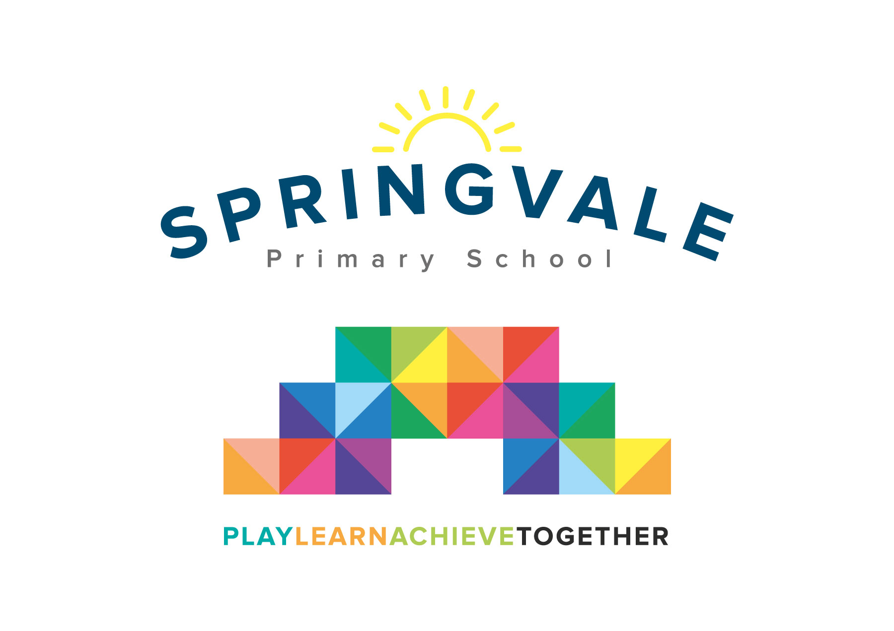
SPRINGVALE PRIMARY SCHOOL
01226 760930
Headteacher: Mr L McClure
office@springvaleprimary.org
www.springvaleprimary.org
@SpringvalePS

Dear Family,

Our school has been nominated for the Modeshift STARS National School Travel Awards, following our recent success in achieving Modeshift STARS Silver accreditation. It is recognition for the work that we have done to promote walking, cycling and other forms of sustainable travel for the journey to school. Of the 3,500 schools that are signed up to Modeshift STARS, we are one of just over 100 schools across the country that have been nominated for the 2019/20 National Awards.

Your child has been chosen to attend the Modeshift STARS Regional Awards where we’ll get to meet other schools and local authorities from across the region that have been nominated for the awards. Also in attendance will be the national Modeshift STARS Team and other key stakeholders that are associated with Modeshift STARS.

Event Details
North East, Yorkshire and the Humber Modeshift STARS Regional Awards
Date Wednesday 20th November
Location Everyman Cinema York
Arrival 10:30 for an 11am start. The event finishes at 1:30pm

We will travel in my car to the event, setting off and returning in school time. Your child will need to wear school uniform and lunch is provided.
Please return the slip below before the day of the event.

Kind regards,
Mr Venus

I give consent for ________________________ to attend the ModeshiftSTARS awards and to travel in Mr Venus’ car.

Signed: ______________________ Date: ___________________

Circle one:
My child can appear in photographs for ModeshiftSTARS’ social media accounts.

Yes No

If your child has any dietary requirements, please write them below:

__________________________________________________________________________

