Springvale Primary School
Intent Statement
Faith (Religious education)
2019-20
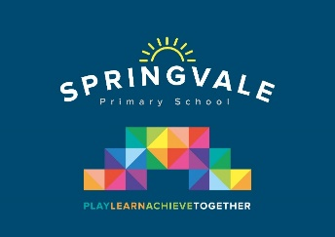
Leaders: Mrs R Andrew
Faith statement of intent
Faith is an important curriculum subject in its own right and also makes a unique contribution to the spiritual, moral, social and cultural development of pupils and supports wider community cohesion.

At Springvale Primary School, we believe that it is vital for all our pupils to learn from and about religion, so that they can understand the world around them. Through Studying different faiths, pupils develop their knowledge, understanding and awareness of the beliefs, values and traditions of other individuals, societies, communities and cultures. We encourage our pupils to ask questions about the world and to reflect on their own beliefs, values and experiences. Our Faith curriculum is enhanced further with trips to places of worship in our local area.

We use the agreed Barnsley SACRE syllabus as the basis for our faith curriculum.

This statement sits alongside our ‘Curriculum and Learning Policy’

KNOWLEDGE…I know | …therefore…. | SKILLS…I can
I know some religious stories and identify some religious beliefs and teachings. | … | I can talk about some religious stories and beliefs and what they mean to people’s faith.
I know some religious practices and know that some are characteristic of more than one religion. | … | I can talk about what people of different faith believe and how they celebrate or practise this in daily life. I can respond sensitively and with understanding.
I know the meanings of religious symbols, language and stories. | … | I can understand that certain symbols, language and stories have a special meaning to people in certain faiths.
I know that people often have a special place where the meet to share their faith as a community. | … | I can talk about a special place for different faiths, and why it is special to them.

