Springvale Primary School
Intent Statement
Geography
2019-20
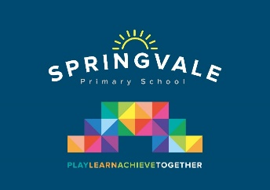
Leader: Mrs R Henstock
‘Intent’
At Springvale Primary we believe that Geography helps to provoke and provide answers to questions about the natural and human aspects of the world. Children are encouraged to develop a greater understanding and knowledge of the world, as well as their place in it. The geography curriculum at Springvale enables children to develop knowledge and skills that are transferable to other curriculum areas and which can and are used to promote their spiritual, moral, social and cultural development. Geography is, by nature, an investigative subject, which develops and understanding of concepts, knowledge and skills. We seek to inspire in children a curiosity and fascination about the world and its people which will remain with them for the rest of their lives; to promote the children’s interest and understanding of diverse places, people, resources and natural and human environments, together with a deep understanding of the Earth’s key physical and human processes. The curriculum is designed to develop knowledge and skills that are progressive, as well as transferable, throughout their time at Springvale and also to their further education and beyond.
This statement sits alongside our ‘Curriculum and Learning Policy’
‘Implementation Examples’
KNOWLEDGE…I know | …therefore…. | SKILLS…I can
I know the world’s seven continents and five oceans and can locate them. | … | I can use world maps, atlases and globes to identify the United Kingdom and its countries, as well as the countries, continents and oceans studied at this key stage
I know simple compass directions (North, South, East and West) and locational and directional language [for example, near and far; left and right], to describe the location of features and routes on a map. | … | I can use compass directions and directional language.
I know basic geographical vocabulary to refer to: key physical features, including: beach, cliff, coast, forest, hill, mountain, sea, ocean, river, soil, valley, vegetation, season and weather | … | I can identify and use the names of geographical features such as beach, mountain, river etc.
Aims
It is our aim at Springvale Primary School to develop and encourage:
- develop contextual knowledge of the location of globally significant places – both terrestrial and marine – including their defining physical and human characteristics and how these provide a geographical context for understanding the actions of processes
- understand the processes that give rise to key physical and human geographical features of the world, how these are interdependent and how they bring about spatial variation and change over time
- are competent in the geographical skills needed to:
  - collect, analyse and communicate with a range of data gathered through experiences of fieldwork that deepen their understanding of geographical processes
  - interpret a range of sources of geographical information, including maps, diagrams, globes, aerial photographs and Geographical Information Systems (GIS)
  - communicate geographical information in a variety of ways, including through maps, numerical and quantitative skills and writing at length.

