Springvale Primary School
Intent Statement
History
2019-20
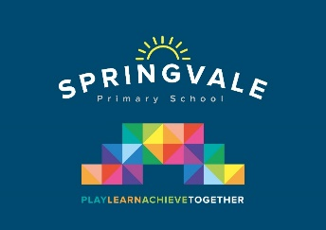
Leaders: Mrs R Henstock
‘Intent’
At Springvale Primary our History curriculum includes termly/half termly topics for all children from Year 1 to Year 6. We aim to offer a high-quality history education that will help pupils gain a coherent knowledge and understanding of Britain’s past and that of the wider world. It should inspire pupils’ curiosity to know more about the past. Teaching should equip pupils to ask perceptive questions, think critically, weigh evidence, sift arguments, and develop perspective and judgement. History helps pupils to understand the complexity of people’s lives, the process of change, the diversity of societies and relationships between different groups. It also helps children gain a sense of their own identity within a social, political, cultural and economic background. Because of this, we feel it is important for the subject to be taught discretely as well as incorporated within other curriculum subjects such as English and Art.
This statement sits alongside our ‘Curriculum and Learning Policy’
‘Implementation Examples’
KNOWLEDGE…I know | …therefore…. | SKILLS…I can
I know the lives of significant individuals in the past who have contributed to national and international achievements. | … | I can write the life story of important historical individuals, eg. Captain Scott of Antartica.
I know changes within living memory. | … | I can remember changes within my family, eg. A baby being born.
I know the Roman Empire and its impact on Britain. | … | I can talk about about Roman British resistance, for example, Boudica.

Aims
Springvale Primary history aims to ensure that all pupils:

- know and understand the history of these islands as a coherent, chronological narrative, from the earliest times to the present day: how people’s lives have shaped this nation and how Britain has influenced and been influenced by the wider world  
- know and understand significant aspects of the history of the wider world: the nature of ancient civilisations; the expansion and dissolution of empires; characteristic features of past non-European societies; achievements and follies of mankind
- gain and deploy a historically grounded understanding of abstract terms such as ‘empire’, ‘civilisation’, ‘parliament’ and ‘peasantry’
- understand historical concepts such as continuity and change, cause and consequence, similarity, difference and significance, and use them to make connections, draw contrasts, analyse trends, frame historically-valid questions and create their own structured accounts, including written narratives and analyses
- understand the methods of historical enquiry, including how evidence is used rigorously to make historical claims, and discern how and why contrasting arguments and interpretations of the past have been constructed

