Information for the website

Useful websites/apps:
- BBC Bitesize
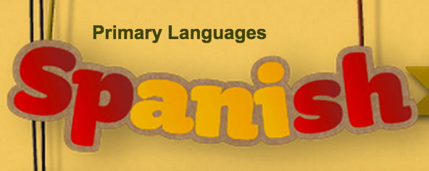

KS1 - https://www.bbc.co.uk/bitesize/subjects/zhyb4wx
KS2 - https://www.bbc.co.uk/bitesize/subjects/zxsvr82

- Duolingo - https://www.duolingo.com

Learning with Duolingo is fun and addictive. Earn points for correct answers, race against the clock, and level up.

- RockAlingua - https://rockalingua.com/
Games, songs, worksheets and other tools for making Spanish for kids fun.
Many free games available.

