Springvale Primary School
Intent Statement
Maths
2019-20
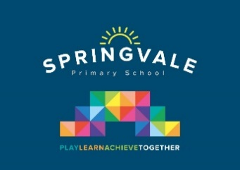

Leaders: Mrs Evans and Mrs Mayston

Maths Statement of Intent

At Springvale Primary School our intent for mathematics is to teach a rich, balanced and progressive curriculum using Maths to reason, problem solve and develop fluent conceptual understanding in each area. Our policies, resources and schemes support our vision e.g. our calculations policy, White Rose Maths and NCETM Teaching for Mastery. The mapping of Mathematics across school shows clear progression in line with age related expectations and within each unit taught. Children in EYFS are exposed to a wide range of mathematical experiences which develop knowledge and skills of key learning. Maths books contain a range of activities showing evidence of fluency, reasoning and problem solving. Children develop skills in being articulate and are able to verbally, pictorially and in written form reason well. Pupils who grasp concepts rapidly will be challenged. Those who are not sufficiently fluent with earlier material will be offered opportunities to consolidate their understanding, before moving on. Mathematics in our school is enhanced by class working walls designed to aid children through each topic and through our TT Rockstars and Numbots competitions.

This statement sits alongside our ‘Curriculum and Learning Policy’

‘Implementation Examples’
We follow the JIGSAW programme of PHSE and we employ a school counsellor. We also have wellbeing programme for pupils and staff that run throughout the year.

KNOWLEDGE…I know | …therefore…. | SKILLS…I can
I know the place value of numbers. | … | I can identify 1 more and 1 less than a given number. (Y1)
I know my times tables up to 12x12. | … | I can answer any times table/division question within 5 seconds. (Y4)
I know the properties of 2-D shapes. | … | I can identify and describe the properties of a 2-D shape including the number of sides and line symmetry in a vertical line. (Y2).
I know equivalent fractions. | … | I can identify, name and write the equivalent fractions of a given fraction. (Y6) .

