Springvale Primary School
Intent Statement
Music
2019-20
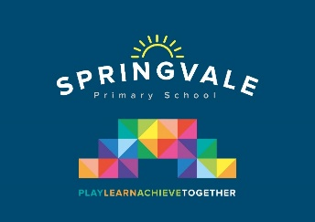
Leaders: Mrs R Andrew
Music statement of intent
At Springvale Primary School we make music an enjoyable learning experience. We encourage children to participate in a variety of musical experiences through which we aim to build up the confidence of all children. Our teaching focuses on developing the children’s ability understand and use rhythm, pulse, pitch, to perform on their own and with other people. Through singing songs, children learn about the structure and organisation of music. We teach them to listen and to appreciate different forms of music. Also, we teach the children how to work with others to compose music and perform for an audience.

Children with a special interest in learning an instrument have opportunities for peripatetic teaching, also in year 3 the whole class are taught an instrument together both of these groups have a chance to perform what they have learnt to an audience. There are many occasions for the children to sing as part of whole school celebrations throughout the year.

We use active music (primary music specialist) the as a basis for our music curriculum.

This statement sits alongside our ‘Curriculum and Learning Policy’

KNOWLEDGE…I know | …therefore…. | SKILLS…I can
I know how to use my voice to sing songs. | … | I can use my voice expressively and creatively by singing songs and speaking chants and rhymes.
I know how to play and perform using my voice or an instrument. | … | I can play and perform in solo and ensemble contexts, using my voice or playing musical instruments with increasing accuracy, fluency, control and expression.
I know a range of different music styles and traditions and their composers. | … | I can appreciate and listen with concentration to a range of high quality live and recorded music from different traditions and from great composers and musicians.
I know about rhythm, pulse, pitch and ostinato. I know about simple music notation. | … | I can recognise and use musical terms such as rhythm, pulse, pitch, ostinato. I can recognise simple written rhythms.

