Springvale Primary School
Intent Statement
Computing
2019-20
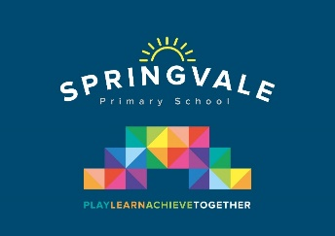
Leaders: Mr T Venus
‘Intent’
At Springvale Primary School, we intend on providing our children with the Computing skills and knowledge they will need in secondary school and adult life. Technology moves very quickly and we have identified the need for children to develop a logical and computational approach to solving new problems. This, along with allowing children to use a broad range of software, will help them to grasp new technology and coding problems in the future.
We also recognise that children need to identify the value technology can bring to their daily lives but when it is not appropriate or does not add value. Similarly, we recognise that children need to understand how to be safe and respectful with technology, especially in today’s increasingly connected world.
To deliver the Computing curriculum effectively, we have divided it into three key strands:
- E-Safety
- Computer Users
- Computer Programmers
This statement sits alongside our ‘Curriculum and Learning Policy’
‘Implementation Examples’
KNOWLEDGE…I know | …therefore…. | SKILLS…I can
I know which tools do what in Inkscape | … | I can use a range of software to complete a specific task.
I know how a network works | … | I can describe how the internet is a way of sharing information across numerous networks.
I know what a repeat loop is | … | I can write increasingly longer and more complex algorithms
I know where my fingers go on the keyboard | … | I can type on a keyboard

Aims
It is our aim at Springvale Primary School to develop and encourage:
- Resilient and logical programmers who can break larger problems into small sections
- Children to use their knowledge of different programs to complete a range of tasks
- Children who use technology respectfully and safely
- Children who can confidently use technology to enhance their learning and work

