Springvale Primary School
Intent Statement
Modern Foreign Languages (MfL)
(Spanish is our chosen language)
2019-20
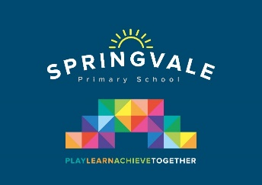
Leaders: Mrs H Kelly
Modern Foreign Languages Curriculum Statement
Language learning allows our children to develop their understanding of community, diversity and equality and our aim is to promote this across the curriculum. At Springvale Primary School, we recognise the importance of MFL and the role it has to play in exploring other cultures, linking with diversity, customs and traditions. It is the intention that all children in KS2 will access quality teaching of Spanish in order to adequately prepare them for KS3. KS1 children will be introduced to MFL through exploring languages informally when appropriate. It is our vision for every pupil to succeed and achieve their potential in languages.
Our aim is to provide opportunities for pupils to develop values and transferrable life skills enabling children to access the wider curriculum and to prepare children to be a global citizen now and in their future roles within a global community. We are developing a MFL curriculum that incorporates the understanding of Spanish so that children know more, remember more and understand more. As a result children will develop the knowledge to be able to communicate in another language other than English, enabling children to develop friendships and thrive in a shared society.
This statement sits alongside our ‘Curriculum and Learning Policy’

‘Implementation Examples’

KNOWLEDGE…I know | …therefore…. | SKILLS…I can
I know a range of greetings in Spanish and appropriate answers/responses. | … | I can participate in a short exchange greeting someone and confidently use a range of Spanish greetings.
I know Spanish numbers up to 30 and how to use numbers. | … | I can understand and say numbers to 30 with the correct pronunciation and recognise numbers in a range of situations.
I know how to give personal details including name and age. | … | I can introduce myself by understanding and answering questions.
I know how to talk about food. | … | I can recognise a range of food and drink and order from a menu.

