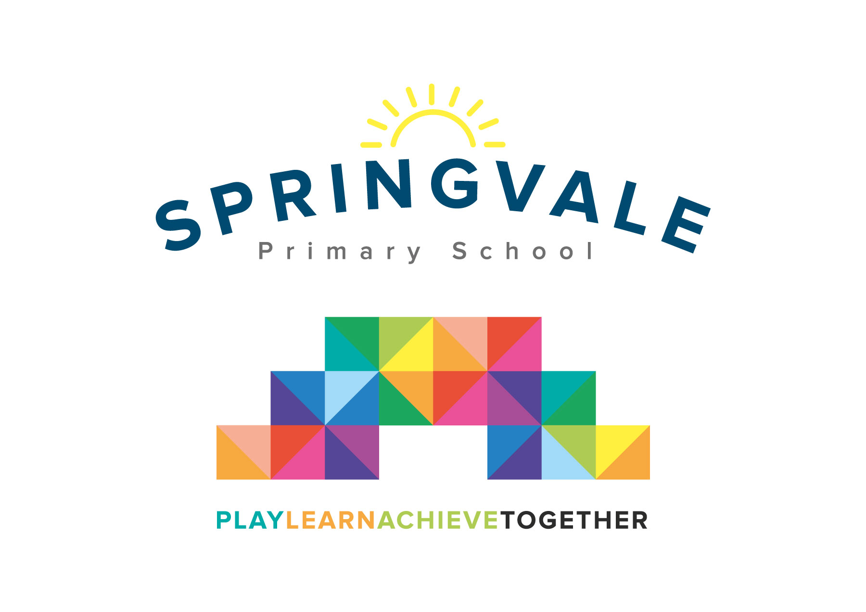
SPRINGVALE PRIMARY SCHOOL
01226 760930

Headteacher: Mr L McClure
l.mcclure@springvaleprimary.org
www.springvaleprimary.org
@SpringvalePS

Basketball Reward Visit Tuesday 7th January 2020

We are delighted to see so many children now engaged in sports clubs, PE sessions and competitions. Over the last few years we have organised very successful visits to watch professional sports at Sheffield Wednesday FC, Barnsley FC and the Sheffield Steelers. These visits seem to inspire the pupils to get even more involved in sport and we are always looking for further opportunities to engage the children!

On Friday 31st January we have pre-booked 60 places to watch a basketball match featuring the Sheffield Sharks at the English Institution of Sport (EIS) with ‘face off’ at 7.30pm. We are offering this opportunity to all 122 pupils in KS2 so please be quick to reserve your child’s place! The plan for the evening is set out below:

- Meet at school between 6.20 and 6.30pm for departure by private coach (children should have had their evening meal before we meet up)
- Arrive at the venue at approximately 7.00pm
- Watch the match in courtside seats at 7.30pm
- We also expect to get the opportunity to get on court and have a few goes at ‘shooting hoops’ in the interval (please don’t tell the children though as we can’t guarantee it!)
- 9.10pm transfer back to school for approximately 9.30pm (accurate updates on Twitter)

We can offer all of the above, including the transport, at a cost of £10 per child or £7 for Pupil Premium children. This price will be set in the Schoolmoney system when you log in.

Children would just require comfortable, warm clothing (uniform not required), a drink in a sealed bottle and a snack. A small amount of sweets are also allowed. As ever we would stress no nuts or seeds please and please don’t share sweets without checking with staff as some children have allergies. We will give the children a high-visibility jacket to wear from the coach to the seats and back as it will be very busy and dark.

You will have just received an email & text notification with information about how to pay for this trip on the Schoolmoney system. Please follow the link on this message to login to your account. If you have any account login or payment queries, please do not hesitate to contact the school office. You will also be asked to give your parental consent online as well.

As ever we would stress that a ‘reward’ visit is linked to pupils having excellent attendance, outstanding attitudes to learning and children staying on GREEN in class! Children who book this event will only be allowed to take part if they follow the school’s steps to success!

Kind Regards

Mr L McClure

Headteacher

