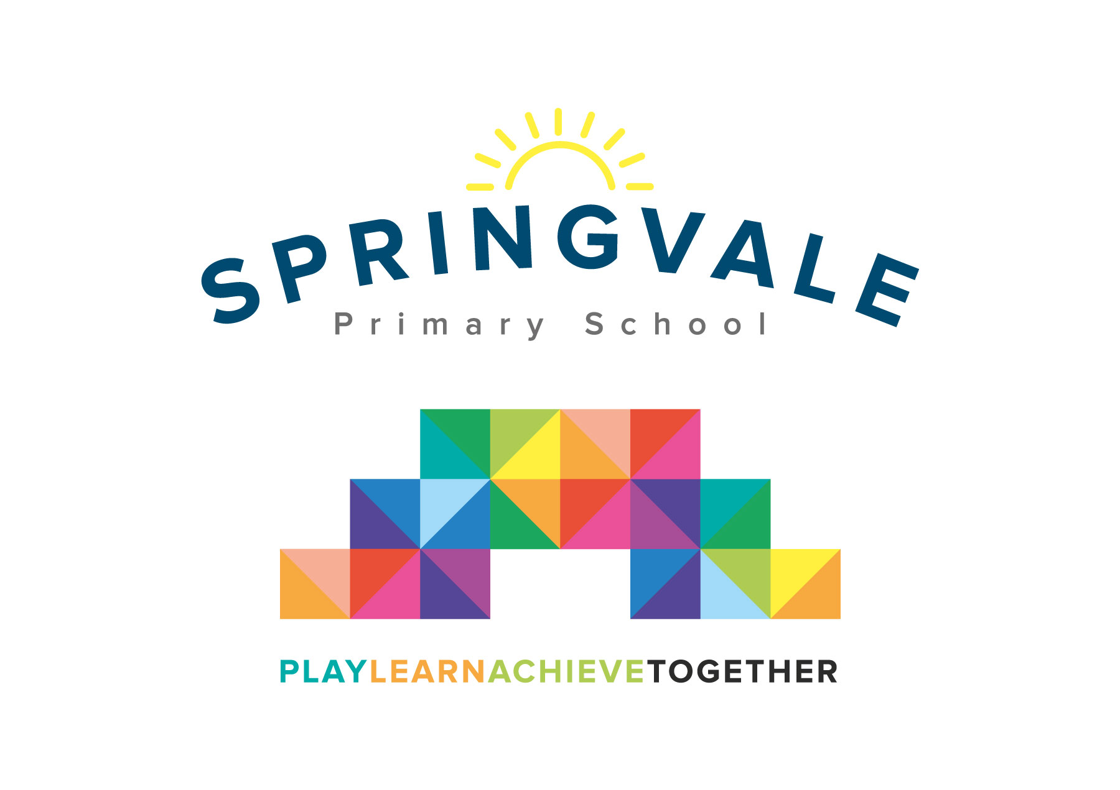
SPRINGVALE PRIMARY SCHOOL
01226 760930

Headteacher: Mr L McClure
l.mcclure@springvaleprimary.org
www.springvaleprimary.org
@SpringvalePS

Lower Key Stage 2 trips

As part of our summer topics, Year 3 and 4 are going on two exciting educational visits.
The first visit will be to the National Coal Mining Museum in Wakefield on Thursday 23rd April to launch our topic “Going Underground”
During this visit, children will have the opportunity to go underground, with an ex coal-miner as their personal tour guide and discover the jobs children had in the coal mines. They will also take part in a workshop called “Sally and Sam Fletcher” where they will discover in more detail what life was like in the 19th century for a family of pit workers.

The second visit will be on Tuesday 30th June, where children will go to Centenary Riverside to explore ‘pond dipping’ for half a day as part of our animal habitat topic “Who lives in a house like this”
The cost for the two trips and coaches will be £15- reduction for Pupil premium children.
You will receive an email & text notification with information about how to pay for this trip on the ‘Schoolmoney’ system. Please follow the link on this message to login to your account.
We will send out another separate letter closer to the time to remind you what children will need on each visit.
Thank you for your continuous support with your child’s education.
Miss Alderson, Mr Venus and Miss McNaught

Please tick your child’s lunch option and return to school by Monday 30th March:

Child’s Name: ________________________ Class: ______________

National Coal Mining Museum: Date of Trip: Thursday 23rd April

Own Sandwiches Grab a bag

Grab a Bag Flavour

Ham Cheese Tuna Mayo
___________________________________________________________________

Child’s Name: ________________________ Class: ______________
Centenary Riverside: Date of Trip: Tuesday 30th June

Own Sandwiches Grab a bag

Grab a Bag Flavour

