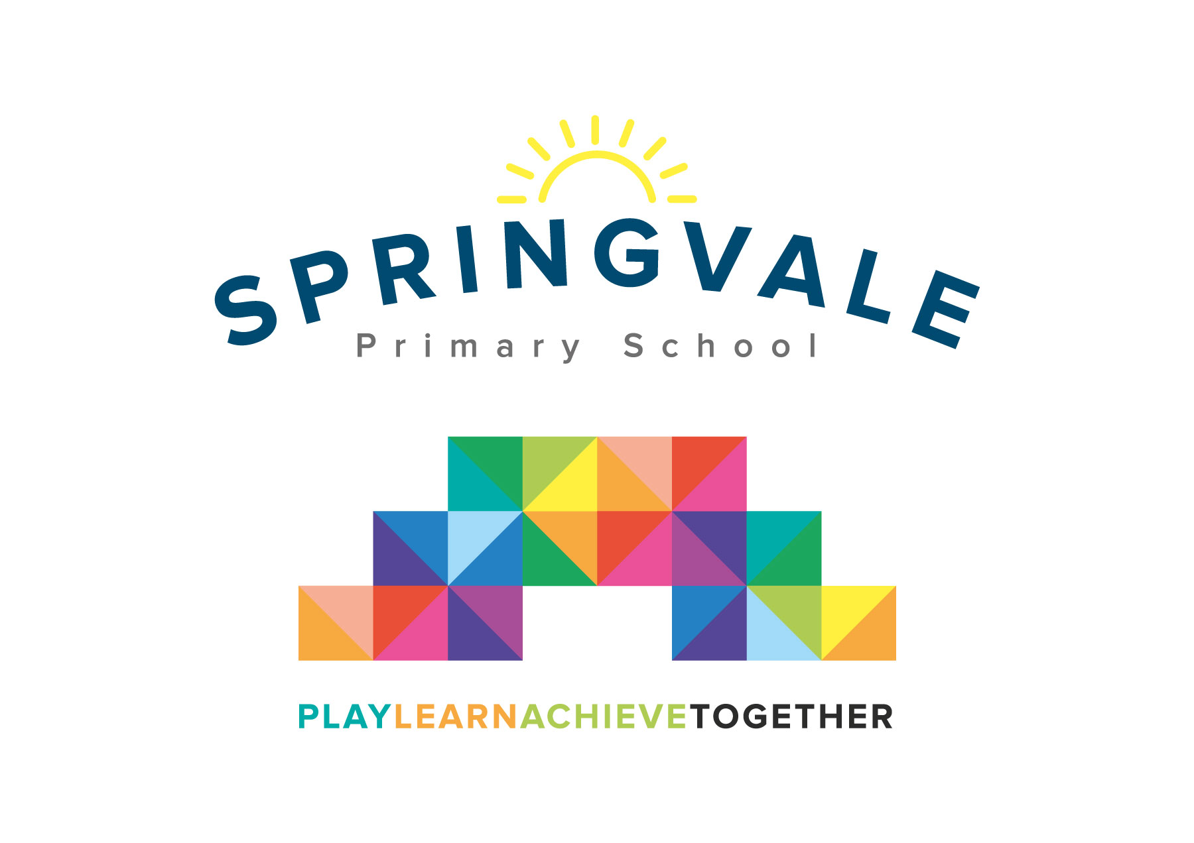
SPRINGVALE PRIMARY SCHOOL
01226 760930
Headteacher: Mr L McClure
l.mcclure@springvaleprimary.org
www.springvaleprimary.org
@SpringvalePS

Dear Year 3/4 Parents,

Thank you so much in advance for your support in this strange and difficult time. Attached are ideas of work you can do with your child. To help support your child’s learning, we have included some other helpful links.

Mr Venus will continue to set spelling tests on spelling frame every week on Thursdays (just like we have been doing for a while now).

We will also be available for the children to send us ‘Rock Slams’ (they will know what that means!)

If anyone needs help getting any more resources they’d like to use, please don’t hesitate to get in touch and we will find and send you whatever we can find ASAP.

We can download and distribute resources from www.twinkl.co.uk (Please be mindful that we can’t print and send things home to isolated children but can send document for you to complete electronically or print yourself.)

Here are some useful links in addition to the hyperlinks on the weekly home learning guide:

www.topmarks.co.uk
www.spellingframe.co.uk
https://www.topmarks.co.uk/maths-games/daily10
http://myths.e2bn.org/
https://www.twinkl.co.uk/resources/twinkl-originals

Kind regards,

Miss Alderson and Mr Venus

