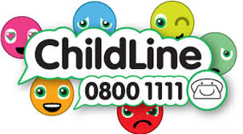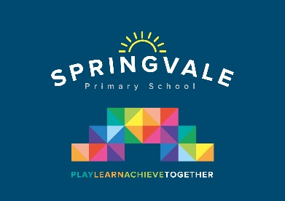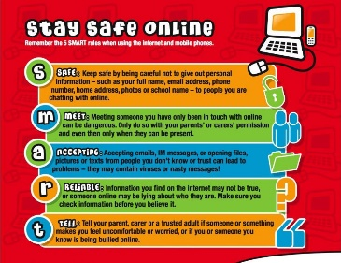

Learning Project WEEK 4- Animals
Age Range: Nursery
Weekly Maths Tasks (Aim to do 1 per day) | Weekly Reading Tasks (Aim to do 1 per day)
- Watch a Numberblocks clip each day at: BBC or CBeebies. .  - Play this counting game. Count how many of each animal you can see.  - Practise counting groups of animals. Build a field with any available resources and then fill the field with toy animals. Ask your child to tell you how many? | - Read a variety of books at home. Favourites can be repeated. Hearing the patterns of language in a story will support your child’s language development.  - Using a familiar story, can your child tell you the story?  - Can you find the props for a story and act it out?
Weekly Phonics Tasks (Aim to do 1 per day) | Weekly Writing Tasks (Aim to do 1 per day)
- Sing Nursery Rhymes and songs together. Add in actions and change the words. Can children think of different rhyming words to add in? Repeat old favourites and learn new rhymes. You can find an A-Z of Nursery Rhymes here.  - Daily phonics - Practice the sounds your child is working on. Interactive games.  - Play this animal sound match game.  - Sing the song, ‘Old McDonald Had a Farm’. Instead of saying the name of the animal, make the sound that its name starts with. Can your child figure out which animal it is? | - Draw an animal of your choice. Label the parts of the animal.  - Practice name writing. Can they write their first name? Middle name? Surname?  - Practice forming the letters of the alphabet, following school guidance.
Learning Project - to be done throughout the week
The project this week aims to provide opportunities for your child to learn more about key animals they are interested in. Learning may focus on exploring the physical aspects of an animal, their habitat, categorising animals etc.

- Read the story, ‘Dear Zoo’ or watch the online video -
  - Visit the book’s website and play the interactive games
  - Add your own animal into the story and label it e.g. So they sent me a...hedgehog, but he was too prickly....so I sent him back.
  - Choose a soft toy animal or small animal figure and create a junk modelled container for it.

- Identify the birds in your garden-
  - Use the RSPB bird identifier website
  - Draw a picture of the birds you can see.

- Play animal charades-
  - Take it in turns to act as different animals. Add in noises as a clue…

- Learn the song, ‘The Animals Went in Two by Two’
  - Ask your child to draw out two of each animal and practice writing the numeral 2.

- Looking after your pet-
  - If you have a pet at home encourage your child to take part in their daily care. They could help feed, groom and clean up after your pet.

- Big and small animals-
  - Draw as many big animals as you can on one piece of paper and as many small animals as you can on another sheet of paper. Some children may be able to write a list as an alternative.

- Find all of the animal books in your house-
  - Ask your child to look through the books in your house and to find any with animals on the front cover. Ask them to sort the books into groups of their choice e.g. animals that can fly, swim, big, small, live on a farm/ at the zoo.

- Create an animal den-
  - Provide your child with blankets and sheets to make an animal den. Act out being an animal in the den.

Additional learning resources parents may wish to engage with
Twinkl - to access these resources click on the link and sign up using the school password, found on school website. Use the offer code UKTWINKLHELPS.
#TheLearningProjects

