Springvale Primary School
COVID-19 Provision
Home-School Agreement
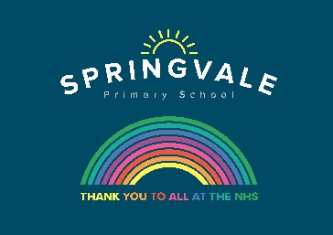
The expectation from the Government is that from 1st June we begin to extend school provision for the key educational cohorts: Nursery, Reception, Year 1 and Year 6. This is in addition to already prioritised group of children including those whose parents are classed as critical workers and the vulnerable children group. The safety of pupils, staff, families and the wider community is paramount and is everyone’s responsibility. With that in mind we would ask that all families choosing to return their children to school at this stage please sign and return this home-school agreement to reflect the mutual responsibilities we are all undertaking.

Keeping our School and Community Safe
✓ I understand that attendance at school is a recommendation, and is not compulsory. However, I am choosing to send my child to school. I will contact the school if my child cannot attend for any reason.

✓ Before returning to school, I will ensure that I have educated my child (at an age appropriate level) as to the importance of social distancing and have explained to them that the school will feel different.

✓ I understand that only a parent/carer is authorised to drop off and collect my child if they are accessing the F1, F2, Y1 or Y6 class provision and, where the emergency provision is utilised, other childcare providers will be used only when necessary and this will be communicated with school.

✓ I will adhere to the schools social distancing systems at drop off and pick up times and will follow social distancing guidance generally as a family during this time to minimise risk to ourselves, school staff and other pupils.

✓ I understand that any breaches of social distancing guidelines will result in the withdrawal of a school place for a period of 7 days. In the case of persistent breaches, I understand that the school may, in its discretion, refuse to allow my child to access school for a period of time to be agreed by the leaders and Governors to protect pupils and staff.

✓ I will notify the school if my child has any symptoms of Covid-19 including a persistent cough, high temperature or loss of smell or taste and not return my child to school until the period of self- isolation has been completed.

✓ I will provide all equipment and stationery as requested by the school. This will be kept at school after my child’s first visit and returned at the end of the term.

✓ I understand that any contact with the school should be by telephone or email and that no parents/guardians are allowed onto the school premises.

✓ I confirm that I have read and understood the ‘COVID school extension plans’ letters for parents and pupils and have shared the version for children with my child at an age appropriate level. I am happy with its content, and understand that these measures are in place to mitigate any risk.

Before my child returns to school, I confirm that I have read, understood and will comply with the Home School Agreement.

Pupil Name …………………………………………………………………………….

Parent/Carer Name(s) ……………………………………………………………….

Parent/Carer Signature(s) ..…………… ………………………………..……………………..

