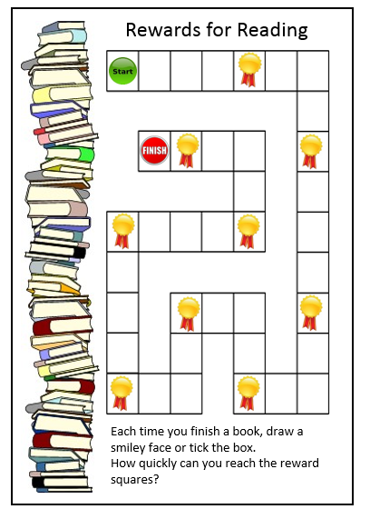

Parents may like to use this reading rewards at home. They can think of a reward, such as play a game, have a treat, time to chat with a friend etc.

