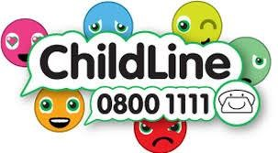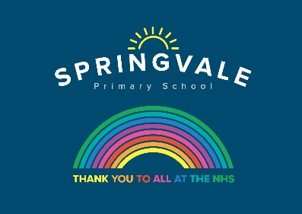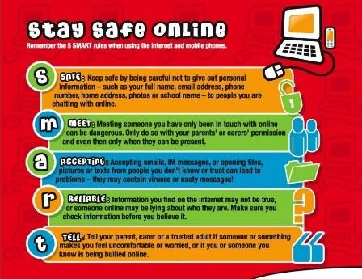

Learning Project Wc 01.06.20: Under The Sea
Age Range: KS1 YR 1 / 2 Mrs Evans, Mrs Royston, Mrs Tomlinson, Mrs Andrew
Weekly Maths Tasks (Aim to do 1 per day) | Weekly Reading Tasks (Aim to do 1 per day)
- Write the days of the week on paper and cut them up into cards. Take turns turning over the cards. If, when you turn the card, you have a day that is before or after the day shown you can say snap.  - With your child, list different activities/chores they have to do throughout the day. Can they order them after making the list? Can your child sort them into the times of day each thing happens in (e.g. morning, afternoon, night etc)?  - Write the months of the year on separate pieces of paper and mix them up. Can your child order them correctly?  - Using a clock in your house practise telling the time with your child to the nearest hour, half hour, 15 minute intervals and 5 minutes intervals.  - Ask your child to survey the family about their favourite sea creature (choose from 5). Represent the results using a tally chart or a pictogram. Which sea creature was the most popular? Which was the least popular? | - Encourage your child to learn the rhyme  ‘A Sailor went to Sea, Sea, Sea’. Click here for a video of the rhyme and lyrics. Can your child perform this rhyme by heart?  - Task your child with building an ‘Under the Sea’ themed reading den. Can they find some sea-themed books to cosy up with and share in there?  - Ask your child to make a sea-themed bookmark. They could take inspiration from ‘Sharing a Shell’ or ‘The Snail and the Whale’.  - Your child could read a story/poem/nursery rhyme to another family member. This could be to a younger sibling before bedtime or they may wish to Facetime an elderly relative (with adult supervision of course).  - Read along with ‘There’s a Hole in the Bottom of the Sea’ or listen to ‘How the  Whale got his Throat’. Ask your child to retell one story by drawing a comic strip of the events.
Weekly Phonics/Spellings Tasks (Aim to do 1 per day) | Weekly Writing Tasks (Aim to do 1 per day)
Our children are all in very different places for learning sounds and spellings. We have provided a list of sounds / words, which increase in challenge to suit all needs.  Set 2 sound of the week: or  Read and spell words such as:  fork, short, stork, torch, sport, storm, north, born | - Ask your child to:  - Follow the link to visit a desert island https://safeyoutube.net/w/Dxh6 Can you write a message in a bottle? What can they see, hear, feel, taste and smell? Why not roll the message up and pop it in a plastic bottle for the reading den?  - Plan the perfect beach trip. Can they draw and label all the things that they would pack including a picnic? Who would they take? What games would

Set 3 sound of the week: are Read and spell words such as: care, share, dare, rare, bare, stare, glare, spare  Year 1 spellings of the week: have, give, live, love, five, gave, move, above  Extra challenge – can you write these words in a sentence?  Year 2 common exception words of the week:  Mrs, parents, Christmas, Everybody, even.  Extra challenge – can you write these words in a command / question / statement or exclamation sentence?  Year 2 homophones: threw / through, which / witch, hour / our, meet / meat, know / no  Extra challenge – can you think of different ways to use these homophones in writing ie I don’t know what to wear!  Year 2 Summer Spag mat 5 (find on the school website)  Year 1 Summer Spag mat 3 (find on the school website) | they play? How much time would they spend in the sea?  - Speak to your child about all of the things that make them happy or all of the things that they’re grateful for. Ask them to record these in a list.  - Help your child to create a fact file about the endangered Sea Turtle. Can they find out about its appearance, its diet and its habitat? This link may help. Following this, your child could draw a detailed sketch of the Sea Turtle.  - Design a beach safety poster. What tips would you give beach- goers for staying safe at the seaside?
Learning Project - to be done throughout the week: Celebration
The project this week aims to provide opportunities for your child to learn more about life in and around the sea. Learning may focus on the strange and wonderful creatures and plants that occupy our oceans, their habitats and how human beings affect this environment.
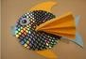
- Guess Who?- Write some fact cards about animals from under the sea.
You could use books or websites to find out about the appearance, habitat and diet of each creature. After this, play a game of ‘Guess Who?’ using the cards and yes/no questions.

- Junk Modelling- Using junk or recycling materials from around the home, design and make a Sea Turtle. You may wish to make another sea creature after this. Remember to ask an adult to tweet a photo of your creation on the school Twitter page.

- Put Your Goggles On- Visit this website and watch a live stream of a tropical reef. Whilst watching, sketch all of the animals that you can see. Remember to look at the shapes and patterns on each creature and to include these in your sketches.

- How do Humans Affect the Sea?- Are you aware of all the ways that humans affect the sea and the living things within it? Investigate the impact that human beings have on the sea. Think about fishing, transport and pollution. You could create a poster or information report.

- The Oceans of the World- Use this game to practise naming and locating the oceans. Can you find them in an atlas too?

Additional learning resources parents may wish to engage with
Visit this BBC website for more sea themed music and learning ideas.
There are some lovely games and ideas from the Royal National Lifeboat Institution here.

Classroom Secrets Learning Packs - These packs are split into different year groups and include activities linked to reading, writing, maths and practical ideas you can do around the home.
Twinkl - to access these resources click on the link and sign up using your own email address and creating your own password. Use the offer code UKTWINKLHELPS.
Headteacherchat - This is a blog that has links to various learning platforms. Lots of these are free to access.
#TheLearningProjects

