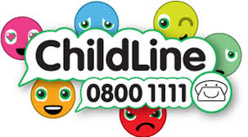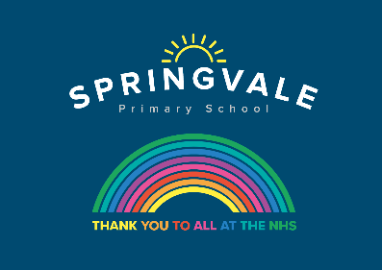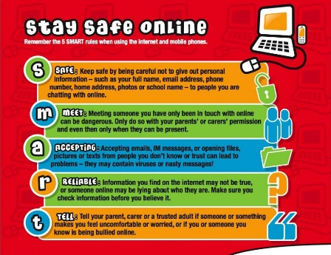

Learning Project WEEK 7 - Celebrations
Age Range: Y5/6 Mrs Fearn/Henstock/Mayston
Weekly Maths Tasks (Aim to do 1 per day) | Weekly Reading Tasks (Aim to do 1 per day)
- Get your child to play on Times Table Rockstars. Well done all for winning the inter school competition!  - Ask your child to show everything they know about measures on a piece of paper. This could be pictures, diagrams, explanations, methods etc. Get them to be as creative as they want to be.  - Here are some mini maths tasks. Encourage your child to work through the activities they have not done for their specific year group.  - Daily arithmetic for different areas of maths. Ask your child to work on level 4, 5 and 6 activities  - List with your child different festivals that happen around the world. Research the percentage of people across the world or within a country that celebrate this festival. Can your child create a graph showing this information?  - Get your child to work on their reasoning and problem solving by practising past SATs questions that are broken down into topic areas and have videos linked to them that can be watched if needed. As these are older papers these are suitable for both years 5 and 6. Click on one of the topic areas listed to gain access to the questions.  - Each day use bbc bitesize daily lesson year 5 or year 6  https://www.bbc.co.uk/bitesize/dailylessons | - Ask your child to read a chapter from their home reading book or a book that they have borrowed from the library. (Remember books are available in the school shelter to borrow - Monday and Fridays)  - Your child can now design an alternative book cover for their chapter book.  - Why not ask your child to create a true or false quiz about a book that they have recently read. They can then test out the quiz on somebody else who has read the book.  - Authors love receiving mail from their readers. Your child can write a letter to their favourite author. Encourage them to visit their website first so that they can learn a little more about their chosen author. Why not send the letter and wait for a reply?  - Try reading from: https://www.booktrust.org.uk/  https://www.bl.uk/childrens-books  There’s lots of books, puzzles, quizzes and activities on here to choose from.  - Remember to complete your  reading log.  - Using Twinkl (website - see below), find a reading comprehension that your child is interested in and try writing the answers to the questions. Search 'celebrations reading comprehensions ks2' and choose one you'd like to study.  - https://www.dk.com/uk/information/stay-home-hub/ reading literature and activities
Weekly Spelling Tasks (Aim to do 1 per day) | Weekly Writing Tasks (Aim to do 1 per day)
- Encourage your child to practise the Year 5/ 6 Common Exception Words : profession, programme, pronunciation, queue, recognise, recommend, relevant, restaurant, rhyme, rhythm, sacrifice, secretary  - Then ask your child to choose 5 Common Exception words. They can then write a synonym, antonym, the meaning and an example of how to use the word in a sentence.  - Your child can create their very own word search. The theme of this should be ‘Celebrations’.  - When proofreading their story, your child should be thinking about which words could be improved. They may want to use a thesaurus or on-line version to make sure their word choices paint a picture for the reader. | - Ask you your child to write a diary entry/newspaper report summarising the events from the day/week  - Get your child to create a newspaper report of the day they were born- include weather on the day, stories in the news, etc. Can they find any famous people who were born on that day?  - Celebrate a local person- ask your child to write a list of local people worth celebrating. Afterwards, get them to write an information report about the contribution the top three have made to their community.  - Ask your child to select a celebration from their culture and generate a multiple choice quiz about this event.  - Birthdays should not be celebrated. Does your child agree or disagree with the statement above? Ask them to justify their opinion using facts.  - Story Task: As your child has now completed their draft version of their story, ask them to use this time to proofread their writing for any spelling or grammar errors. Following this, ask them to make sure the tense is consistent throughout and that the word choices they have made to convey meaning to the reader.
Learning Project - to be done throughout the week
This project this week aims to provide opportunities for your child to learn more about celebrations. Learning may focus and different types of celebrations that take place and who may celebrate them. It could look at how people celebrate different events differently in other parts of the world.

Planning a Celebration- it’s time to plan a celebration event of their choice. This could be a birthday party, an Eid celebration, an end to lockdown or anything else they wish to plan. Tell them they have £150 to spend and 25 guests will be attending. What will the money be spent on? Ask them to plan the celebration considering the location of the event, how they will decorate the venue, what their guests will eat and drink and how they will entertain their guests. Get them to detail the timings of the event and any timings for preparation.

Time to Design- Can they imagine their perfect celebration outfit? What would it look like? What would it be made from? How comfortable would it need to be? Ask them to design a costume for a celebration of their choice. Think about the patterns they would like to incorporate on their design and the cultural traditions.

Birthdays around the World- Birthdays are celebrated differently in different countries. Write an information report detailing how birthdays are celebrated in the following countries: China, England, Spain, Italy and Mexico. Ask your child which country would they like to celebrate their birthday based on their findings? Why?

What’s the same and what is different? - Select a holiday/festival of their choice and research how different countries around the world celebrate this event. They could compare whether it is celebrated at the same time, the outfits people wear, the food eaten etc. Make a video, poster or report of the things they have discovered.

British Celebrations- In Great Britain, Valentine’s Day, St Patrick’s Day and Bonfire Night are just some of the celebrations that take place. Ask your child to choose one celebration day and research how the celebration came to be. Using the information they have found, plot the events on a timeline and include dates, details and pictures/sketches. Now create a poster advertising the celebration day. This could be done on a computer programme of your choice or on paper.
Additional learning resources parents may wish to engage with
Classroom Secrets Learning Packs - These packs are split into different year groups and include activities linked to reading, writing, maths and practical ideas you can do around the home.
Twinkl - to access these resources click on the link and sign up using your own email address and creating your own password. Use the offer code UKTWINKLHELPS.
Headteacherchat - This is a blog that has links to various learning platforms. Lots of these are free to access.
#TheLearningProjects

