Springvale Primary School
Pupil Premium Projected Spending 2020-21
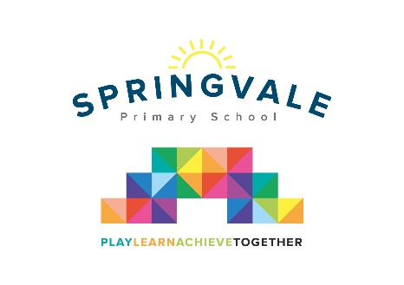
Pupil Premium funding is allocated to schools by the government to support children who fall into vulnerable groups. It is for schools to decide how the funding is spent, and careful consideration should be made, taking into account the various needs of the children eligible for this funding. We endeavor to ensure that our funding is used to support all eligible pupils in making at least good academic progress each school year.
In this financial year, 2020-21 Springvale School estimate that they will receive £29,520 in Pupil Premium funding.
In 2020/21 our funding will be spent on the following:
- Employment of TA to support increased pupil progress across the EYFS and improve early intervention strategies including improved speech and language levels. | £11,200
- Programme of academic support for learning needs of specific children, delivered by teaching assistants. | £6,870
- Counselling Services- bespoke service for pupils and families. | £2,400
- Additional Ed Psych support. | £1,600
- Additional SCI support. | £950
- SALT family support workshops and TA intervention time across KS1 and KS2. Includes phonics and fine motor development where required. | £1,400
- Welcomm subscription to support the screening of communication needs in Foundation Stage. | £360
- Subsidy for pupil premium children to support participation in visits/residential etc and additional rewards. | £1,100
- Programme of pastoral support for learning needs of specific children, delivered by teaching assistants, including a new pastoral lead role 1.5 hours daily- this was developed due to COVID-19. | £3,640
Total | £29,520
Please note that the numbers relate to the teacher/leader Pupil Premium Tracking documents completed termly following parental discussions and leader/teacher/TA pupil progress discussions. These numbers help to track links to key pupils and impact to support effective evaluation of our spending strategies.
We also produce a termly Pupil Premium tracker for leaders and all staff. This is scrutinised by Governors each term. This tracker includes references to attendance, punctuality, behaviour, progress and attainment.

