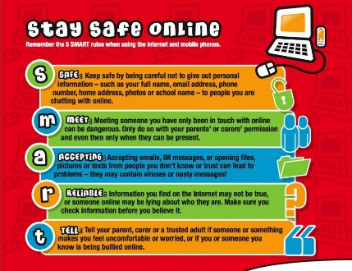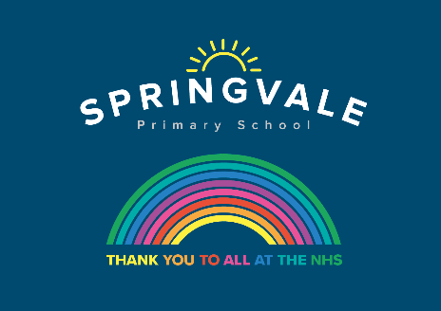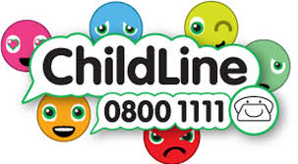
W/C 29.06.2020: Learning Project - Around the World
Age Range: EYFS
FS2 The Curious Cubs
Weekly Reading Tasks | Weekly Phonics Tasks
Monday- Listen to stories from around the world - including: Handa's Surprise, The Tiger’s Child and If The World Were a Village. | Monday Introduce the sound of the week  Mrs Slack/Mrs Gale/Mrs Evans  Revise/Re-cap Set 2 Sounds, (see Speed Sounds Set 2 mat attached). Read Moon Farm Park on phonicsplaycomics.co.uk  Mrs Cliffe/Mrs Honey and Mrs Parr  Re-cap: ch sh th ng nk ay  Sound of the week: ee (What can you see?)  Read and spell words such as, see, sheep, feet, been, cheek, jeep
Tuesday- Choose one of the above stories to share again. Ask your child to retell the story in their own words once they are familiar. | Tuesday- Play Odd and Bob here. Children sort real words and nonsense words by sounding out.
Wednesday- Follow the story All Are Welcome Here with your child. Discuss how your child’ school makes everybody feel welcome. | Wednesday- There are live phonics lessons on Youtube daily. Click here to watch.
Thursday- Play memory games, ‘I went to the market, I bought… The next person repeats the above sentence remembering the items bought already and adding a new one to the list each time. Use fruits like in Handa’s Surprise. | Thursday- Splat the Letter- Write out the letters for the sounds your child has been practising on pieces of paper and spread out on the floor. Take it in turns to shout out a sound and both players have to try and splat the sound with their hand.
Friday- Your child can practice reading the tricky words: into, he, she, me, we, be, you, are, they, my all, her. Look at newspapers, magazines or leaflets together and circle these words with a felt tip pen or highlighter. | Friday- Visit phonicsplay.co.uk and play Reading Robot. You can enter words containing sounds that your child needs to practise.
Weekly Writing Tasks | Weekly Maths Tasks- Numerical Patterns – Odds and Evens
Monday- Encourage your child to look at the food in your kitchen and find out what countries some of it comes from. Search on a map for those countries. Help your child to trace the letter with which the name of those countries start. | Monday- Watch Numberblocks (Series 2 Episode 11, odds and evens) and discuss.
Tuesday- After listening to the story Handa’s Surprise, ask your child to name and draw different fruits that they know. Label them using describing words. | Tuesday- Go to BBC Bitesize and search for ‘What are odd and even numbers?’ Watch the video that explains how to tell the difference between odd and even numbers, then play the ‘Sort the bananas’
Wednesday- Ask your child to play in role as Handa from Handa’s Surprise. Ask them questions and they must answer as Handa e.g. ‘Handa, what is your favourite fruit?’ They might answer by saying ‘My favourite fruit is tangerines. I was very excited to find lots of them’. | Wednesday- Explore odd and even by grouping quantities into pairs. Even quantities and be grouped into pairs and odd quantities will have one left on their own when they are grouped into pairs. Prompt them to recognise that some numbers can be halved or grouped into pairs and some numbers will have one left over.
Thursday- Your child can draw a picture of a suitcase and all the things they might take on holiday. CHALLENGE: Ask your child to label the items. | Thursday (theme)- Look at these pictures of flags from around the world with your child. Can they spot any shapes in the flags and can they name them?
Friday- Ask your child to pretend they are on holiday. Get them to make a postcard to send to someone at home. Ask your child to draw a picture of what they are doing on holiday. Can they make a list of what they are doing? | Friday (theme) – Explore the attached activity from Nrich, Owls Packing List

Learning Project - to be done throughout the week
The project this week aims to provide opportunities for your child to learn more about countries and cities around the world. Learning may focus on different cultures and traditions, famous landmarks, food and clothing.

Flags
- Look at flags from around the world. Discuss which are your child’s favourites and why? Ask your child to design and make their own flag using 2d shapes.

Food Tasting
- Find some different foods/fruits from around the world and taste each one. These might include: pizza (Italy), curry (India) and taco (Mexican) or the fruits from the story Handa's Surprise. Your child can create a chart putting a tick next to each food they like and a cross next to the foods they dislike over the course of the week.

Pleasing Puppets
- Make your own Handa’s Surprise character puppet. Click here for more ideas.

Toys from Around the World
- Look at this photography project of children with their toys from around the world. Discuss how life is the same and how life is different in other countries. Can your child draw their favourite toy and write a sentence explaining why this is their favourite?

Where in the World?
- Discuss with your child where your family comes from in the world. If you have them available, show your child photographs of where you, or their grandparents, grew up. This might be similar to where they live now or completely different. Encourage your child to think about the differences between the places. Share your family photographs on Twitter at #TheLearningProjects so children can compare their own family origins with others.
Coronavirus and Wellbeing- Coping with Change
The change that Covid-19 has caused to our lives has been difficult and has provided countless challenges. For many children, the uncertainty and disruption to everyday life has caused worry and anxiety. These tasks are designed to help children process the current situation, begin to make sense of it and plan for returning to a different normal.

Think
- We are experiencing an unusual time and your child probably has lots of questions about the changes to their life. The book ‘Staying Home’ is a great starting point in answering many of the questions your child might have. ‘Good Days in Unusual Times’ offers child-friendly tips for coping with change.
Talk
- Talk to your child about a skill they would like to develop or an activity they would like to complete during this extra time at home. Together, create a plan of when and how this could be achieved. This could be illustrated on a weekly timetable or added to your family calendar.
Do
- Go on a Rainbow Walk together. Ask your child to identify things that are red, orange, yellow, green, blue, purple, pink, brown and black.
Visit
- This document from Emerging Minds offers evidence based advice for anyone supporting children and young people with their worries.
STEM Learning Opportunities #sciencefromhome
Engineering Around the World – Bridges
- A bridge helps people move over obstacles like a river, a valley or a busy road. The world’s longest bridge is in China and is 164.8km long. It would take more than two days to walk the length of this bridge. Do you have any bridges near your home? What do they look like?
- Try building a bridge out of paper, Lego or any other building materials you might have at home. Your bridge needs to be big enough for a toy car or small toy to travel over.
Additional learning resources parents may wish to engage with
White Rose Maths online maths lessons. Watch a lesson video and complete the worksheet (can be downloaded and completed digitally).
Numbots. Your child can access this programme with their school login.
IXL Click on Maths, Reception. There are interactive games to play and guides for parents.
Talk for Writing Home-school Booklets are an excellent resource to support your child’s speaking and listening, reading and writing skills.
The Learning Projects are based on the National Curriculum expectations for the key stage which your child is in. It may be that your child finds the tasks set within the Learning Project for their year group too simple. If this is the case, then we suggest that your child accesses the Learning Projects which are set for the key stage above. Equally, if the projects are too challenging, then we advise that your child accesses the projects for the key stage below.
If your child requires more of a challenge, or you believe that there are some gaps in their learning then Century Tech is a fantastic resource that is currently free for home learning. The app is designed to address gaps and misconceptions, provide challenge and enables children to retain new knowledge. It uses artificial intelligence to tailor the learning to your child’s needs. Sign up here.
#TheLearningProjects

