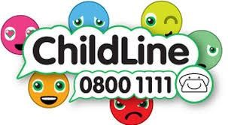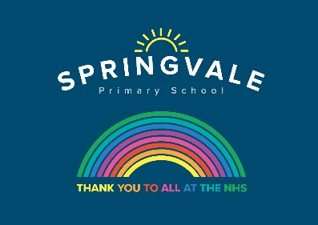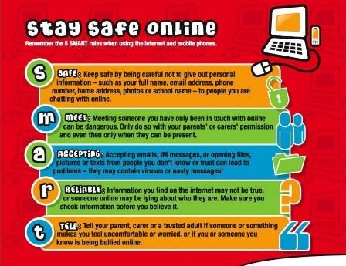

Learning Project WC 22.06.20: Famous & Significant People

Age Range: KS1 YR 1 / 2 Mrs Evans, Mrs Royston, Mrs Tomlinson, Mrs Andrew
Weekly Maths Tasks (These don’t have to be done in order but aim to do 1 per day) | Weekly Reading Tasks (These don’t have to be done in order but try to do 1 per day)
Monday- ​Encourage your child to write all of the number facts up to 20 e.g. 3 + 1720, 17 + 3 = 20. Can they use these to write the inverse e.g. 20 - 3 = 17? | Monday- Benjamin Zephaniah is a famous poet from Birmingham. Your child can listen to his poem ‘​Royal Tea​’ at https://safeyoutube.net/w/SNh6 . What did your child like about the poem? What did they dislike about the poem?
Tuesday- ​Give your child a number between 1 and 20 and ask them to think about how many ways they could make the number using addition. | Tuesday- Ask your child to find out about one significant person​. They could use the following website and have a go at the activities. https://www.bbc.co.uk/bitesize/topics/zf49q6f Can they read any tricky words? Why is this person important?
Wednesday- ​Practise totalling amounts on this ​game​ by dragging the robot to the correct silhouette. https://www.topmarks.co.uk/addition/robot-addition | Wednesday- Ask your child to re-read their favourite story out loud. Remind them to use expression. Task your child with creating a new book cover for their favourite story​ ​or writing an alternative ending!
Thursday- ​Get your child to write one of the number bonds to or within 10 - e.g. 2 + 8 = 10 or 3 + 4 = 7. Can they use these facts to find out the addition facts up to 100? E.g. 20 + 80 = 100 and 30 + 40 = 70. | Thursday- Who was Queen Elizabeth I? Watch ​this short video​ (https://www.bbc.co.uk/bitesize/topics/zkrkscw/articles/zkh7bdm) and then your child can record what they’ve learned about this royal. They may also wish to use books or ​websites​ to help.
Friday- ​In Benjamin Zephaniah’s poem ‘​Royal Tea​’ he tells the reader that he paid £8.50 to visit Buckingham Palace. What coins could he have used to pay for his ticket? How many different ways can your child represent this amount? | Friday- Set up an interview where your child can be the interviewer and you can be the famous person (choose one from https://www.bbc.co.uk/bitesize/topics/zf49q6f ​). Ask them to write down and read back to you some of the things you have said.
Weekly Phonics/Spellings Tasks (Aim to do 1 per day) | Weekly Writing Tasks (Aim to do 1 per day)
Our children are all in very different places for learning sounds and spellings. We have provided a list of sounds / words, which increase in challenge to suit all needs.  Set 2 sound of the week: ou  Read and spell words such as:  loud, house, hour, mouth, lounge, ground, mouse  Set 3 sound of the week: ow  Read and spell words such as: down, shower, flower, towel, powder, crown, town, tower.  Year 1 spellings of the week (Rule= Add ‘ed’ to the root word to write a verb in the past tense): walked, picked, reached, pushed, jumped, buzzed, stomped, limped.  Extra challenge – Can you write these words in statements?  Year 2 Theme related Spellings: famous, celebrity, people, palace, royal, wealthy, majestic, person.  Extra challenge – can you think of any sentences that have these words in them? Perhaps you could write them down?  Year 2 Summer 2 Spag mat 2 (find on the school website)  Year 1 Summer 1 Spag mat 6 (find on the school website) | Monday- Listened to the poem ‘​Royal Tea’ (https://safeyoutube.net/w/SNh6) then ask your child to create a list of questions that they’d like to ask Benjamin Zephaniah about his visit to the palace.
 | Tuesday- Ask your child to write their very own royal adventure story. They could write in role as a king, queen, prince, princess, knight or servant. Think about what will happen at the beginning, in the middle and at the end.
 | Wednesday- When your child has completed their royal adventure story, they can design a cartoon strip to accompany their writing or a front and back cover for their story.
 | Thursday- ​Can your child write a letter, postcard or email to their teacher? They may want to describe what they have been doing at home. They might want to tell their teacher about the things that they are missing about school​
 | Friday- Look at a picture of Buckingham Palace and write a description of this majestic building. The following website contains a fabulous photo but please be warned that it takes a few moments to load, so please be patient. https://en.wikipedia.org/wiki/Buckingham_Palace#/media/File:Buckingham_Palace_from_gardens,_London,_UK_-_Diliff_(cropped).jpg

Learning Project - to be done throughout the week:
Famous & Significant People
The project this week aims to provide opportunities for your child to learn more about famous or significant people. Learning may focus on past or present inventors, explorers or scientists and how they influence society today.

- How Important is Mary Seacole?​- Mary Seacole was a Jamaican-born nurse who is remembered for helping soldiers during the Crimean War. Using ​this video​ (https://www.bbc.co.uk/bitesize/topics/zns9nrd/articles/zjsxcqt) your child can create a simple timeline of Mary Seacole’s life. If this is too challenging, why not ask your child to design an award for Mary Seacole. Your child could also locate Jamaica and Scotland on a world map.

- Keep them Clean! -​ Mary Seacole visited Florence Nightingale, another important nurse, during the Crimean War. Florence Nightingale was known for highlighting the importance of hygiene when caring for the sick, particularly handwashing. Ask your child to create handwashing posters for the home. They might want to make up a jingle too!

- Intriguing Inventions- ​Challenge your child to invent something new. Perhaps a new gadget for the home to keep the family entertained, or something that would help a doctor or a nurse. They can draw and label their design, and could have a go at making it using things from the recycling box. Don’t forget to tweet us a photo of your design.

- The Queen: Then and Now- ​What was life like for Queen Elizabeth I? ​This video ​may help your child to understand (https://www.bbc.co.uk/bitesize/topics/zkrkscw/articles/zkh7bdm) How is life different for the current queen, Queen Elizabeth II? Ask your child to create a list of the similarities and differences. They might focus on appearance, family and interests. They could show this using illustrations too.

- A Seriously Significant Somebody-​ Who is important to your child? What makes them so important? Your child could draw or paint a portrait of their significant somebody using a photograph or digital image to support them. They may wish to write an information report about this person too!

- Reading comprehensions: This week’s reading comprehensions are based on famous people that your child may know; David Walliams and Ed Sheeran. Encourage them to read the information and answer the questions. Did they learn anything new about them? Find both of these reading comprehensions on the school website.

Additional learning resources parents may wish to engage with
- Beulah Henry 1912 – 1970
Beulah was a famous American inventor who invented over 100 new products. She made several umbrella inventions from clip on covers to special umbrella bags.
If you were going to design an umbrella what would it look like and what materials would you use?
Try making a model umbrella using junk box materials you might find at home.
- Numbots. Your child can access this programme with their school login.

#SpringvalePrimary

