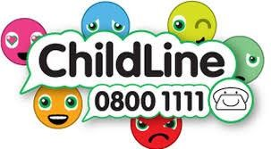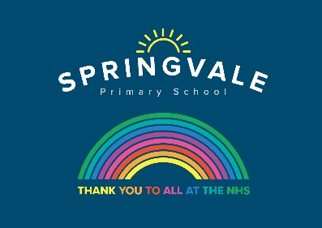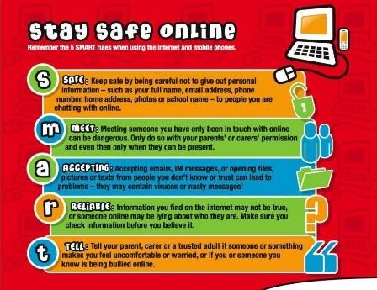

Learning Project Wc 08.06.20: Sport
Age Range: KS1 YR 1 / 2 Mrs Evans, Mrs Royston, Mrs Tomlinson, Mrs Andrew
Weekly Maths Tasks (These don’t have to be done in order but aim to do 1 per day) | Weekly Reading Tasks (These don’t have to be done in order but try to do 1 per day)
Monday- Play a board game together so that your child can practise their counting and the language of position and direction. Maybe Snakes and Ladders? | Monday- Provide your child with a bag and ask them to collect items to go in it that relate to a well known story. If they can’t find an item, they could draw a picture instead. Ask them to use the objects in the story bag to retell the familiar story.
Tuesday- Place an object on the ground and use positional language such as forward, backwards, up, down, left and right to direct them to the object. You could switch roles and get your child to give the directions. If you wanted to make it harder, you could use a blindfold but be extra careful! | Tuesday- Talk to your child about a hero from a book they have read recently, for example the Prince from Rapunzel or Mulan. Ask them to draw the hero or heroes from a story and list adjectives to describe their appearance and personality.
Wednesday (theme)- Play ‘Catch’ with your child using a ball or anything else that can be thrown safely. Instead of counting in 1s each time the ball is caught, ask your child to only count every second, fifth or tenth catch. | Wednesday- Your child can listen to the Cbeebies story ‘Martin the Mouse’ (click here). Ask your child to record the main events from this sporty story. They can draw the events, write sentences or even retell the story orally in their own words.
Thursday- Encourage your child to play this NRICH activity to develop their understanding of positional language. | Thursday- Ask your child to choose and read a healthy recipe from a recipe book. If you have the ingredients, have a go at following the recipe together?
Friday- Each member of the family could have a go at the Long Jump. Ask your child to measure the length of each jump using a measuring tape and record the lengths. Who jumped the furthest? Who had the shortest jump? What was the difference between the shortest and longest jump? | Friday- Watch and listen to ‘The Little Princess: I Want to Win’ based on the Tony Ross book. Talk to your child after this about how the Little Princess felt each time she won a game. Can they think of a time they felt like the Little Princess?
Weekly Phonics/Spellings Tasks (Aim to do 1 per day) | Weekly Writing Tasks (Aim to do 1 per day)
Our children are all in very different places for learning sounds and spellings. We have provided a list of sounds / words, which increase in challenge to suit all needs.  Set 2 sound of the week: air  Read and spell words such as:  Hair, chair, fair, stair, pair, repair, air, flair  Set 3 sound of the week: ue  Read and spell words such as: blue, clue, glue, true, argue, statue, value, due  Year 1 spellings of the week (Adding s or es to the end of words): cats, dogs, spends, rocks, thanks, catches, watches, witches  Extra challenge – can you write these words in a sentence?  Year 2 have now covered all of the common exception words and the common homophones, so we will learn to read and write some words related to the weekly theme: competition, athlete, medal, stadium, arena, podium, position, score.  Extra challenge – can you think of any sentences that have these words in them? Perhaps you could write them down?  Year 2 Summer Spag mat 6 (find on the school website)  Year 1 Summer Spag mat 4 (find on the school website) | Monday- Has your child got a favourite sportsperson? This could someone who has taught them P.E. Ask them to write an information booklet about this person.
 | Tuesday- Ask your child to think of questions they’d love to ask their favourite athlete. They could write a list of questions using a range of questions words such as ‘when’, ‘why’, ‘who’, ‘what’, ‘where’ and ‘how’. Your child could then answer their own questions in the role as their hero.
 | Wednesday-.Visit the Literacy Shed for this wonderful resource on The Catch or your child could write their own sporting story featuring their hero.
 | Thursday- Can your child design a poster all about teamwork? This could be linked to your family and how you all have to work together as a team.
 | Friday- Ask your child to design a gold medal and present it to somebody deserving within the household. Why have they chosen this person? Ask them to write a few sentences and include the word ‘and’, ‘because’ and ‘if’.

Learning Project - to be done throughout the week: Sport
The project this week aims to provide opportunities for your child to learn more about sports and games. Learning may focus on the history of sport, sporting-heroes, physical challenges and performance.

- Obstacle Course Fun- Task your child with designing and making their very own obstacle course in the garden. Ask them to draw and label their design first and include all of the equipment they need. They can then use their design to create their obstacle course. Ask the family to complete the obstacle course whilst your child times them. Your child could even make medals from tin-foil or any other suitable material and present them to the winner during a winner’s ceremony.

- Make a Family Mascot- Your child could make their very own family mascot using materials from around the house. First of all, visit the Olympic Mascot Official list here and look at past mascots. What makes a good mascot? What qualities does the mascot represent?

- Remarkable Routines- Can your child create their very own simple routine, just like a gymnast, dancer or synchronised swimmer? Perhaps your child could choose a piece of music to practise their routine to. When they are confident, why not film your child’s sequence and share it on our school twitter page? Watch the performance together- what does your child think went well? What could be even better?

- Terrific Team Kits- Ask your child to design their very own team kit. They should consider the flag of the country that they would represent and how to incorporate these colours into the design. They could draw the design with a pencil or use a computer program to do this.

- Can you Invent a New Olympic Game?- Challenge your child to invent their very own game for the 2021 Olympics. Look at a list of all of the sports that already compete in the summer Olympics here. Can they write a set of instructions for the new game or draw illustrations. Why not test the game out as a family?

- Read about Lewis Hamilton and see if you can answer questions about what you’ve read. Find the reading comprehension on the school website.

- Have a go at the reading comprehension: ‘The Terrible Trip Up’, also on the school website.

Additional learning resources parents may wish to engage with
Brilliant Bodies
- What can your body do? Balance on one leg? Touch your nose with your tongue? Look at the body challenge cards and see how many you can do. Ask your family to join in and make your own body challenge cards.
The complete resource can be downloaded here.
- The NHS Change 4 Life website has some great games and activities, specifically ones for staying indoors. Have a look here.
- For lots more clips, activities and ideas to get active visit the sport’s section on the Cbeebies website.
- Numbots. Your child can access this programme with their school login.

#TheLearningProjects

