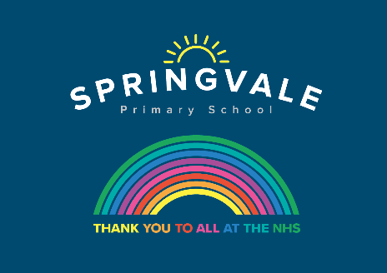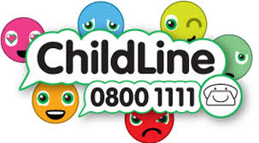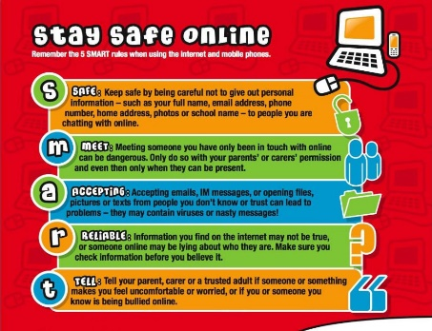

W/C 29.6.20 : Learning Project - Around the World
Age Range: Nursery
Weekly Reading Tasks | Weekly Phonics Tasks
Monday- Listen to stories from around the world - including: Handa's Surprise, The Tiger’s Child and If The World Were a Village. | Monday- Ask your child if they can think of a fruit or vegetable for each letter of the alphabet i.e. a=apple, b=banana. If your child will struggle with this, put some fruit and the sounds they begin with on a tray and see if your child can match them.
Tuesday- Choose one of the above stories to share again. Ask your child to retell the story in their own words once they are familiar. | Tuesday- Play Odd and Bob here. Children sort real words and nonsense words by sounding out.
Wednesday- Follow the story All Are Welcome Here with your child. Discuss how your child’s school makes everybody feel welcome. | Wednesday- There are live phonics lessons on Youtube daily. Click here to watch.
Thursday- Play memory games, ‘I went to the market, I bought… The next person repeats the above sentence remembering the items bought already and adding a new one to the list each time. Use fruits like in Handa’s Surprise. | Thursday- Splat the Letter- Write out the letters for the sounds your child has been practising on pieces of paper and spread out on the floor. Take it in turns to shout out a sound and both players have to try and splat the sound with their hand.
Friday- Your child can look for sounds in newspapers, magazines or leaflets together and circle them with a felt tip pen or highlighter. Write very simple words such as - and at is can got and have a go at finding them in books. | Friday- List countries and places from around the world e.g. Spain, Penistone. Ask your child to identify the initial sound each country/place begins with.
Weekly Writing Tasks | Weekly Maths Tasks- Take Away
Monday- Encourage your child to look at the food in your kitchen and find out what countries some of it comes from. Search on a map for those countries. Help your child to trace the letter with which the name of those countries start. | Monday- Watch this video to support counting back from 10. CHALLENGE: Ask your child to start at 10 and take away 1. Repeat this until they get to zero. Do they recognise the amount is getting smaller?
Tuesday- After listening to the story Handa’s Surprise, ask your child to name and draw different fruits that they know. Label them. | Tuesday- Generate your own subtraction number stories. Use real life objects at home to show this e.g. ‘I have 4 bananas. I eat one. How many are left?
Wednesday- Ask your child to play in role as Handa from Handa’s Surprise. Ask them questions and they must answer as Handa e.g. ‘Handa, what is your favourite fruit?’ They might answer by saying ‘My favourite fruit is tangerines. I was very excited to find lots of them’. | Wednesday- Use a teddy and count backwards making deliberate mistakes. Can your child spot the mistakes? Mistakes can include omitted numbers, repeated numbers or a number in the wrong place. CHALLENGE: Ask your child to spot the mistake when the numbers are written down.
Thursday- Your child can draw a picture of a suitcase and all the things they might take on holiday. CHALLENGE: Help your child to label the items. | Thursday (theme)- Look at these pictures of flags from around the world with your child. Can they spot any shapes in the flags and can they name them?
Friday- Ask your child to make a postcard to send to school and draw a picture of what they are doing at home. Help them to write the card. When we get your card, we will send one back. | Friday- Make your own flag for your house and family using shapes. Decide what shape it will be and then draw shapes on it. Colour it in. Cut it out and put it on a stick. Fly it in your garden.

Learning Project - to be done throughout the week
The project this week aims to provide opportunities for your child to learn more about countries and cities around the world. Learning may focus on different cultures and traditions, famous landmarks, food and clothing.

Flags
- Look at flags from around the world. Discuss which are your child’s favourites and why?

Food Tasting
- Find some different foods/fruits from around the world and taste each one. These might include: pizza (Italy), curry (India) and taco (Mexican) or the fruits from the story Handa's Surprise. Your child can create a chart putting a tick next to each food they like and a cross next to the foods they dislike over the course of the week.

Pleasing Puppets
- Make your own Handa’s Surprise character puppet. Click here for more ideas.

Toys from Around the World
- Look at this photography project of children with their toys from around the world. Discuss how life is the same and how life is different in other countries. Can your child draw their favourite toy and write a sentence explaining why this is their favourite?

Where in the World?
- Discuss with your child where your family comes from in the world. If you have them available, show your child photographs of where you, or their grandparents, grew up. This might be similar to where they live now or completely different.
Coronavirus and Wellbeing- Coping with Change
The change that Covid-19 has caused to our lives has been difficult and has provided countless challenges. For many children, the uncertainty and disruption to everyday life has caused worry and anxiety. These tasks are designed to help children process the current situation, begin to make sense of it and plan for returning to a different normal.

Think
- We are experiencing an unusual time and your child probably has lots of questions about the changes to their life. The book ‘Staying Home’ is a great starting point in answering many of the questions your child might have. ‘Good Days in Unusual Times’ offers child-friendly tips for coping with change.
Talk
- Talk to your child about a skill they would like to develop or an activity they would like to complete during this extra time at home. Together, create a plan of when and how this could be achieved. This could be illustrated on a weekly timetable or added to your family calendar.
Do
- Go on a Rainbow Walk together. Ask your child to identify things that are red, orange, yellow, green, blue, purple, pink, brown and black.
Visit
- This document from Emerging Minds offers evidence based advice for anyone supporting children and young people with their worries.

