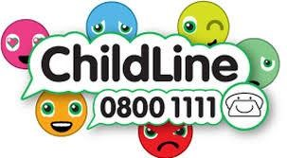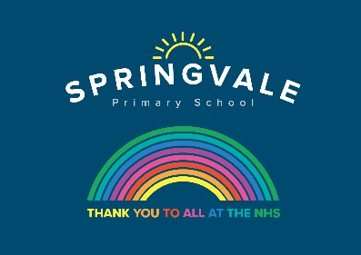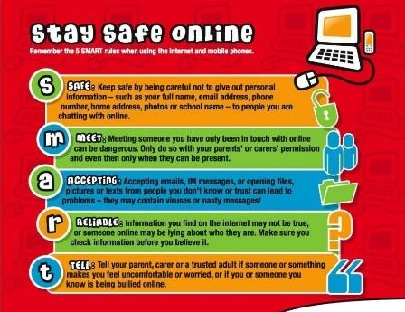

Learning Project WC 29.06.20: Around The World

Age Range: KS1 YR 1 / 2 Mrs Evans, Mrs Royston, Mrs Tomlinson, Mrs Andrew
Weekly Maths Tasks (These don’t have to be done in order but aim to do 1 per day) | Weekly Reading Tasks (These don’t have to be done in order but try to do 1 per day)
Monday- ​​Get your child to have a go at this online subtraction game ​for subtraction facts up to 20. | Monday- Ask your child to look through their books and identify any places from around the world by looking at the illustrations. They could also look through a magazine or newspaper and find the names of different countries.
Tuesday- ​ Give your child a number between 1 and 50 and ask them to list how many ways they could make the number using subtraction. Try 20 if this is too hard. | Tuesday- Follow the story ​Here We Are​ with your child. What makes our world so special? Using the story, your child can make a list.
Wednesday- ​ ​Get your child to write a subtraction number bond to or within 10 - e.g. 9 - 4 = 5 or 7 - 2 = 5. Can they use these facts to find out the subtraction facts up to 100? E.g. 90 - 40 = 50 and 70 - 20 = 50. | Wednesday- Help your child to look through cookery books for a recipe originating from another country. Ask them to use decoding skills to read some of the ingredients. Why not make it if you have the ingredients!
Thursday- ​ ​Look at flags from around the world either in books or on the internet​. Ask your child to list any shapes they see and name the properties of the shapes they find. Ask your child how many lines of symmetry the flag has. | Thursday- Use an atlas or a map and locate countries that make up the UK. Your child can then locate a contrasting country such as Brazil or Kenya. What is different? What is the same?
Friday- ​Encourage your child to practise different ways to subtract by playing these different ​activities​. | Friday- Follow the story ​When I Coloured in the World​. What would your child change about the world? Task them with drawing a picture of their ideal world.
Weekly Phonics/Spellings Tasks (Aim to do 1 per day) | Weekly Writing Tasks (Aim to do 1 per day)
Our children are all in very different places for learning sounds and spellings. We have provided a list of sounds / words, which increase in challenge to suit all needs.  Set 2 sound of the week: oy  Read and spell words such as:  boy, toy, enjoy, royal, annoy, alloy, employ  Set 3 sound of the week: ai  Read and spell words such as: rainy, paint, brain, again, email, daisy, wait, train.  Year 1 spellings of the week (Rule= Add ‘er’ to a root word that ends in 2 consonants): fresher, grander, quicker, builder, defender, helper, golfer, sprinter.  Extra challenge – Can you write some questions that include these words?  Year 2 Theme related Spellings: passport, foreign, world, continent, country, travel, aeroplane, ocean.  Extra challenge – can you think of any sentences that have these words in them? Perhaps you could write them down?  Year 2 Summer 2 Spag mat 3 (find on the school website)  Year 1 Summer 2 Spag mat 1 (find on the school website) | Monday- Ask your child to create a leaflet about a place in the world they would like to visit/have visited. Include the weather, landmarks and cuisine​.
 | Tuesday- ​Draw a picture of 10 different pieces of fruit or vegetables from around the world and label them using adjectives e.g. fresh, juicy pineapple.
 | Wednesday- Your child could write a set of instructions for a meal they would love to share with family and friends. They can use illustrations too.
 | Thursday- ​Your child could​ ​write a letter to a friend or a family member who lives in a different part of the world - describe where they live and describe school. Think of questions to ask about where they live and about their school.
 | Friday- Visit the Literacy Shed for this wonderful resource on ​The Black Hat​ or your child could write their own version of ​When I Coloured in the World​.

Learning Project - to be done throughout the week:
Around The World
The project this week aims to provide opportunities for your child to learn more about countries and cities around the world. Learning may focus on different cultures and traditions, famous landmarks, food and clothing.

- Flags- ​Look at ​flags from around the world​ with your child. Discuss which are your child’s favourites and why? Ask your child to recreate their favourite; this could be through drawing, collaging etc. Can they place the flag on a map? There are some quizzes that your child can have a go at ​here​. Can they create their own quiz about the UK?

- Dance Around the World- ​Watch the following dances: ​Diwali Stick Dance​, ​Maypole Dancing​ and ​Spanish Flamenco Dancing​. Encourage your child to have a go at some of the moves used in these videos. You could record the dances and ask your child to evaluate what they did well and what they could do even better when watching them back. Can your child recreate one of the costumes using items from their wardrobe? They could perform the dance to a family member.

- Food Tasting Fun- ​Find some different fruits from around the world. This could include: mangos, kiwis, pineapples, bananas. Encourage your child to try them and have a discussion about which ones they liked and which ones they did not like. Cut the fruits open and ask your child to sketch the inside of each fruit. Remind them to look closely at the patterns and shapes.

- Where in the World? - ​Have a discussion with your child about your own family heritage. Discuss with them your traditions and where your family originates from. This may be where you live now or it could be somewhere completely different. Ask your child to create a poster or PowerPoint all about their own family. Can they include a map identifying the country they’re from?​

- Speak the Language- ​There are lots of different ways to say hello around the world. Learn how to say hello in Spanish, French, Mandarin, German, Arabic and Italian with your child using ​Google Translate​. ​Practise writing hello using the colours of the flag for each country.

- Numbots- Your child can access this programme with their school login.

- Reading comprehensions: This week’s reading comprehensions continue with the theme ‘Around The World’. The non-fiction text is about Mark Beaumont who rode around the world on his bike in 80 days. The fictional text is a story about a Bear who comes to babysit for a family. Read the texts and see how many questions your child answer. Find both of these reading comprehensions on the school website.

Coronavirus and Wellbeing- Coping with Change
The change that Covid-19 has caused to our lives has been difficult and has provided countless challenges. For many children, the uncertainty and disruption to everyday life has caused worry and anxiety. These tasks are designed to help children process the current situation, begin to make sense of it and plan for returning to a different normal.

Think
● We are experiencing an unusual time and your child probably has lots of questions about the changes to their life. The book ‘​Staying Home​’ is a great starting point in answering many of the questions your child might have. ‘​Good Days in Unusual Times’​ offers child-friendly tips for coping with change.

Talk
● Talk to your child about a skill they would like to develop or an activity they would like to complete during this extra time at home. Together, create a plan of when and how this could be achieved. This could be illustrated on a weekly timetable or added to your family calendar.

Do
● Go on a Rainbow Walk together. Ask your child to identify things that are red, orange, yellow, green, blue, purple, pink, brown and black.

Visit
● This document​ from Emerging Minds offers evidence based advice for anyone supporting children and young people with their worries.

#SpringvalePrimary

