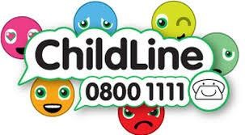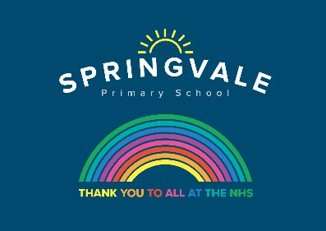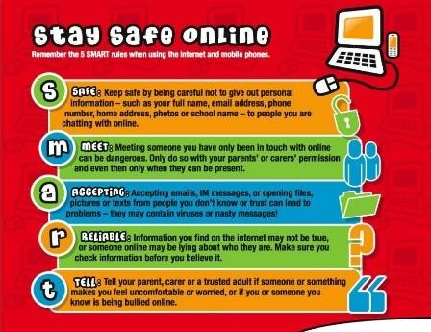

Learning Project WC 15.06.20: Rainforest
Age Range: KS1 YR 1 / 2 Mrs Evans, Mrs Royston, Mrs Tomlinson, Mrs Andrew
Weekly Maths Tasks (These don’t have to be done in order but aim to do 1 per day) | Weekly Reading Tasks (These don’t have to be done in order but try to do 1 per day)
Monday- Cut pieces of paper into different shapes or food that can be sliced, then work with your child to find half by cutting or drawing on the shapes or by slicing the food. Make sure both sides are equal and if they aren't, talk about why it is not half. Repeat for finding a quarter. | Monday- Create a sock puppet based on a favourite story character. Show your child how to use the puppet to retell the story the character appears in.
Tuesday- Ask your child to watch these videos and complete the activities about what a fraction is and how a fraction should be written. | Tuesday- Watch Eric Carle’s Slowly, slowly, slowly, said the Sloth. Once your child is familiar with the story, they can read along or join in with familiar sentences.
Wednesday- Get a chocolate bar and work with your child on how it could be split into half, quarters and thirds. You could investigate whether the size of the chocolate bar affects how much they get. Does ½ always look the same? | Wednesday- Ask your child to go and read in a sunny spot in the garden. How did it make them feel reading outside?
Thursday (theme)- Your child could estimate and count the number of different plant types or insects that they can see/find in the garden. Record in a table. | 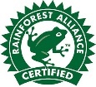  Thursday- Some of our everyday food comes from the rainforest. Your child can look in the kitchen cupboards and identify foods with the ‘Rainforest Alliance’ logo.
Friday- Select an even number of some of your children’s toys (e.g. toy cars, marbles). Work with your child on splitting the total amount in half by sharing out into 2 piles. Repeat this to find a quarter but share the amount into four piles. | Friday- Help your child to look through cookery books for a recipe involving chocolate. Ask them to use decoding skills to read some of the ingredients. They can learn about where chocolate comes from here.
Weekly Phonics/Spellings Tasks (Aim to do 1 per day) | Weekly Writing Tasks (Aim to do 1 per day)
Our children are all in very different places for learning sounds and spellings. We have provided a list of sounds / words, which increase in challenge to suit all needs.  Set 2 sound of the week: ir  Read and spell words such as:  girl, bird, birth, twirl, swirl, circle, circus  Set 3 sound of the week: er at the end of words  Read and spell words such as: letter, faster, baker, dancer, runner, teacher, writer, answer.  Year 1 spellings of the week (Rule= If you want to add ing to a verb like ‘get’, you must double the consonant before adding ing.): running, buzzing, sitting, cutting, swimming, stopping, putting, getting.  Extra challenge – Can you write these words in statements?  Year 2 Theme related Spellings: forest, jungle, species, canopy, habitat, tropical, climate, umbrella.  Extra challenge – can you think of any sentences that have these words in them? Perhaps you could write them down?  Year 2 Summer 2 Spag mat 1 (find on the school website)  Year 1 Summer 1 Spag mat 5 (find on the school website) | Monday- Your child could start a nature diary. At the same time each day, they could record the animals that they can see in the garden or from their window describe the weather and plants. What differences do they notice over the week? Would there be any changes if you looked again in a months time?
 | Tuesday- Can your child create a fact file about a spider monkey or a tree frog? Describe the animal’s appearance, habitat, diet and any other facts.
 | Wednesday- Your child could write a short description of the rainforest. Ask them to think about what they can see, hear, feel and smell. This live stream may help.
 | Thursday- Many trees in the rainforest are chopped down to use for paper. Ask your child to create a poster about saving and reusing paper at home.
 | Friday- Visit the Literacy Shed for this wonderful resource on Caterpillar Shoes. Or, write an acrostic poem about a rainforest creature.

Learning Project - to be done throughout the week: Sport
The project this week aims to provide opportunities for your child to learn more about the world’s rainforests. Learning may focus on the plants, animals and insects that inhabit the rainforest, food that originates there and weather patterns. It could look at plants and animals that can be found in the garden too.
- Fascinating Forest Floor- Can your child create their own replica forest floor? Task them with collecting materials from the garden or during your daily exercise. Why not share a photograph of your child’s creations on the schools twitter page?

- The Sounds of the Rainforests- There are many wonderful and intriguing sounds that can be heard in the rainforest. You can listen and watch real footage from a rainforest here or watch this BBC Our Planet clip. Which animal makes the most noise in the rainforest? Ask your child to record what sounds they can hear and to predict what animals the sounds have come from. Can your child replicate these sounds using objects from around the home?

- Where in the World are the Rainforests?- Using an atlas or online map, can your child locate the continents (Africa, Asia, Australia, Central America and South America) where rainforests can be found? If this is too challenging, can your child locate one country with a rainforest, and then locate the UK. Ask them to describe the similarities and differences between the UK and the country they have located.

- The Big Garden Tidy Up- Why not work together as a family and have a Big Garden Tidy Up? Task your child with pulling out weeds, raking up the leaves or just having a general tidy. Take before and after photographs and tweet us your achievements.

- Sketch a Spider Monkey or a Tree Frog- Can your child create a detailed sketch of an animal that inhabits the rainforest? Using pencils, crayons or whatever else you have, ask your child to copy an image of a rainforest animal, thinking carefully about the patterns and tones.

- Read ‘Ronald the Rhino’ and see if you can answer questions about the story. You’ll find the reading comprehension on the school website.

- Reading comprehension: Find out all about Rainforests in this weeks reading comprehension. Can you answer all the questions correctly? Find this non fiction text and its questions on the school website.

Additional learning resources parents may wish to engage with
- Watch this video.
- There are lots of insects/mini-beasts in the rain forest. You can see some pictures of them here. Look out for the Flannel Moth Caterpillar, it’s the strangest thing!
- Look for mini-beasts living in the garden or on a walk. What are these mini beasts called? Which one do you like the best and why? Are there any that you don’t like? Why? Try drawing pictures of the mini-beasts you find.
- The Rainforest Alliance website is packed full of information, resources and games which may support some of the above activities.
- For lots more clips, activities and ideas to get active visit the sport’s section on the Cbeebies website.
- Numbots. Your child can access this programme with their school login.

#SpringvalePrimary

