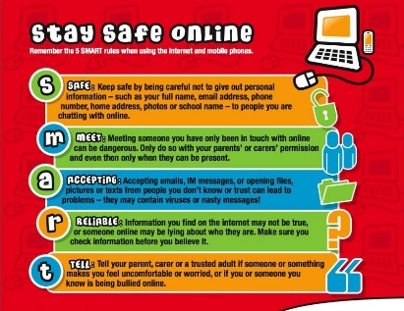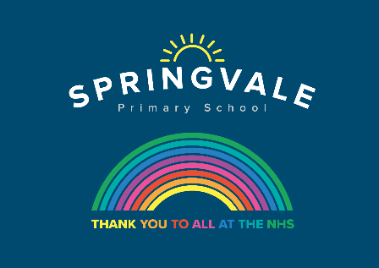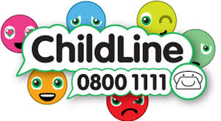
W/C: 08.06.2020: Learning Project - Sport
Age Range: Y5/6 Mrs Fearn/Mrs Henstock/Mrs Mayston
Weekly Reading Tasks | Weekly Spelling Tasks
Monday- Ask your child to read the sports pages of a newspaper and consider the language used. They could add interesting language to a sports’ word bank. | Monday- Can your child list sport related noun phrases and verbs that correspond with each letter of the alphabet? This will support their writing tasks.
Tuesday- Here is a reading comprehension activity about circus performers. Ask your child to read the text in under 3 minutes and complete the questions. | Tuesday- Can your child complete this word search which focuses on words ending in -cial or -tial? Can they find the meanings of these words too?
Wednesday- Ask your child to listen to and read along with Arundel Swimming Pool. Ask your child to summarise each verse using one word only. | Wednesday- Ask your child to create their own sporting wordsearch. This could include the names of athletes, sports or sporting equipment.
Thursday- Encourage your child to listen to a free age-appropriate audiobook here, choose a book from Oxford Owl or continue with their chapter book. | Thursday- Can your child unscramble these sporting words: queenmipt, poicmlys, tannidmob, cagminssty & pochmashpini.
Friday- Ask your child to consider the actions of a character in a book they’ve recently read. Do they agree or disagree with the actions? They should verbally give reasons for their opinions and justify them using evidence from the text. | Friday- Practise Common Exception words from the Year 5/6 spelling list: System, temperature, thorough, twelfth, variety, vegetable, vehicle, yacht. Challenge your child to spell them as you throw a ball to each other. Everytime the ball is thrown the next letter must be said.
Weekly Writing Tasks | Weekly Maths Tasks- Position and direction
Monday- Visit the Literacy Shed for this wonderful resource on The Catch. Or create a short victory story about a character succeeding. | Monday- Get your child to watch this video to understand the difference between reflection, translation and rotation.
Tuesday- Task your child with writing two newspaper articles on a sport of their choice, one reporting on an event and the other reporting ‘behind the scenes’. Pay attention to the different language that will be used in each. Can your child include direct speech from ‘interviews’? They could present this on Word or Google Docs if they have access to a PC. | Tuesday- Place several household objects on the ground indoors or in the garden spaced apart. Blindfold your child using a scarf and using the positional language, such as turn left, right, forwards, clockwise etc, give them instructions to lead them to the items. You could say something like: “Turn 90 degrees left, move forwards 3 spaces.” Can your child follow the given instructions to find the object?
Wednesday- Ask your child to choose a sports person they admire. Encourage them to create a biography which tells the story of their life in chronological order. | Wednesday- Using this online resource, ask your child to make a pattern and then reflect it. Or try this activity that allows reflecting, translating and rotating practice.
Thursday- Ask your child to choose a sport which is popular in another country and write an information report, giving key details about the sport and its history. | Thursday (theme)- Show your child the picture of different sport equipment below. How many different ways can they classify/sort the PE equipment?
Friday- Your child can create a persuasive leaflet for a new school sports club.  They should use persuasive language including modal verbs (e.g. will, should) and adverbs of possibility (certainly, probably). | Friday (theme)- Play catch. Each time the ball is caught, count up in a particular multiple (this could be any number between 2 and 100). If the ball is dropped, start again. It can be made harder by spacing out or by giving a higher target number.

Learning Project - to be done throughout the week
The project this week aims to provide opportunities for your child to learn more about sports and games. Learning may focus on the history of sport, sporting-heroes, physical challenges and performance.

- Sport Genius- Ask your child to research about sporting history and see how many different facts they can find out about sports from the past. Ask them to create their own sporting trivia quiz which they can test out on members of the household. Or place different sporting events from the last 100 years onto a timeline.
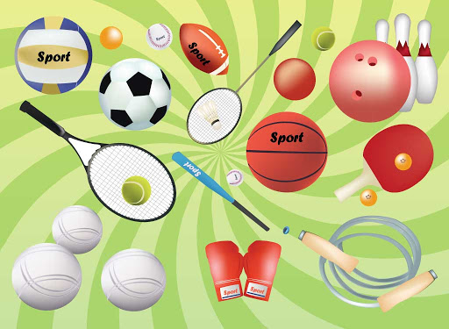
- Sporting Heroes- Get your child to select their favourite sporting star. Then they can draw a portrait of them in the style of the famous pop artist Roy Lichtenstein using felt tip pens or paint.

- Name that Sport - Get your child to create an orienteering map of your home/garden. At each location they will need to create a question relating to a sport e.g. Which sport has the most rules? The answers can then be recorded on an orienteering sheet. How about giving them a challenge? Can they create an answer that begins with the letter of the next location? Get your child to test it out on a family member.

- Beat It!- Begin by getting your child to measure their resting heart rate by counting how many beats in a minute. Then get them to carry out an exercise e.g. running, skipping, star jumps etc. for 3 minutes. Once they have completed this they are to carry out a recovery activity e.g. walking or sitting and see how long it takes for their heart rate to go back to normal. Ask them to repeat this with different recovery exercises to see which is the most effective at getting their heart rate back to normal the quickest. Can they create a way of showing their results?

- Anyone Can Be a Champion!- This activity is all about exploring the diversity of sport. Ask your child to research the history of the Paralympics . Discuss why we have the Paralympics. Get your child to create a poster which presents the importance of the Paralympics and the range of different sports there are.
- Heart Beaters
Can you tickle yourself? How many litres of blood do you have in your body? How many times does your heart beat in a day? Test your family with a body trivia quiz.
- Although last week’s theme was ‘Under the sea’ there is an online event on facebook for World Ocean day on Monday 8th June for anyone who fancies it: https://www.facebook.com/events/479707706275164/permalink/629025811343352/
Additional learning resources parents may wish to engage with
- BBC Bitesize - Lots of videos and learning opportunities for all subjects.
- Classroom Secrets Learning Packs - Reading, writing and maths activities for different ages.
- White Rose Maths online maths lessons. Watch a lesson video and complete the worksheet (can be downloaded and completed digitally).
- Times Table Rockstars. Your child can access this programmes with their school logins. On Times Table Rockstars, children should aim to play Soundcheck for 20 minutes daily.
- IXL online. Click here for Year 5 or here for Year 6. There are interactive games to play and guides for parents.
- Mastery Mathematics Learning Packs. Take a look at the mastery mathematics home learning packs with a range of different activities and lessons.
- Y5 Talk for Writing Home-school Booklets and Y6 are an excellent resource to support your child’s speaking and listening, reading and writing skills.

