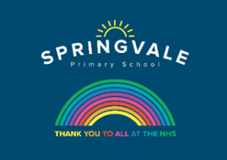
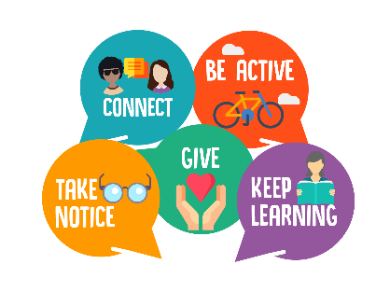
Year 5 & 6 Wellbeing Activities

This week at home and at school, as well as our learning projects, we will be focusing on our five ways to wellbeing. These are: be mindful, keep active, keep learning, stay connected and give.
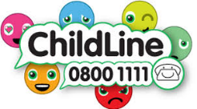
Below are ideas to do each day for the different areas. Please pick which activity/activities you would like to have a go at and keep a little diary of what wellbeing activities you do.
Monday - Be Mindful
- Look at a picture and concentrate on it. Remove it and name 5 things on the picture or answer questions such as ‘What colour was the umbrella?’. You could also do this by covering objects with a blanket or with a video.
- Host a session of Cosmic Yoga for you and your family.
- Go for a walk (perhaps you could go somewhere new?) and make a list of all the sounds that you can hear.
- Writing activity – write a letter to someone and post it. For example, you could choose Captain Tom Moore, another inspirational person, the NHS or a friend or family member.
- Write down topics on lollipop sticks (or small pieces of paper) and take it in turns to pull one out. Chat about the topic for a few minutes and then choose a new one.

Tuesday - Be Active
- Choose an exercise (e.g. hops, star jumps, press ups) and see how many you can do in 1 minute. How many can members of your family do? Record and compare! With help from an adult, you could even try and compete against your friends on a video call!
- Climb Everest at home. Walk up and down your stairs 20 times a day.
- Maths/Science activity – Measure your heart rate before exercise, during exercise and after exercise. Then, measure the difference and compare them to each other. Can you explain what happens? (You can measure your heart rate by finding your pulse and counting the number of beats in a minute, or by using a smart watch/phone with a heart rate monitor).
- Writing activity – Create a new game and write a set of instructions explaining how to play it.
- Run your own daily mile!

Wednesday - Keep Learning
- Make a list of five words or phrases that you’d like to learn in another language. Each day, learn your phrases in a different language!
- Read a new book
- Learn a magic trick. For example, you could use this website to learn a card trick. https://www.mykidstime.com/things-to-do/8-easy-card-tricks-for-kids-delight-amaze/
- Reading activity – Using your current reading book, find and research some words that you don’t know the meaning of. If you can’t find any, use this website to research new words. https://www.superkids.com/aweb/tools/words/middle/index.shtml Once you know the meaning, see if you can use it in conversation!

Thursday - Give
- Give yourself some ‘me time’ and do something you enjoy doing.
- Writing activity - Make a ‘thank you’ note for a member of the community. It could be the postal workers, bin collectors, shop assistants, bus drivers or for everyone! You could give it to them or place it in your window or garden for everyone to see.
- Make your own jar of kindness. Think of 10 things you could do for your family members, for example: make them laugh, put away the toys or help with a chore. Pick something out of the jar and try to do it today.
- Give up your time to help someone.

Friday - Connect
- Today, challenge yourself to talk to as many family and friends as possible that you can’t see face to face. You could do this by phone, text, Skype, WhatsApp etc (with adult support). This could even be your friends from school!
- Writing activity – Script and record a video message for the class describing what you have been up to. Imagine it as a ‘virtual show and tell! You can also send in a photo with some writing about what you have been doing.
- ‘Smile and the world smiles with you’. Smiling is free and it is contagious! Smile at everyone you see today – parents, siblings, people on walks and watch them smile back!

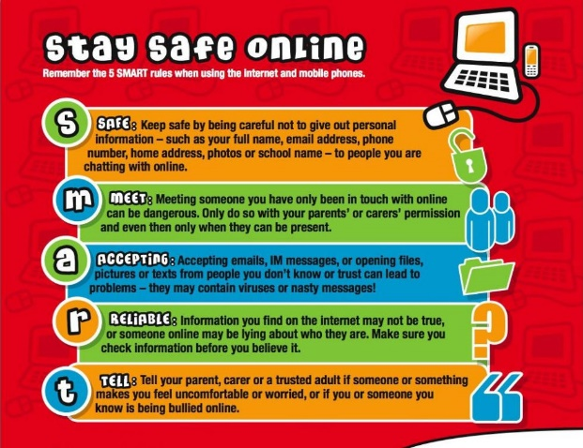
Other activities you may wish to try:
5 Mindfullness activities for children from Maths No Problem: https://mathsnoproblem.com/blog/learner-focus/mindfulness-activities-for-children/
25 Fun Maths Games for Kids: https://thirdspacelearning.com/blog/fun-maths-games-activities-for-kids/
Cosmic Yoga: https://www.youtube.com/user/CosmicKidsYoga

