Dear Families/Carers of children with Special Educational Needs,

Covid19 has brought significant change for all children and families. In life there are lots of changes that happen. ‘Change’ for most children is difficult and even more so when it is unexpected. Transition is the process of changing from one place or activity to another. Change can produce feelings of anxiety, confusion, uncertainty and possibly even fear, and for a child with social communication and interaction needs, these feelings may be heightened.

Why is change difficult for a child with Social Communication and Interaction Needs?

- Anxiety linked to the unknown – When can I visit family? When will I return to school?
- Desire for sameness – Preference for the familiar and routine
- Difficulties in predicting what might happen in a new setting, so may preference sticking with what is known and familiar
- Difficulties in social understanding – The child may take longer to understand the social rules of a new environment (setting/school) knowing how to respond or how to adapt their behaviour in a new social situation, e.g. assembly

The transition into a new setting from home to early years, or from an early years setting to full time school, and re integrating back into a setting/school, are big changes. However, transition is not just about major changes that occur in life, some transitions occur on a daily basis, for example: moving from one task to another (carpet to table) and from playtime back into the classroom.

With that in mind during this very challenging and ever-changing time, we know that preparation is key in order to support children with social, communication and interaction needs. We can support children to try to reduce anxiety by implementing changes gradually and by supporting their understanding through the use of visual supports and working alongside yourselves. Please remember, that it can take time for a child with social, communication and interaction needs to adapt to change, but remember that all the staff at Springvale are here to support you.
Some of the behaviours that may be seen in school or at home after returning to school may be:
- Increase in repetitive behaviour
- Being withdrawn
- Becoming easily frustrated or refusing to comply
- Crying
- Change in body language
- Difficulty separating from parents/carers
- Not being able to effectively communicate how they feel
These behaviours would be a normal reaction for a child who has a communication and interaction need, or suffers from acute anxiety. The reasons why a child may feel like this include:
- Coming in through new doors
- Not knowing when parent/carer is coming back
- New/unfamiliar vocabulary e.g. line up, carpet time, jobs, work
- No understanding of why they are in school
- Longer days
- Change to routine
- Unfamiliar environment e.g. new smells, sounds, lights
In order to combat all those behaviours at Springvale we shall try and adapt the TEACCH Iceberg metaphor. By introducing this we hope that the children with social, communication and interaction difficulties will feel:
- Calm
- Happy
- Confident in their learning environment
- Be familiar with key adults (where ever is possible)
- Be engaged and ready to learn
- Be able to separate from parents/carers
Springvale will manage this by:
- All teaching staff having good communication with parents/carers-who know what works well for their child.
- Having alternative communication methods in place if needed
- Having displays, objects and pictures to help children understand any new vocabulary
- Social stories will be shared to help visualise change- these will be sent home to help the children familiarise
- Having phased transition
All staff at Springvale have also considered all the following points in making sure that all the classrooms in school are social and communication friendly this includes:
- Environment
- Provision for children with a School Focused Plan or EHCP
- Child centred approach- planning reflects the needs of the child
- Visual supports and structures
- Rewards and motivators
What this may look like may include the use of fiddle toys and access to sensory activities, ear defenders (if required), movement and brain breaks, calming child-led activities, first and then board, visual timetables, social clues, rewards, motivators and timers.
In order to make the transition run as smoothly as possible here are some ideas for when your child returns to school.
Starting/returning suggestions for parents with a child who has a social, communication and interaction difficulty
- Encourage the child to bring in things they have made or done during the lockdown period
- Bring photos of key people in their life to help them feel secure and provide conversation starters

Here are some images that you may wish to share with your child that may help some of the expectations that will be required of them when they return to school:
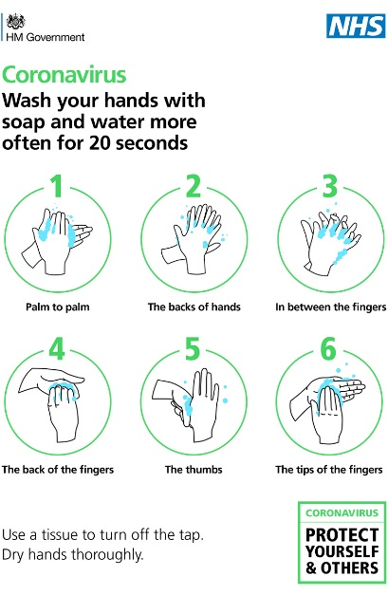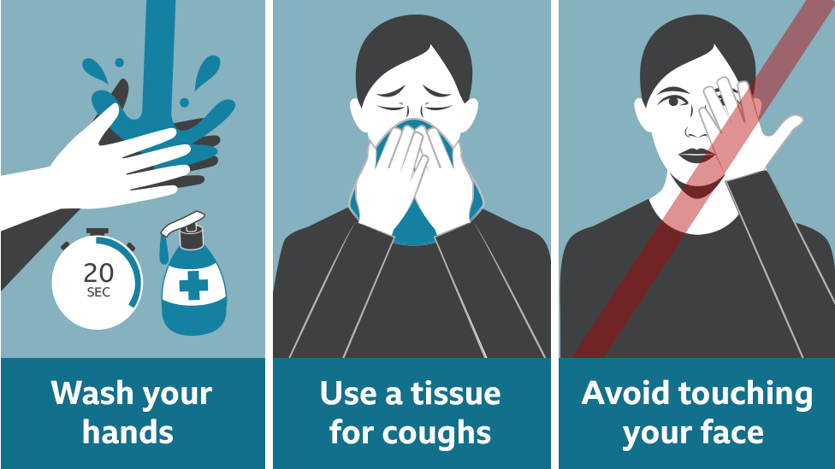
It may be an idea Consider a timer/song to support your child to understand how long they’re expected to wash their hands for.
NHS Hand Washing song: https://www.youtube.com/watch?v=S9VjeIWLnEg

Here are some good websites that you can have a look at to help your child with hand washing. Social Stories are a tool with use a lot with children who have social, communication and interaction difficulties. We find them an excellent learning tool that supports the safe and meaningful exchange of information between parents, professionals and pupils with social, communication and interaction difficulties of all ages.

Social Story for return to school following closures:
https://www.lgfl.net/covid19socialstorie

The following links are for Social Stories about the virus and supporting
understanding for hygiene measures e.g. hand washing:
https://carolgraysocialstories.com/wp-content/uploads/2020/03/Pandemicsand-
the-Coronavirus-1.pdf

https://carolgraysocialstories.com/wp-content/uploads/2020/03/COVID-19-ICan-
Help-1.pdf

https://carolgraysocialstories.com/wp-content/uploads/2020/03/Washinghands-
carefully-with-reprint-permission.pdf

Free Resource for parents/carers

Here is a free resources and online training for parents/carers and staff supporting
children with social communication and interaction needs to transition and reintegrate
into setting/school: https://www.schudio.tv/courses/preparingautistic-
send-children-for-going-back-to-school

Please do not hesitate to get in touch if you are wanting any further advice, or support, from school my email address is r.fearn@springvaleprimary.org and school’s number is 01226760930.
You can get further advice and support from this website.
www.barnsley.gov.uk/services/children-families-and-education/schools-and-learning/educationinclusion-
services/

Thank You
R. Fearn
Deputy Head and SENCO

