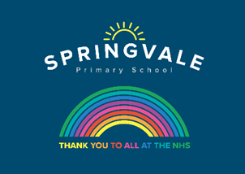
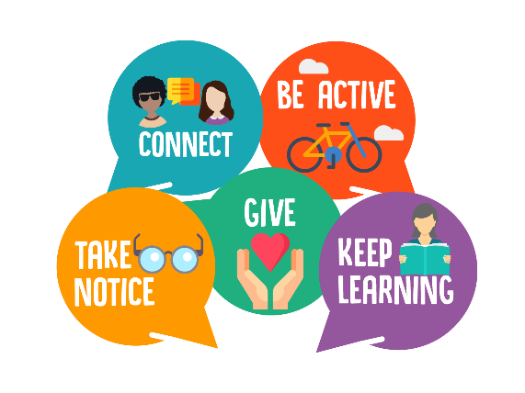
Year 3 & 4 Wellbeing activities.
This week at home and at school, as well as our learning projects, we will be focusing on our five ways to wellbeing. These are: be mindful, keep active, keep learning, stay connected and give.

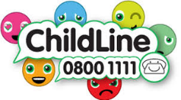
Below are ideas to do each day for the different areas. Please pick which activity/activities you would like to have a go at and keep a little diary of what wellbeing activities you do.
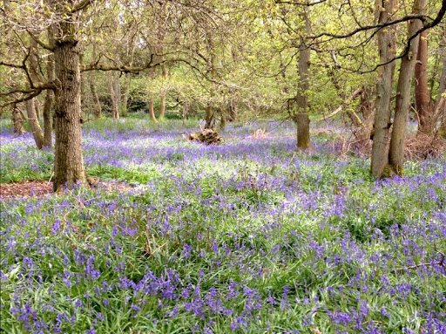
Monday - Be mindful

- Make a glitter jar https://heartmindkids.com/how-to-make-a-glitter-jar-for-mindfulness/
- READING ACTIVITY – read the instructions attached for how to make a glitter jar.
- Look at the picture of the woods. Think about what thoughts and feelings the picture provokes. Write them down.
- Go for a walk and sit and listen to the sounds around you.
- https://www.youtube.com/watch?v=cyvuaL_2avY use the clip and copy the monkey whilst listening to the lovely music
- At the end of the day, tell a grown up 3 things which you are grateful for or that have made you happy.
- WRITING TASK: Make up a story for the picture.

Tuesday - Keep active

- Put your favourite songs on and have a good dance!
- Set up some circuits at home and do each one for 1 or 2 minutes e.g. jumping on the spot or running the length of the garden.
- WRITING TASK: create your own fitness program like Joe Wicks. Write down the activity and maybe how to do them. Or you could write a healthy meal plan for the
- MATHS TASK: Practise your times tables. Year 3 master the 3s, 4s and 8s. Do star jumps and as you do, count up in 3s, 4s, or 8s. Or you could throw a ball and count. Be creative. Hide the answers to multiplication questions around the garden. Get an adult to ask you a question and run and find the answer.

Wednesday - Keep learning
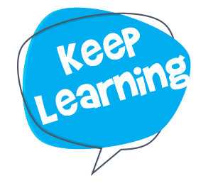
- Learn a new skill. It could be something you’ve always wanted to do or something totally new. Maybe you could learn a new recipe, learn to tie your laces, a new dance routine or knitting.
- WRITING TASK: Think of a topic you would like to learn about and create a fact book. I’d like to learn more about the planets so I will write down some facts about each planet today.
- MATHS TASK: https://www.youtube.com/watch?v=HeO0q0cSvx0 learn a new card game. Maths 4 kids on youtube is great for maths ideas.
- READING TASK: Read a new book.

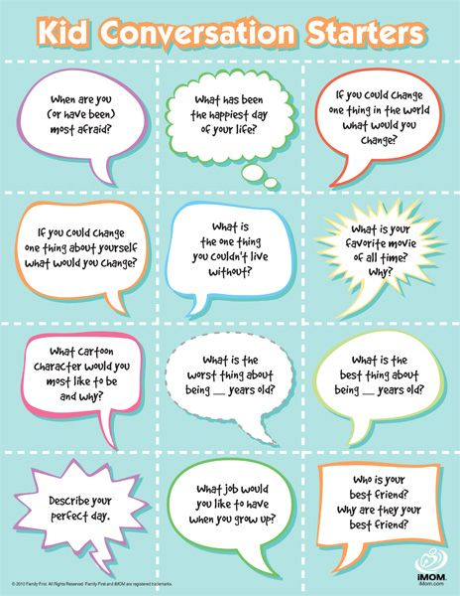
Thursday – Stay connected
- Send in a video message (or a photo) for the class or to a friend or family member.
- Write down some conversation topics to talk about over tea time or in the evening
- Set up a tea party outside and have a chat over a drink and a nibble
- WRITING TASK: Write a message to the whole class to go with the picture. Then I can send them all out
- MATHS TASK: Bake some biscuits for a friend. Follow the recipe and look at the weight of the ingredients.
- READING TASK: sit and read a book with an adult. Maybe you could video call a grandparent and read to them.
Friday – Keep giving
- ‘Smile and the world smiles with you’. Smiling is free and it is contagious! Smile at everyone you see today – parents, siblings, people on walks and watch them smile back!
- Make your own jar or kindness. Think of 10 things you could do for your family members. E.g. make them laugh, put away the toys or help with a chore. Pick something out of the jar and try and do it that day
- WRITING TASK: Write a thank you letter to a key worker. It could be the milk man, post man or the NHS.
- MATHS TASK: As you use your jar of kindness, keep a tally chart of how many times you do each act of kindness.

Keep a diary of what you have done each day of the week. Maybe you could include pictures of each activity.
Monday

Tuesday

Wednesday

Thursday

Friday

