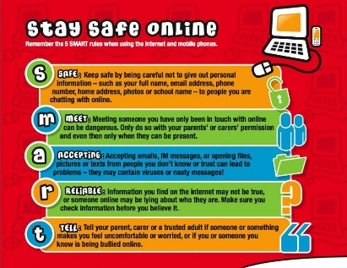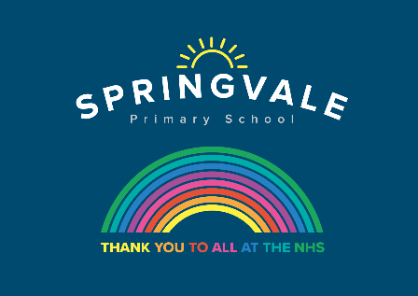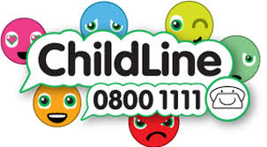
W/C 29.06.2020: Learning Project - Around the World
Age Range: Y5/6 Mrs Fearn/Mrs Henstock/Mrs Mayston
Weekly Reading Tasks | Weekly Spelling Tasks
Monday- Encourage your child to read the world news section of a newspaper. Discuss with them what they have found out. | Monday- Challenge your child to complete an alphabetical list of cities from around the world. Where possible, include capital cities.
Tuesday- Ask you child to choose a country or culture you would like to read about, and search online for information about their chosen country/culture. | Tuesday- Ask your child to record the meaning, an example sentence using the word, associations, synonyms (word with the same/similar meaning), antonyms (word that has the opposite meaning) and a dictionary definition of the following words: appreciate, guarantee and occupy.
Wednesday- Click here for a reading activity about The Lost World. Challenge your child to read the text in 3 minutes and complete the questions. | Wednesday- Can your child complete this prefix challenge from Talk for Writing? Ask your child to choose 5 words and apply them into different sentences.
Thursday- Ask your child to read an age-appropriate story from another culture. This could be from their own collection, Google Books or Oxford Owl. | Thursday- Ask your child to mind map words they associate with Birmingham and words they associate with Johannesburg (see here). This will support a later task.
Friday- Ask your child to summarise a book they’ve read this week in 100 words. Alternatively, they could summarise the main events in the form of a cartoon strip. | Friday- Pick 5 Common Exception words from the Year 5/6 spelling list. Task your child with choosing 4 words that have something in common and an odd one out.
Weekly Writing Tasks | Weekly Maths Tasks- Multiplication and Division
Monday- Visit the Literacy Shed for this wonderful resource on The Blackhat or your child write a description about their ideal world. | Monday- Get your child to test their times table knowledge by finding the products and factors in this game. Can they work through all of the levels?
Tuesday- Your child can pick a city of choice and create a travel leaflet all about it. Make sure that they include information on: weather, travel time, key tourist spots, accommodation and the local cuisine. | Tuesday- Play multiplication war with your child with a deck of cards. Flip two cards over and multiply. Whoever has the highest product keeps the cards. Ask your child what the inverse division fact would be. Use 3 cards as a challenge.
Wednesday- Listen to Zahra. Discuss what the story is about and how we know Zara is from a different country. Ask your child to rewrite the story of Zahra. | Wednesday- Encourage your child to practise their column multiplication and short division with these missing digit games. Can your child make their own versions?
Thursday- Use the story of Zahra to ask your child to create an advert to support WaterAid. What persuasive language could they use? How could they make their advert eye-catching? | Thursday (theme)- Choose three or four countries and record the temperature over the course of a week for each of the countries in a table. Your child can draw a line graph showing each country's temperature each day across the week.
Friday- Ask your child to create a poster which will assist younger children to learn about where the continents, particular countries and oceans of the world are. It must provide key facts and an imaginative layout/design to get children to learn where key places are around the world. | Friday (other)- Give your child the digits 3, 7, 8, 0, 6 and ask them to make as many whole numbers as they can. How can they be sure they have found all the potential numbers? After, give them five different digits and ask them to repeat. Do they find the same amount of potential numbers? If so, why could this be?

Learning Project - to be done throughout the week
The project this week aims to provide opportunities for your child to learn more about countries and cities around the world. Learning may focus on different cultures and traditions, famous landmarks, food and clothing.

- Flags of the World- Flags are a national symbol for all countries. Cultures use different symbols and colours on their flags which are meaningful to them and represent their history and people. Ask your child to pick 5 countries and investigate their flags. What symbols and colours have they used? Why are these significant to this country? Can your child create a flag for the UK which they feel represents our culture, history and people? Share on twitter.

- Tastes of the World- Children all around the world eat a variety of food and many of the foods we eat today are inspired by other countries. Can your child research and make a dish from another country which they have not tried before? They could find a recipe, source the ingredients via an online shop and follow the recipe to create a dish for the whole family.

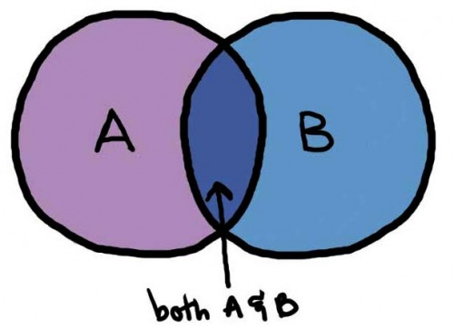
- International Games- As part of the London 2012 Olympics a variety of countries were asked to name a traditional game which represented their culture and traditions. These can be seen here. Ask your child to research these games and take inspiration from them to design their own game. Encourage your child to think about how the game is played, how you win and what equipment is needed. Where possible, they should test their game and make any changes needed. Ask them to present their game through writing and pictures. These could be handwritten or digital.

- From Birmingham to Johannesburg- Direct your child to think about what it would be like to live in another country. Do they think their life would be the same or completely different? Use the following clip to compare living in Birmingham to Johannesburg. Ask your child to show the similarities and differences between their life and Nwabisa’s life in South Africa. They may wish to show this in a Venn diagram, table or a poster.

- Exploring the World- Throughout history many people have explored new places. You can find out about some of them here. Ask your child to pick an explorer from the list or one of their choice. They could map out the places that the explorer visited or they could create a piece of art inspired by the places they visited using digital images as support. They may wish to write a diary entry from the explorer’s point of view to share what they have seen and experienced.
Coronavirus and Wellbeing- Coping with Change
The change that Covid-19 has caused to our lives has been difficult and has provided countless challenges. For many children, the uncertainty and disruption to everyday life has caused worry and anxiety. These tasks are designed to help children process the current situation, begin to make sense of it and plan for returning to a different normal.

Think
- Explaining to children what the Coronavirus is and how to stop the spread can be a challenging task. This fact sheet does this in a child-friendly way. Alternatively, there is an animated version here.
Talk
- Talk to your child about their worries and anxieties, considering what they can control and what they cannot control e.g. I can keep up with my home learning by checking which tasks I have to do today. I cannot control when this will all be over. Scientists, doctors and governments will help to manage this.
Do
- Ask your child to make 2 lists: one listing all of the issues that are not within their control and the other listing issues that are within their control. After this, support your child with listing who is responsible for the issues out of their control and then what they can do to support the issues within their control. This activity should help your child feel more in control about the current situation.
Visit
- This document from Emerging Minds offers evidence based advice for anyone supporting children and young people with their worries.
Music
This is not linked to our topic this week but is an exciting opportunity for any musicians out there. Barnsley Music Services are putting together a special music concert, if you play an instrument or sing you can get involved, or if you just like to listen to music you can watch the concert on Friday. Check out this link for more details: https://www.barnsleymusichub.com/key-stage-two-music-festival-online
Additional learning resources parents may wish to engage with
- BBC Bitesize - Lots of videos and learning opportunities for all subjects.
- Classroom Secrets Learning Packs - Reading, writing and maths activities for different ages.
- White Rose Maths online maths lessons. Watch a lesson video and complete the worksheet (can be downloaded and completed digitally).
- Times Table Rockstars. Your child can access both of these programmes with their school logins. On Times Table Rockstars, children should aim to play Soundcheck for 20 minutes daily.
- IXL online. Click here for Year 3 or here for Year 4. There are interactive games to play and guides for parents.
- Mastery Mathematics Learning Packs. Take a look at the mastery mathematics home learning packs with a range of different activities and lessons.
- Y5 Talk for Writing Home-school Booklets and Y6 are an excellent resource to support your child’s speaking and listening, reading and writing skills.

@SpringvalePS
Stay safe, we miss you!

