Mrs Tomlinson’s Art & DT Summer Holiday Challenges

Wacky Wheels-​ Cut out a circle from an old cardboard box. Have a go at creating a wheel print using this as a template. Perhaps you could use some string to create the spokes? Think about how you could stop the string from moving when you use it to print your design. How will you create your print? You could use paint or make a rubbing? Alternatively you could draw around the circle and create a repeating pattern. Look at this ​Sonia Delaunay print​ for inspiration. Share photos of your print via email or Twitter.

Float your Boat!- Have a go at designing and making some model boats. You could make a few out of different materials. Think about the qualities that the materials will need. What shape will make the best boat? Why? Perhaps you could use some recycled junk? ​Construct your boats and then predict whether or not they will float. Then you could test them in the bath or in a paddling pool. Which design floats the longest or travels the furthest? Do any of your boats stay afloat if you put some coins in them?

Fruit and Vegetables –​ Watch this video that explains the​ ​work​ ​of the artist Lynn Flavell. She uses fruits and vegetables to print repeating patterns. Can you create a piece of artwork in the style of Lynn Flavell?

What’s in your fruit bowl? Vincent Van Gough painted what was in his fruit bowl. You can see this painting here. This is known as a ‘still life’ painting. A still life is a representation of household objects (often food or flowers) in a picture. Can you draw what’s in your fruit bowl? Look carefully at the sizes and shapes of the fruit. Think about their sizes when they are next to each other. Where is the light coming from? This will help you to create the shadows. You might decide to leave this as a pencil sketch, or perhaps you’ll add some colour? It’s up to you.

Tweet Tweet! Have you noticed the birds singing outside? Have you spotted any birds? Watch this video for some tips on how to draw birds and get started drawing your favourite garden bird. You may wish to find a picture in a book to draw from as birds don’t usually sit still for very long!

Oodles of Doodles! Many of you have read the Tom Gates books by Liz Pichon. The books are full of really cool doodles. Click here to find out how she does it. Your task is to create a doodle with your name and words that mean something to you in the style of Liz Pichon.

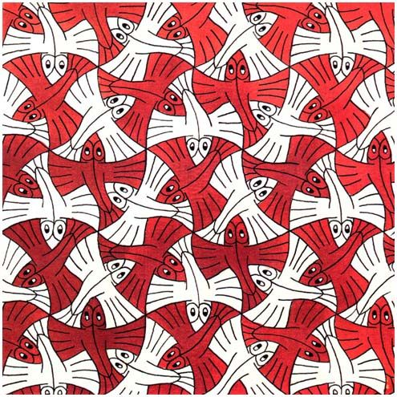
Lets Tessellate! Do you know what a tessellating means? It is where something is covered with a pattern of repeated shapes, especially polygons that fit together closely without gaps or overlapping. Here is an example of one of M. Escher’s tessellations.
You can research more of Escher’s work online. What do you notice about his style? Where do you think he gets his inspiration from? Use these videos as a guide to create your own tessellations: Fish or Frog

