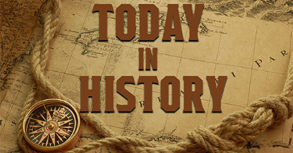
HISTORY IDEAS FOR SUMMER HOLIDAYS 2020.
- What can you find out about local history? Place names, roads, buildings, cemetery, railway, famous people, market, Penistone Show etc. Look for clues in the environment today.
- Can you find an artefact? What do you think it is? Who might have used it? What is it made from? What is it used for? How is it decorated? What skills were needed to make it? What might it tell us about life at the time? Any other observations? Can you sketch it?
- Make a timeline. This could simply be of your life or a period of history that you have learnt about at school. It could be more challenging to look at key events in British history, World history or a period of history that you are interested in. Could you make this into a board game or sorting cards game?
- Make a model of a historical building.
- Could you make up your own alphabet code and then write some messages for your friends?
- Research a famous historical person of your choice. If you know your new class name e.g. Year 5 will be Hippocrates – can you find out about them? Make some fact cards about this person.
- Research a topic that interests you and find out about its history - the history of medicine, space, cars, gaming, railways, dance, seaside holidays, slavery etc. Present your findings.
- Create a history quiz with questions for your family and friends.
- Draw/make a costume for a particular period of history – photograph yourself in it.
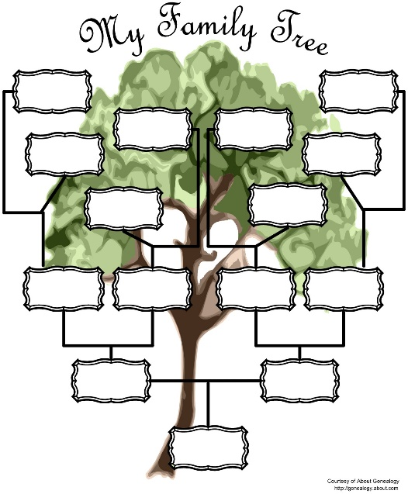
- Draw your family tree.

