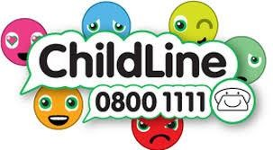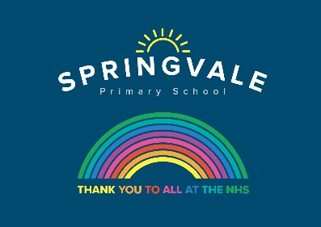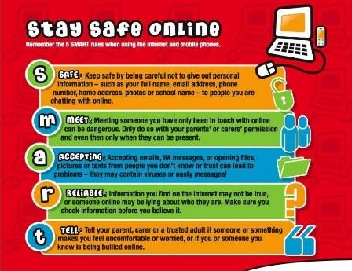

Learning Project WC 6.07.20: Music

Age Range: KS1 YR 1 / 2 Mrs Evans, Mrs Royston, Mrs Tomlinson, Mrs Andrew
Weekly Maths Tasks (These don’t have to be done in order but aim to do 1 per day) | Weekly Reading Tasks (These don’t have to be done in order but try to do 1 per day)
Monday- ​​ ​Can your child complete the patterns on ​these sequencing games​ using 2D shapes? This will help your child to recognise 2D shapes and to problem solve. | Monday- Listen to the programme ​Instruments Together​. Your child can design a poster for a concert – who will be performing? What instruments will be played?
Tuesday- ​ ​Look at the tins/cartons of food in your cupboards. Discuss with your child which ones are cylinders, which are cubes and which are cuboids. Sort them into groups. Which 3D shape do they think makes the best packaging and why | Tuesday- ​Ask your child to read their favourite story. When reading, play some classical music. Talk to your child about how it made them feel. Mind map their feelings after this e.g. relaxed, calm.
Wednesday- ​​Ask your child to practise spelling the names of these 2D and 3D shapes- square, circle, rectangle, pentagon, hexagon, octagon, cube, cuboid, sphere, pyramid. | Wednesday- Read along to the story ​Every Bunny Dance​.​ Following this, ask your child to list all of the instruments and dances that appeared in the book.
Thursday- ​​Go on a shape hunt around the house or on your daily walk. Label things that match the shape names they have been practising. | Thursday- Practise a favourite rhyme or poem. ​ ​Your child could learn the National Anthem for their country​. ​Create actions and perform this to the family.
Friday- ​ Describe 2D shapes to your child based on their properties. Ask your child to draw the shape or make the outline using pasta or rice. | Friday- Listen to the story of ​a poor musician and a stray dog​. ​Stop the film at certain points, e.g. 5:11 or 5:43. Discuss together what the characters might be thinking. Can your child draw thought bubbles to show this?
Weekly Phonics/Spellings Tasks (Aim to do 1 per day) | Weekly Writing Tasks (Aim to do 1 per day)
Our children are all in very different places for learning sounds and spellings. We have provided a list of sounds / words, which increase in challenge to suit all needs.  Set 2 sound of the week: ea  Read and spell words such as:  beat, seat, cheat, hear, fear, clear, clean  Set 3 sound of the week: oa  Read and spell words such as: coat, cloak, coast, moat, groan, moan, coach, raod.  Year 1 spellings of the week (Rule= The digraph oi is hardly ever used at the end of a word, but often in the middle: boil, joint, coin, point, soil, spoil, coil, foil.  Extra challenge – Can you think of any other words that contain this oi sound?  Year 2 Theme related Spellings: singer, dancer, player, instrument, music, microphone, note, musician.  Extra challenge – Perhaps you could write a song that includes some of these words?  Year 2 Summer 2 Spag mat 4 (find on the school website)  Year 1 Summer 2 Spag mat 2 (find on the school website) | Monday- Make an A-Z list of musical vocabulary. This could include instruments, artists or musical verbs. Apply some of these into sentences.
 | Tuesday- Create fact files about musical instruments. This could include where they originate from, what they’re made from, etc. Your child can include an illustration of the instrument and label the parts.
 | Wednesday- Can your child rewrite the events from​ ​Every Bunny Dance​ as a newspaper report? If this is too challenging, they could draw the events in a comic strip style using words such as ‘first’, then, and ‘after that’.
 | Thursday- ​Task your child with writing their own family song. When ready, they can perform it- perhaps to a family member on Facetime (with adult supervision).
 | Friday- Visit the Literacy Shed for this wonderful resource on ​Once in a Lifetime​ or your child can create an invitation for their family song performance.

Learning Project - to be done throughout the week:
Music
The project this week aims to provide opportunities for your child to learn more about music. Learning may focus on famous musicians, listening to and performing music and exploring a range of music genres and instruments.

● Famous Musicians-​ ​Find out about famous singers and bands from Sheffield. Listen to some of their music. Ask your child to list what they like/dislike about the music. What genre of music is it? Does it remind them of any singers or bands that they know? Create a fact file about the musician/s.

● Making Music-​ ​Task your child with making a variety of shakers. Using empty bottles from the recycling, fill them with different dry foods/things from the garden​. ​How can they make the shakers sound different? Ask your child to use the shakers during their family song performance (see above). They could also write a set of instructions for making your own musical shakers.

● Making More Music!-​ ​Can your child ​use different parts of their body to make music e.g. clicking fingers, stamping feet. Perhaps they could do a short performance? If you record a video clip of the performance be sure to email or tweet it through to school.

● The Four Seasons- ​Vivaldi wrote ​The Four Seasons ​ during the early Classical period. Divide a piece of paper into 4 and ​ask your child to draw each season in each box as they listen to the music ​here​. Discuss how each movement sounds different e.g. Spring is energetic and has a fast tempo.

● What can I Hear?​ ​Ask your child to visit different places in the home and garden. Get them to list all of the different sounds that they can hear e.g. the humming of the fridge. Which room is the noisiest? Encourage them to use words such as ​volume, tempo, pitch ​and ​beat. ​After this, ask your child to record the sounds and play them to the family. Can the family guess where the sound is coming from? Alternatively, your child can replicate the sound and the family could guess this way instead.

- Numbots- Your child can access this programme with their school login.

- Reading comprehensions: This week’s reading comprehensions continue with the theme ‘Music’. The non-fiction text is about the music artist Ariana Grande and the other reading comprehension is based upon the song ‘The Owl and The Pussy Cat’. You will find both of these reading comprehensions on the school website.

#SpringvalePrimary

