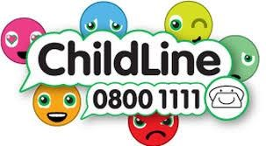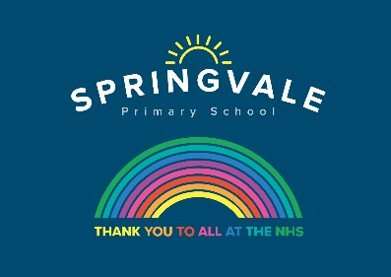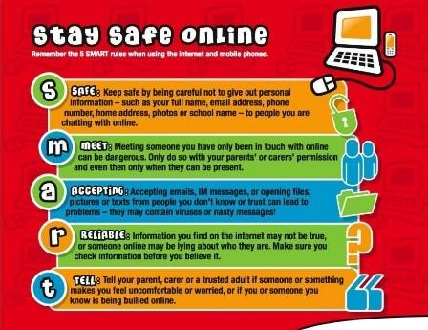

Learning Project W/C 13.7.20: Space

Age Range: KS1 YR 1 / 2 Mrs Evans, Mrs Royston, Mrs Tomlinson, Mrs Andrew
Weekly Maths Tasks (These don’t have to be done in order but aim to do 1 per day) | Weekly Reading Tasks (These don’t have to be done in order but try to do 1 per day)
Monday- Ask your child to find a book in your house. Can they find three items which are longer than the book and three items which are shorter? Order the items from longest to shortest. Measure the items to work out the difference in lengths. | Monday- ​Ask your child to select a book and imagine they are reading it in space. Try reading it with a flashlight just before bedtime.
Tuesday- Can your child write down the name of each family member in order from tallest to shortest? Is the tallest person the oldest person or not? Discuss why this might not be true.​ ​They could measure family members using a measuring tape. | Tuesday- ​Ask your child to listen to ​Look Up!​ read by the author and then take part in a drawing session with the book’s illustrator.
Wednesday- ​Play level 1 of this ​game​ to practise measuring things with a ruler. Then you could write some handy hints for using a ruler e.g. start at 0. | Wednesday- ​Take a look at these ​facts about space​ and read them together. Does your child have any further questions about space that you could investigate?
Thursday- ​Look outside, in your garden or on your walk, can your child find things that are taller than they are and things that are shorter than they are? | Thursday- ​Ask your child to list any space related words from the books they have read or listened to this week. Can they write the meanings of each word?
Friday - ​Can your child design a logo for their rocket? They must include the following 2D shapes: rectangle, triangle, hexagon and heptagon. | Friday- ​Listen to Beegu ​here​. Can your child write a character description about Beegu? Encourage them to reference events from the story.
Weekly Phonics/Spellings Tasks (Aim to do 1 per day) | Weekly Writing Tasks (Aim to do 1 per day)

Our children are all in very different places for learning sounds and spellings. We have provided a list of sounds / words, which increase in challenge to suit all needs.  Set 2 sound of the week: a-e  Read and spell words such as:  bake, shake, snake, cake, take, make, lake  Set 3 sound of the week: ew  Read and spell words such as: chew, crew, newt, knew, threw, jewel, view, screw.  Year 1 spellings of the week (Rule= The digraph oi is hardly ever used at the end of a word, but often in the middle: bake, shake, snake, cake, take, make, lake, awake.  Extra challenge – Can you think of any other words that rhyme with these words?  Year 2 Theme related Spellings: rocket, astronaut, planet, alien, space, galaxy, launch, universe.  Extra challenge – Perhaps you could write a poem that includes some of these words? Remember, poems don’t have to rhyme.  Year 2 Summer 2 Spag mat 5 (find on the school website)  Year 1 Summer 2 Spag mat 3 (find on the school website) | Monday- ​Ask your child to design their own rocket and create a bank of adjectives to describe it and verbs to describe how it moves.
 | Tuesday- ​Now that they have designed their rocket, ask your child to create an advertisement of the rocket launch. How much will it cost? What time will it launch? Is there anything else on offer?
 | Wednesday- ​Ask your child to plan their own trip to space – what will they take and what will they do there? Record this in a timetable.
 | Thursday- ​Encourage your child to research facts about a planet and then create a fact file about their chosen planet. This could be Earth.
 | Friday- ​Watch the Disney short “La Luna” ​here​. Ask your child to write a short diary entry about the star crashing into the moon.

Learning Project - to be done throughout the week:
Space
The project this week aims to provide opportunities for your child to learn more about space. Learning may focus on our Solar System, the Sun and the Moon. It could look at life in outer space from the view of an astronaut and travelling through space.

● Our Solar System-​ ​Encourage your child to think about what they already know about space and create a mind map. Can they name the planets in our solar system? Use ​the Solar System Song​ ​to create a diagram showing the order of the planets. Or make real ones using balloons and paper mache.
● Astronaut Aerobics- ​Astronauts have to be fit and agile for their missions into space. Ask your child to design a home workout and put your agility to the test! You could even use ​Mr Garcia's​ video to help. Then, your child can plan a day of healthy eating for the aspiring astronauts thinking carefully about each food group.
● What are Day and Night?-​ Share the video of ​day and night​ with your child. Watch the video and then create a poster about day and night explaining why we have day and night. Play the quiz and see how many answers you can get right!
● Rocket Creation- ​As part of their writing tasks, your child has designed a rocket. Ask your child to create their rocket using objects they can find in the home such as cardboard boxes, newspapers and tin foil. Can they write a set of instructions to share with a family member or friend? Don’t forget to tweet them to us or email a photo.
● Is There Anything out There?- ​Tim Peake​ is a famous British astronaut. Ask your child to record the questions they would ask him if they could interview him. Can they answer the questions in role as him?
- Numbots- Your child can access this programme with their school login.

- Reading comprehensions: This week’s reading comprehensions continue with the ‘Space’ theme. The non-fiction text looks at some famous astronauts and the other reading comprehension is based upon a few short poems. You will find both of these reading comprehensions on the school website.

#SpringvalePrimary

